Thomas Murphy

Professor Doyle

Flash Research Exam

4/18/17

WordPress

Our company would receive a benefit of $2,451,100 over three years by investing in web development tools under the WordPress platform. WordPress allows for web development work to be completed more efficiently. 78% of the work currently being done by the Web Development team will be done much more efficiently.

WordPress is an online website creation tool that offer freely available code. These codes are easily accessed online, and allow our Development team to save time from writing code. We would be able to increase our efficiency about 78%, lowering the amount of developers from 12 to 7. We only need 2 of our developers to use this tool and delegate the remaining 5 to traditional development technology roles.

Our to-be costs for WordPress would be $2,049,000 for initial costs and training, hardware maintenance, and for the remaining 5 developers’ salaries. Our as-is costs are $4,500,000 from the current salary we pay our 12 developers. This would lead to us having a three year net benefit of $1,635,000 if we switch to this platform.

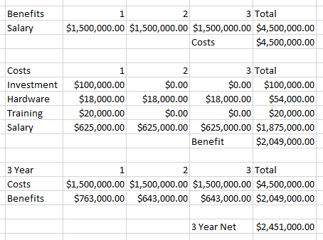

"Storage Cloud Service | Oracle Cloud." *Cloud Service - Cloud Storage Pricing | Oracle Cloud*. N.p., n.d. Web. 02 Mar. 2017. <https://cloud.oracle.com/en_US/opc/storage/pricing>.

Chad Brooks, Business News Daily Senior Writer. "8 Benefits of Online Data Storage." *Business News Daily*. N.p., 23 Apr. 2014. Web. 02 Mar. 2017. <http://www.businessnewsdaily.com/6294-benefits-of-online-data-storage.html>.

"Why Move To The Cloud? 10 Benefits Of Cloud Computing." *Salesforce UK Blog*. N.p., n.d. Web. 02 Mar. 2017. <https://www.salesforce.com/uk/blog/2015/11/why-move-to-the-cloud-10-benefits-of-cloud-computing.html>.