Mussie Woldezghi

Flash research paper # 1

MIS 2501/ 002

Professor Doyle

Data Centers and Networking

Over the past year our organization has experienced 10 unscheduled outages to its ERP system while using a Tier I data center. The downtime with a Tier I costs our company $25,670,304 annually. The same outages and downtime with a Tier III data center would have cost our company $1,555,776 annually (Colocation America). By upgrading we will mitigate the risk of being non-operational and not being able generate revenue during downtime. The Tier III will pay for itself within 3 years saving our company $13,229,056.

The Tier III is more efficient with an uptime of 99.982 percent and a yearly downtime of 1.6 hours. It has a N+1 fault tolerance and has 72 hour power outage protection (Colocation America). The acid test for a concurrently maintainable data center is the capability to perform any planned work activity without disrupting computer room processing (Brill, Seader and Turner). A key capability of the Tier III is it allows for any planned site infrastructure activity without disrupting the computer hardware operation. Another key capability is the redundant capacity components, which guard the primary system and detect failing components before failure occurs, then automatically operate as a backup system. Another key ability of the Tier III is its dual powered equipment and fuel storage for N capacity, which allows for added protection against disruption (Uptime Institute).

The Tier 1with a 99.67 percent uptime and 1734.48 minutes of downtime annually, coupled along with our organization’s approximate downtime cost of $14,800 per minute is costing our company $25,670,304 annually. After a three year period it would cost our organization $77,010,912. The Tier III with a 99.98 percent uptime and 105.12 minutes of downtime annually would cost our company $1,555,776. The difference of the annual costs of the Tier I and III will produce a savings of save $48,229,056 after a three-year period. It will take a year to build the Tier III and integrate it within our organization, costing approximately $35,000,000. Upgrading to a Tier III compared to a Tier I, the company would benefit with a net savings of $13,229,056 after integrating the Tier III data center, which is the difference of its original cost and our net savings after 3 years. After my assessment of the Tier III, I’ve concluded that in order to generate more revenue and increase productivity. Upgrading a Tier III is worth the risk, promising a return on investment of 38 percent. Without the Tier III our organization will not have a competitive advantage of continuous operations and generation of revenue during a power outage or downtime, ultimately hurting our bottom line.

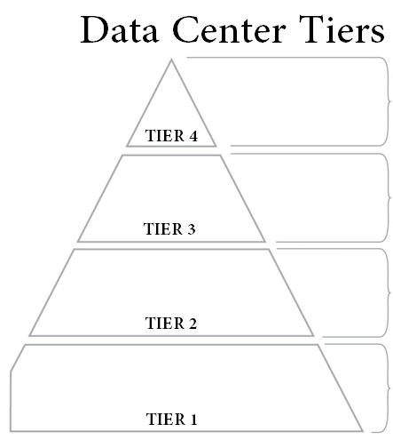

Enterprise Corporations  
99.995% Uptime

2.4 Minutes Downtime Per Year  
2N+1 Fully Redundant  
96 Hour Power Outage Protection

Large Businesses  
99.982% Uptime  
1.6 Hours Downtime Per Year  
N+1 Fault Tolerant  
72 Hour Power Outage Protection

Medium-size Businesses  
99.749% Uptime  
22 Hours Downtime Per Year  
Partial Redundancy in Power and Cooling

Small Businesses  
99.671% Uptime  
28.8 Hours Downtime Per Year

No Redundancy

|  |  |  |  |  |
| --- | --- | --- | --- | --- |
|  | Minutes in a year | Availability | Downtime(min/year) |  |
| Tier I | 525600 | 99.67% | 173448 | 25670304 |
| Tier II | 525600 | 99.98% | 10512 | 1555776 |
|  |  |  | Savings | 24114528 |
|  |  |  |  |  |
|  |  |  |  |  |
|  | Year | Costs | Benefits |  |
|  | 1 | 35,000,000 | 0 |  |
|  | 2 |  | 24114528 |  |
|  | 3 |  | 24114528 |  |
|  | Total | 35,000,000 | 48229056 |  |
|  | Net | 13,229,056 |  |  |
|  | 3 Yr ROI | 0.377973029 |  |  |

Works Cited

1. Uptime Institute. Data Center Site Infrastructure Tier Standard: Topology. Uptime Institute: Data Center Site Infrastructure Tier Standard: Topology 1.0 (2010) 1-12 Print.

2. Colocation America. Data Center Tier Standards. www. Colcationamerica.com,

Sept. Web 28 Jan. 2013.

3. Brill, Seader and Turner. Industry standard Tier Classifications Define Site Infrastructure Performance Uptime Institute: Industry standard Tier Classifications Define Site Infrastructure Performance 1.0 (2005): 1-4 Print.