Paul Carbone
Enterprise IT Architecture – Wordpress
Mart Doyle
3/18/15

Our company can save $2,451,000 by implementing the Wordpress platform into our web development process. Wordpress is a content management platform that will enable our web developers to increase their efficiency by roughly 80%. Wordpress is the best way that our web developers can maximize their productivity, while decreasing our company’s costs by $875,000 per year.
The key capability of Wordpress is its ability to simplify the complex process of launching and maintaining a website. Wordpress is a free and open source web development tool that eliminates the need for writing code and enables users to construct functional websites more efficiently through the use of templates, themes, plugins and widgets. Additionally, users are able to ‘drag-and-drop’ as they are incorporating these add-ons to their websites. With WordPress.org, “you host the site yourself with a web hosting company or your own server, download the software for free from wordpress.com, and [have complete creative control over your website]” (Kreitman). Wordpress offers a substantial amount of themes that can be implemented directly through Wordpress, which in turn eliminates the tedious task of writing code to develop these themes. In the same respect, “plug-ins can extend WordPress to do almost anything you can imagine” (WordPress). These plug-ins allow additional functionality to a website such as social media icons, electronic commerce, and formatting a mobile webpage setup. Users are also able to incorporate widgets which makes navigating around a website much easier.
The cost of implementing the Wordpress Platform over a three-year period $174,000, nonetheless, our company will achieve a three-year net benefit of $2,451,000. Although incurring an initial cost of $100,000 to purchase the hardware/software, an initial cost of $20,000 to train our Wordpress developers, and $18,000 per year for maintenance, this investment will both increase our web developers’ efficiency and productivity. This efficiency boost will result in a headcount reduction from 12 to 5, which in turn reduces our annual costs for these developers by $875,000 each per year. It is crucial for our business to capitalize on this savings opportunity and invest in the Wordpress Platform so our company can maximize its efficiency and productivity, and save $2,451,000 over a three-year period.

Cost/Benefit Analysis:
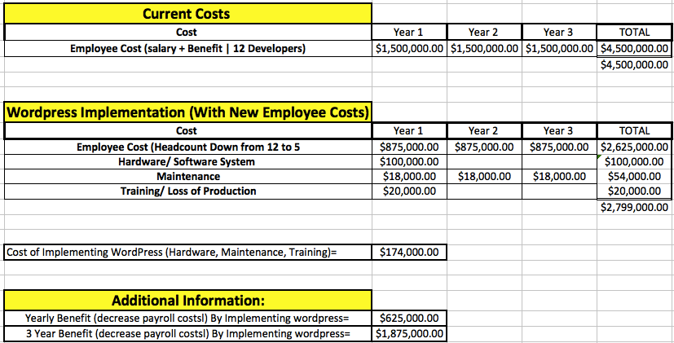

Work Cited

Kreitman, Adam. "7 Benefits of Using WordPress for Your Local Business Websi - YouTube." YouTube - Broadcast Yourself. MSMCexperts, 20 Jan. 2011. Web. 01 Mar. 2015. <http://www.youtube.com/watch?v=2bsT9EeWlBA>.

"Search Engine Optimization for WordPress « WordPress Codex." Main Page « WordPress Codex. Wordpress. Web. 01 Mar. 2015. <http://codex.wordpress.org/Search_Engine_Optimization_for_WordPress>.

"WordPress › WordPress Plugins." WordPress › Blog Tool and Publishing Platform. Wordpress. Web. 01 Mar. 2015. <http://wordpress.org/extend/plugins/>.

