Sophia Alvarez

MIS 3406

Flash Research Exam

Google Cloud

Good4You will generate a three year net benefit of $1,146,000 through implementing Google Cloud. Google provides cloud storage which stores our data remotely, allowing for us to pay only for the data storage that we use. This will allow Good4You to scale data at a much lower cost.

Google Cloud manages data storage and allows for customers to access that data over the internet, paying only for the storage they use. Google stores our data on their remote servers and that can be accessed over the internet without any additional hardware on our part. It offers our company the flexibility of paying only for specific amount of GBs being used, allowing for our data to be scaled at a lower cost. This eliminates the need to lease a SAN to archive data and allows Good4You to eliminate storage administrator headcount.

The three year total cost of implementing Google Cloud will be $1,404,000, which includes the cost per year of multi-regional data storage. The cost avoidance benefit over three years will total $2,550,000, as we eliminate storage administrators headcount and SAN yearly leasing fees. This will generate a total net benefit of $1,146,000 over the three year period.

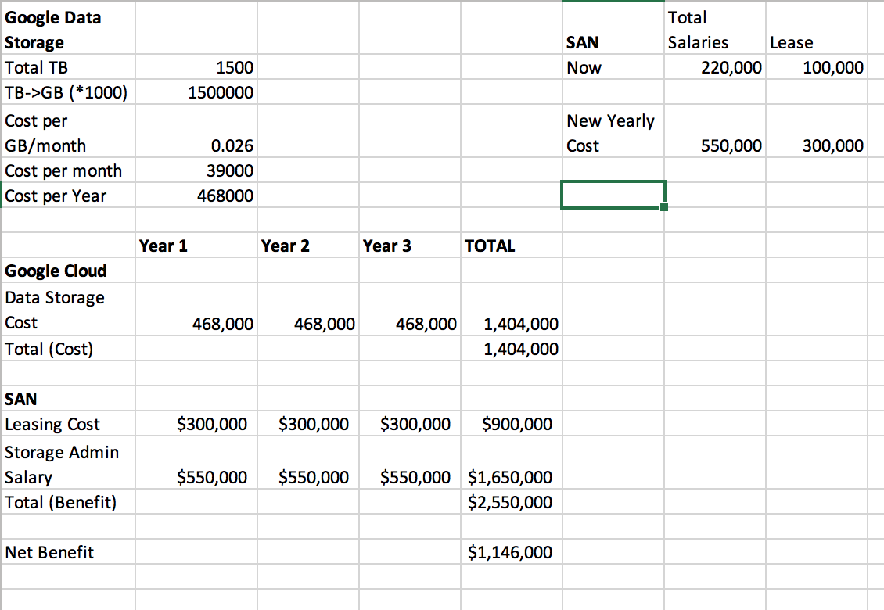

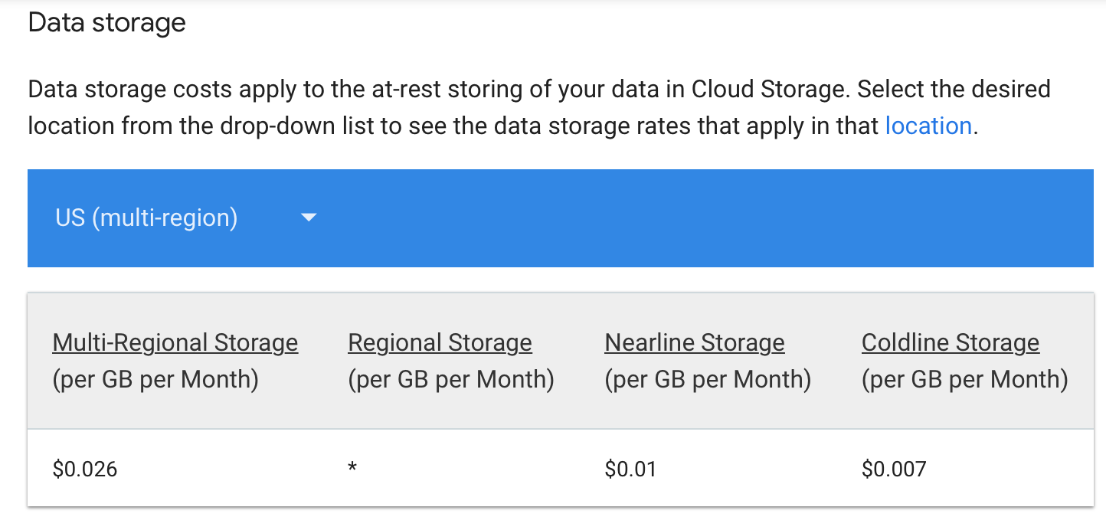

**Works Cited**

“Cloud Storage Pricing  |  Cloud Storage  |  Google Cloud.” *Google*, Google,

cloud.google.com/storage/pricing.

“Cloud Storage - Online Data Storage  |  Cloud Storage  |  Google Cloud.” *Google*, Google,

cloud.google.com/storage/.

“What Is Cloud Storage? | AWS.” *Amazon*, Amazon, aws.amazon.com/what-is-cloud-storage/.