Sarah Labbad
Mart Doyle
MIS 2501
2 April 2018
Sharepoint Flash Research
By investing in Sharepoint, we will increase our net revenue by $1,846,250 over a period of three years. Sharepoint allows us to easily manage and share files among our PMP team, which will result in an increase in billable hours of 3,810 hours/year.
The key capability of Sharepoint is its ability to manage files within a team of users. Our PMPs will be able to easily access each other’s shared files and will not have to waste possible billable hours managing documents. Sharepoint is an intranet that gives us the ability to share documents with select people in our own organization and clients, but also keep sensitive documents protected from those outside the organization. PMPs will eliminate the administrative part of their role and instead use this time to create value for our clients while bringing in more revenue.
The benefit of implementing this technology, due to the increased revenue from additional billing hours, is $2,000,250 over three years. The cost to implement and maintain this system over three years is $154,000. Therefore, the three-year net benefit of investing in Sharepoint is $1,846,250. This investment not only increases our revenue by almost $2M, but provides key benefits with regards to file access and sharing among our organization.
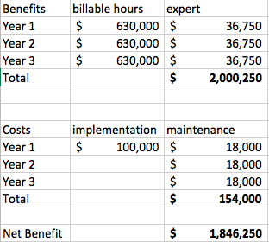

References:
"Microsoft Office SharePoint Server." What Is SharePoint ? A Webopedia Definition. Webopedia, n.d. Web. 20 Mar. 2015.
“Benefits of SharePoint Intranet.” Softeng. Softeng, n.d. Web. 03 Nov. 2013.
“What’s New in Microsoft SharePoint Server 2013.” SharePoint. Microsoft, n.d. Web. 07 Nov. 2016.

