Sarah Labbad
Mart Doyle
MIS 2501
1 March 2018
Cloud Storage Flash Research

By storing our data on the cloud with Amazon Web Services, we can save $11,724,596 over a three-year period. Amazon Web Services (AWS) allows us to store our transactional data in a remote location managed by AWS and access it from any location via Internet. This will eliminate our costs for physical data storage and allow easier access to the data for analysis.

The key capabilities of AWS are reliability and ease of access. Currently, we are storing data on our company’s SAN, which costs a huge amount of money to maintain. By switching over to the cloud, our data will be stored and managed by AWS, which saves us time and money due to transferring these responsibilities. Cloud storage allows us to send our data to this remote server that can then be accessed from any computer with Internet. This will make retrieving the data for analytics easier, especially with our continued sales growth and therefore increased transactional data.

The three year cost of switching to Amazon Web Services for storage will be $717,004, which is the cost to store all of our transactional data on the cloud. The benefit of this project will be $12,441,600 over three years due to avoiding the cost of storing the data on our SAN. The net benefit over three years is $11,724,596. This investment not only saves us millions but provides numerous benefits with regards to data storage and accessibility.

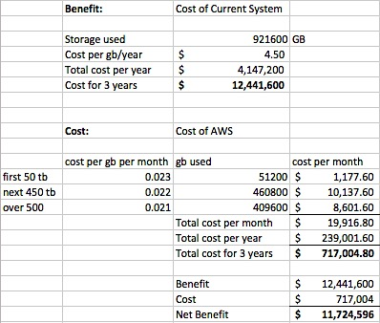

Works Cited
“12 Benefits of Cloud Computing.” Salesforce.com, www.salesforce.com/hub/technology/benefits-of-cloud/.
“Cloud Object Storage | Store & Retrieve Data Anywhere | Amazon Simple Storage Service.” Amazon Web Services, Inc., aws.amazon.com/s3/?hp=tile&so-exp=below.
“Cloud Storage Pricing | S3 Pricing by Region | Amazon Simple Storage Service.” Amazon Web Services, Inc., aws.amazon.com/s3/pricing/.
Denise, Sullivan. “The Risks and Benefits of Cloud Storage.” Cloudwards, 5 Dec. 2017, www.cloudwards.net/the-risks-and-benefits-of-cloud-storage/.

