Sarah Labbad
Mart Doyle
MIS 2501
17 April 2018
WordPress Flash Research
By training our employees in WordPress, we will reap a net benefit of $2,451,000 over the next three years. WordPress is an open-source website creation tool that will significantly increase our web development team’s efficiency. This increase in efficiency will allow us to decrease our headcount and subsequently our web development costs.
The key benefit of WordPress is its ability to decrease the time it takes to create a website. A large community of developers contribute to the open-source library, which allows for the reuse and editing of code instead of building every web page from scratch. Due to increased efficiency, we can cut down our team of developers and save millions of dollars.
The three year cost of switching most developers to WordPress, which includes the purchase of necessary hardware and software, maintenance, and developer training, is $174,000. The three year benefit, due to increased headcount, is $2,625,000. The three year net benefit is $2,451,000.

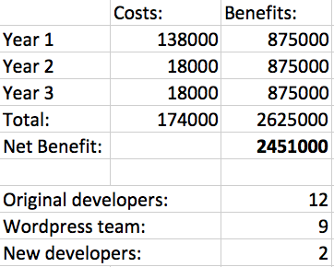

References:
“10 Benefits of Using WordPress to Power Your Company's Website.” Aspire Internet Design, 26 Sept. 2017, aspireinternetdesign.com/web-design/10-benefits-of-using-wordpress-to-power-your-business-website/.
“The Advantages of WordPress.” Digital Neighbor, 13 June 2017, digitalneighbor.com/advantages-of-wordpress.
“WordPress.org.” Blog Tool, Publishing Platform, and CMS - WordPress, wordpress.org/.

