MIS 2101 Mart Doyle section 002 Sara Monahan

915077518

Project 2 SAP Systems

Procure to Pay (P2P)

1. My first impression of working with the SAP system was how different it looked than I expected it to. In the book they show us small screen shots of different pages but the SAP easy access page has a lot more than I thought it would. There were a huge array of tabs that opened to an enormous amount more which then directed the users where to go. Everything was extremely organized and in the correct tab making it very user friendly. It looked much easier to work than I was expecting from listening to how it operated in class. I was very impressed at how the system worked and how difficult it is to do something without having the SAP system okay the process and making the numbers from each step match up.
2. In order to use this system I do think there are a select few skills that a person would need to have to access everything correctly. The user should have a basic understanding of an SAP system in order to access the correct tabs to get to where they need to go to create whatever they are in need of. Also a person needs to have basic computer skills in order to work the system. The user should also know what they are planning on doing and need to know the account and customer numbers, without those it will be very hard to make anything productive happen in the SAP system. Other than knowing the tabs and where everything they need to complete is the SAP system really helps to create orders and anything else a user would need it for.

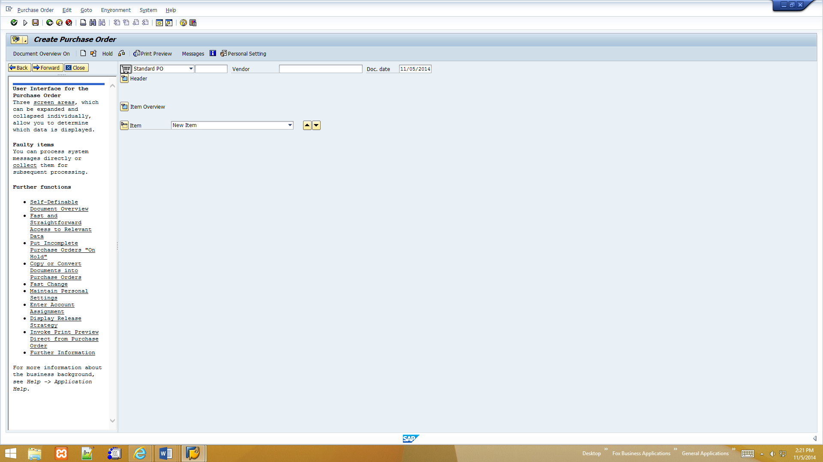

1. This screen occurs in the procurement activity
2. Create a Purchase Order is the name of this screen
3. The screen before the “create purchase order” screen is the SAP easy Access screen where the user needs to then select logistics, materials management, purchasing, purchase order, create and then vendor/supply plant known. Finally the Create Purchase Order screen will appear to make the actual order. The screen that comes after this is a “Vendor Search Screen” where we find the items that we need to put on the purchase order.
4. The warehouse manager completes this activity
5. When ordering products the warehouse manager may choose an item that they do not have enough of to complete that order. If this is the case then the SAP system will not allow them to create the order because the system knows that there is not enough material to complete the order as it was received.
6. Make an informal diagram of the data that flows among the actors during this process.

1. Create a purchase order

2. Create goods receipt for purchase order

4. Post Payment

3. Create invoice

1. Informal diagram to how the material (the water bottles and cages) moves.

1. Water bottles and cages move Space Bikes warehouse to Global Bikes warehouse

1. In order for a fake supplier to be created and actually receive any money then the accounting department would need to be in on the scheme. The accountants are the ones who check invoices and make payment to the suppliers so if anything were to happen in a company the accountants would be the ones who know about it. SAP can help reduce the chance of a fraud scheme like this because in the post outgoing payments screen there is a section for account number. The numbers for the accounts already need to be in there from an order that already existed. Without the numbers matching up the SAP system will not allow the user to go any further so much more planning needs to go into a fraud scheme like this than just posting payments to a fake supplier.
2. Creating a Purchase Order
   1. Global Bikes must need supplies to create bikes in order for a purchase order to be drafted.
   2. After creating a purchase order we need to create a goods receipt for the purchase order
   3. If one of the entries were incorrect in the purchase order, for example a material ordered, then the receipt would be incorrect for the supplier, the invoice sent to Global Bikes would have the wrong amount on it, when we post the payment to Space Bikes the amount will still be incorrect making the books in both accounting departments wrong.
   4. In order to prevent the wrong item being selected in the purchase order making the amount incorrect I would put in place a double check in the SAP system to make sure the item selected is the item that Global Bikes really does need. With the double check I believe many people could catch mistakes before they are sent out to the vendor, in this case Space Bikes.

Order to Cash (O2C)

1. Order to cash was similar to procure to pay for a couple reasons. We had to use the same skills in order to know what we were doing and what we were looking for. Also everything we did we ran through the SAP Easy Access screen before had. We had to continue to match up number to make sure the orders were correct and had everything we needed in them. We also had to pick materials again which we did in the procurement exercise this time just for a customer. Sales is different than procurement because clearly we are selling things here. In procurement we needed the items to make the bikes, here we are selling our product and because of that we have different screens we need to go through in order to keep everything in check. Here we have to create a sales order, delivery note, pick and pack materials, post goods issue, create a billing document, and post receipt of goods for the customer payment.

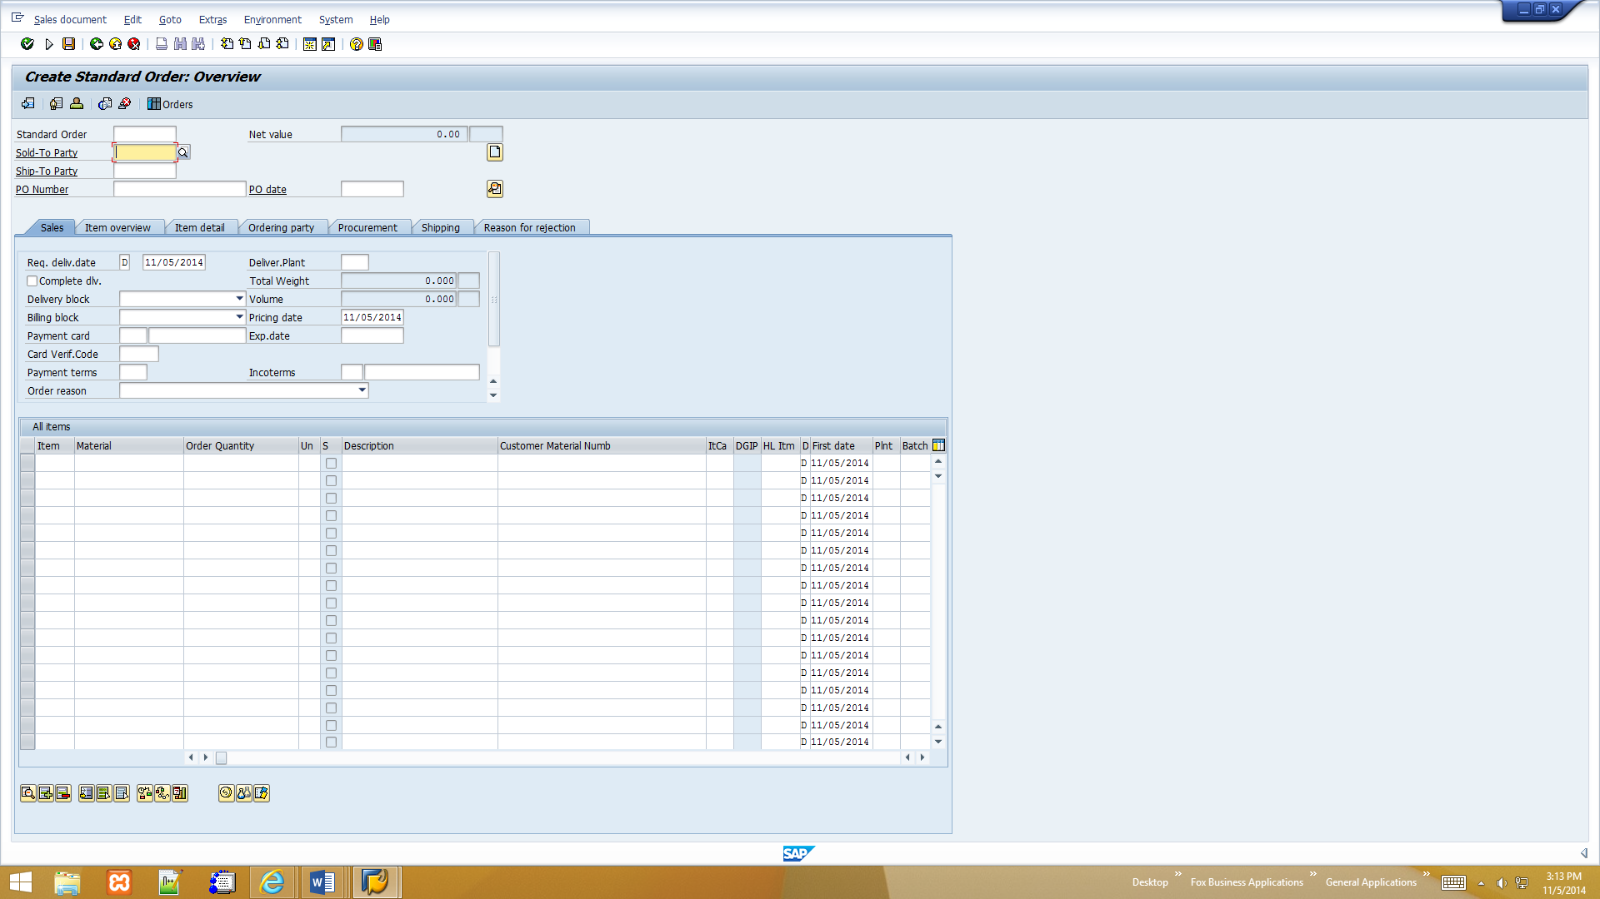

1. This screen occurs in the order to cash activity
2. This is the create standard order overview screen
3. Before this screen is the Create Sales Order initial screen where we input the type of order, sales organization, distribution channel, and division for the sale. After this screen comes the customer search screen where we search for the customer as the name suggests.
4. This action is completed by a sales person from the company.
5. The sales person could select the wrong customer but with the general customer tab in SAP it makes it much easier to see the customer’s names and select the right one from the list.
6. Make an informal diagram that show the data that flows between each of the actors during this process.

1. Create sales order

6. Post receipt of customer payment

2. Create delivery note

5. Create billing document for customer

4. Post goods issue

3. Pick Materials

1. Using the same four main actors, this time show with the arrows how the material (the bikes) moves.

1. The bikes move from Global Bikes warehouse to Philly Bikes warehouse or store

1. Ann in accounting would need to be involved in a fake customer scheme as well. Accounting again is the department that would be crediting any accounts with payments because they are the ones who handle the money in the company. If there was never any money received and Ann were to put a payment then she would be the conspirator. SAP systems helps to lessen the likelihood of something like this happening because SAP has customers already programed into the system and their number pop up in the sold-to party box on the sales order. There also is a warning screen when changes are made in the sales order screen. SAP matches up all the numbers throughout the entire process and when something does not match you usually cannot go on because there is a small warning on the bottom of the screen that informs you about the incorrect numbers.
2. Creating a Sales Order
   1. When a salesperson, like Sue, makes a sale they also need to make the sales order for the company to know what they sold.
   2. After creating the sales order with the materials sold and who they were sold to then the salesperson needs to create a delivery note to make sure the product gets to where it needs to go.
   3. If the salesperson somehow selected the wrong order number when in the outbound delivery screen then the company would be shipping the wrong product to one customer and the other one who actually did order the merchandise either would not get the items they ordered or would get the wrong order completely.
   4. In order to prevent choosing the wrong order number so nothing in the shipping process gets messed up, I would most likely put in an overview page after everything was completed so the sales person can see exactly what they ordered and where it is going very clearly and simply so if anything looks incorrect it would be easy to see.
3. Having completed one or both tutorials, make two suggestions about how:
   1. SAP could make their software easier to use by creating a system introduction program. Here a person would log on and be walked through everything they would need to know when completing their jobs. If there were a simple quick walk through program I think the SAP program would be more widely accepted because anyone would be able to learn and understand how to work it. Even with the tutorials that we went through there were still some things that were difficult to understand and if you missed one line the entire order could be messed up. If there were an actual program that went through all these steps with you and wouldn’t allow you to move on until everything went perfectly the SAP system would be more welcomed.
   2. The tutorials could be easier to understand for the students, and easier to learn first off if the PDFs were a little bit more clear because some parts are very blurry which makes it hard for us to see exactly what we need to do in these sections. Also if, like I said above, the tutorials were in the program and wouldn’t allow the user to complete any steps further unless everything beforehand is correct. If that were the part of this program the students would be able to see what they did wrong and see where they need to make changes. This would help really learn the program and avoid all other issues.