Stephanie Cabrera
Mart Doyle
MIS 3406
September 20, 2018
Flash Research Paper #1: Datacenter
With an upgrade from a Tier I data center to a Tier III data center we are able to save around $13 million a year. Within the past year, we have suffered through 10 outages, in total costing us $14,800 per minute. Our ERP system needs to run without interruption due to the fact that all areas of our organization are affected and benefit from this system.
A Tier III datacenter offers N+1 availability, redundancy capacity components, and consistent performance tests. N+1 redundancy, also called parallel redundancy, is a safeguard to ensure that an uninterruptible power supply (UPS) system is in place to make sure that your server will always be available (Colocation). Our current Tier I offers an availability of 99.67% while a Tier III datacenter offers a 99.98% availability.
This new data center will cost around $35 million to implement. Every minute of downtime costs $14,800, so the tier III increased availability would save a total of $48 million over three years. After three years we will see a net benefit of $13 million. The cost of a new datacenter may seem like a lot at first but the benefit outweighs the cost, which in the end helps keep our company afloat.
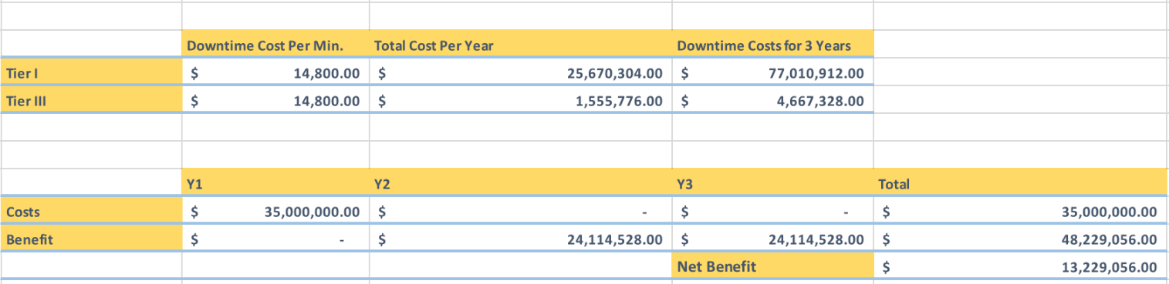

Works Cited
Colocation American Staff. “N 1 Power Redundancy.” Colocation America, Colocation American Staff, 8 Feb. 2016, www.colocationamerica.com/data-center-redundancy/power.htm.

“ERP Benefits | Impact of ERP System on Organization | EresourceERP.” How ERP Systems
Improve Company's Business Performance | EresourceERP, www.eresourceerp.com/how-erp-system-can-make-impact-on-organization.html.

Woodward, Matt. “How Much Does 1 Hour of Downtime Cost the Average Business?” Rand
Group, 9 Jan. 2017, www.randgroup.com/insights/cost-of-business-downtime/.

