On Track Team

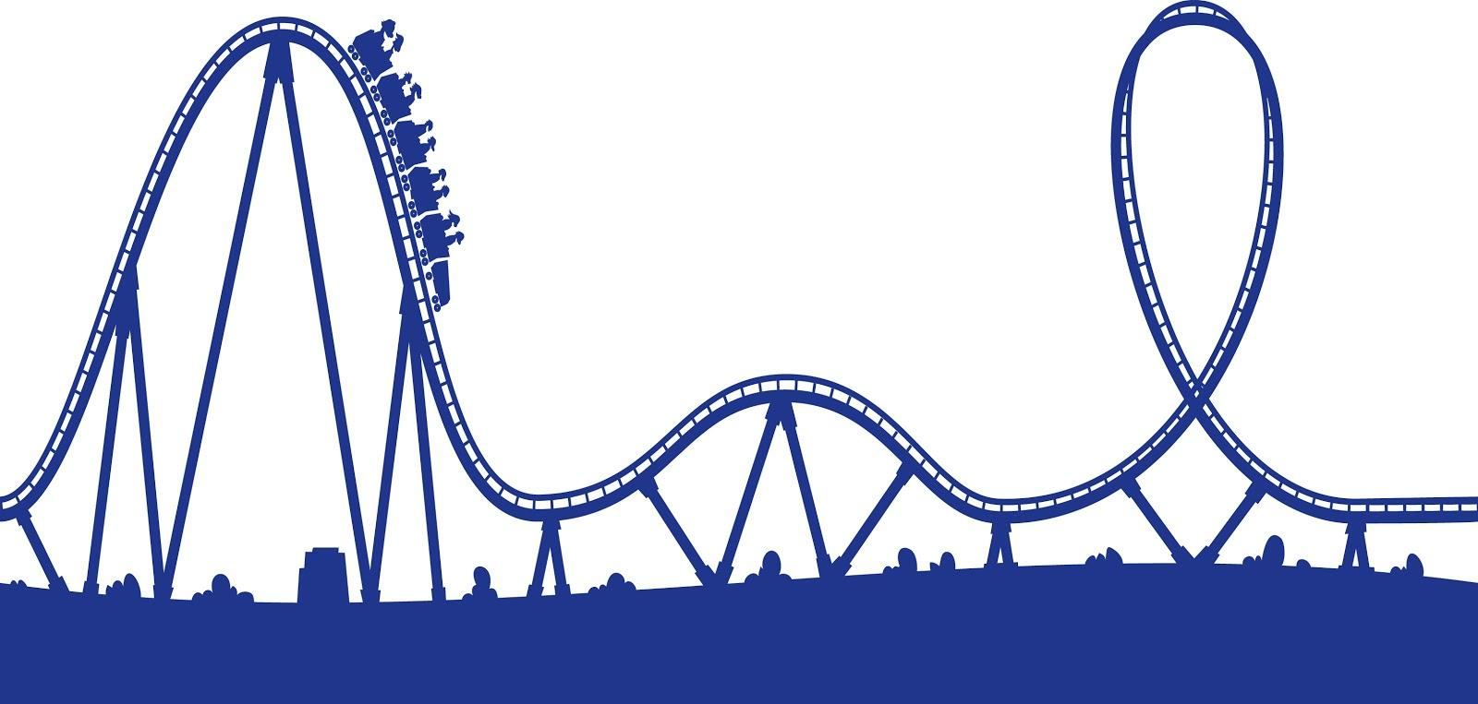

MIS 3535 Marie-Christine Martin

Project Managers: Michael Blum and Shuyue Ding
Engineering Team: Justin Goldman, Junqiang Liu, Tyler Myles, and Mohammed Bah

Table of Contents
Problem Statement ………………………….…. 2
Project Charter ……………………………….... 3
Scope Document ………………………….….... 5
Organization Chart ………………………….…. 7
Stakeholder Register ……………………….…...8
Communications Plan ……………………....…. 9
Risk Management Plan …………………...……11
Risk Register …………………………………...13
Change Management Plan ………………….….15
Change Request Form ………………………….18
Quality Management Plan ……………………...20
RACI Chart …………………………………......23
Work Breakdown Structure (WBS) ………….....24
Budget ………………………………………..…27
Status Report …………………………………....30
Close-out Report ……………………………......31

Problem Statement

With such an increasing demand for rollercoasters to be bigger and faster, the size and materials to make these coasters is becoming increasingly more expensive. The goal is to reach the same result of a thrilling roller coaster ride without spending so much money. The focus will be on the common electromagnetic launch of a rollercoaster and we will experiment with different materials and methods to decrease the cost.

Project Charter

Project name
Engineering a Roller Coaster
Engineers
Tyler Myles
Justin Goldman
Junqiang Liu
Mohamed Bah
Stakeholders
 | Project Managers
 | Engineers
 | Marie-Christine Martin
 | Shriram Pillapakkam
 | Users of Roller Coaster
Purpose
Redesign today’s common launch roller coasters that utilize hydraulic/electromagnetic systems, to make a more affordable launch system. We plan to complete this challenge by implementing a dropped-mass-pulley system that uses cheaper materials that will reduce the typical cost of building a roller coaster.
Project managers
Shuyue Ding
Michael Blum
Project managers' duties
1. Develop policies and procedures to support project objectives
2. Identify roles and positions for members of team
3. Develop project schedule
4. Define project baseline and track project progress
Project Managers' Authority
1. Predict, suggest, and schedule deadlines for specific aspects of the project based on reasonable expectation of the design team pending approval of On Track team
Milestones
Design of rollercoaster launch system, track, cart |  | October 25th, 2017
Design of structural support |  | November 17th, 2017
CAD drawing of full roller coaster |  | December 11th, 2017
Completion of miniature roller coaster |  | April 27th, 2018
Risks
1. Behind schedule with documentation
2. Engineering team member leaves the project
3. Engineering team member joins the project
Budget
Maximum Spending: $1,000
Project Manager Role Sign-Off
 | Name | Signature | Date
Project Manager | Michael Blum
Project Manager | Sueyue Ding
Executive Sponsor | Marie-Christine Martin

Scope Document
Project Name: On Track
Prepared By: Michael Blum, Shuyue Ding
Date Updated: 12/9/2017

Problem Statement | With such an increasing demand for roller coasters to be bigger and faster, the size and materials to make these coasters is becoming increasingly more expensive. The goal is to reach the same result of a thrilling roller coaster ride without spending so much money.
Project Description | The On Track team will be modeling a small-scale, physical, interactive coaster through testing of the mass of cart and desired acceleration and height of ride. Validation of the model will be key so it meets the designed specifications to function as full scale roller coaster.
Project Objectives | - Decrease the cost of the launch system by 10% compared to common launch roller coasters by completion of ride.  - Successfully implement a dropped-mass-pulley system that utilizes cheaper materials to decrease costs by 5% by coaster’s implementation.
Deliverables | - Problem statement  - Project charter  - Risk management plan  - Communications plan  - Quality management plan  - Change management plan  - Scope document  - Work breakdown structure  - Budget  - Stakeholder analysis  - Org Chart  - RACI chart
Acceptance Criteria | - Meet all the deliverables on time  - Satisfy budget expectations  - Complete all weekly process reports on time
Constraints | - Lack of sufficient time to thoroughly work on project and deliverables  - Specific skill sets are lacking (i.e. welding, metal forging)  - Have a limited material supply to construct the roller coaster, restricting design abilities
Assumptions | - On Track project managers and team will remain so throughout the project  - The functioning roller coaster will be the focus of the project, not loading station, seat design, profit analysis  - Proper maintenance is done on rollercoaster in full scale model
Cost Estimate | Maximum spending: $1,000

Organization Chart

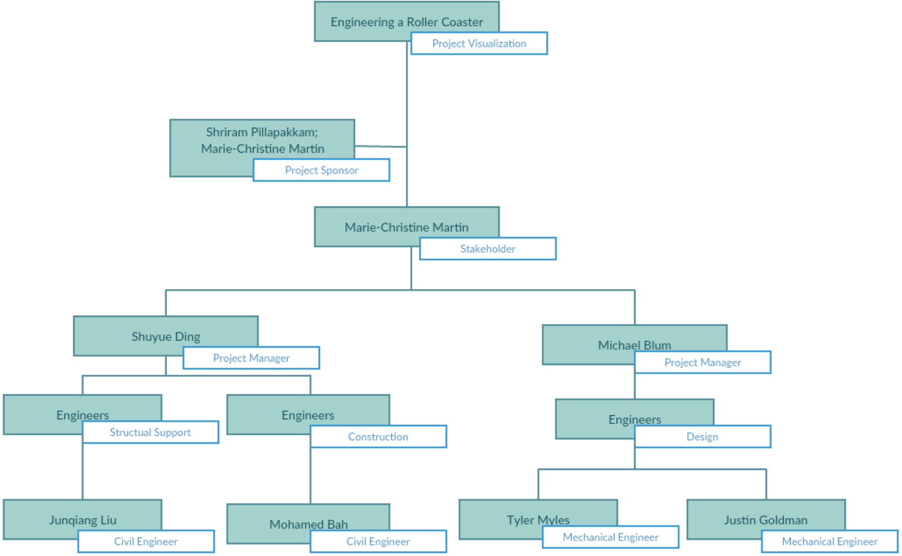

Stakeholder Register

ID | Name | Position | Type of Stakeholder | Requirements | Influence
1 | Tyler Myles | Student | Engineers | Improve the Roller Coaster with lower prices; Provide final deliverables and presentation | High
2 | Justin Goldman | Student | Engineers | Improve the Roller Coaster with lower prices; Provide final deliverables and presentation | High
3 | Mohamed Bah | Student | Engineers | Technical Support of construction; Provide final deliverables and presentation | High
4 | Junqiang Liu | Student | Engineers | Improve the Roller Coaster with lower prices; Provide final deliverables and presentation | High
5 | Marie-Christine Martin | Professor of Management Information Systems | Project Sponsor | Sign off on major project decisions; Support PMs | Medium
6 | Shriam Pillapakkam | Professor of Engineering | Project Sponsor | Sign off on major project decisions; Support Engineers | Medium
7 | Michael Blum | Student | Project Manager | Help and support engineers' documentations | Medium
8 | Shuyue Ding | Student | Project Manager | Help and support engineers' documentations | Medium

Communication Plan

Communication Plan Purpose

The purpose of our communication plan will be to organize a way to keep in touch with our project team in order to review progress and discuss future goals. Communication is vital for any project so this document will outline the mediums this semester.

Communication Objectives

- Stay in touch daily with project team to review progress and goals
- Develop a consistent weekly plan throughout the semester that is beneficial to both project managers and project team
- Get information to project team accurately and efficiently to maximize the amount of workload completed through the semester

Communication Service Level Agreement:
- Text message are to be answered within 12 hours
- Emails are to be answered within 24 hours

Communication Type | Objective | Medium | Frequency | Audience | Owner | Deliverable
Kickoff Meeting | Introductions, review objectives and approach | Face to face | Once | Project managers, project team | Project Manager | Project agenda
Slack | Stay in touch daily | Text messages | Daily | Project managers, project team | Project Manager | N/A
Weekly project meetings | Review previous tasks and discuss upcoming assignments/goals | Face to face | Weekly/bi-weekly | Project managers, project team | Project Manager | Meeting notes
Weekly progress reports | State accomplishments, goals, and total hours devoted to project | Online submission | Weekly | Project sponsor | Project Manager | Progress Report
Google Drive | Start and update documents in real time as well as storing templates and notes from class | Online | Daily | Project managers | Project Managers | Online documents

Risk Management Plan

1 INTRODUCTION

1.1 Purpose Of The Risk Management Plan
A risk is an event or condition that, if it occurs, could have a positive or negative effect on a project’s objectives. Risk Management is the process of identifying, assessing, responding to, monitoring, and reporting risks. This Risk Management Plan defines how risks associated with the On Track project will be identified, analyzed, and managed.
The Risk Management Plan is created by the project manager in the planning phase and is monitored and updated throughout the project. The intended audience of this document is the project team, project sponsor and management.

2 Risk management Procedure

2.1 Process
The project manager working with the project team and project sponsors will ensure that risks are actively identified, analyzed, and managed throughout the life of the project. Risks will be identified as early as possible in the project so as to minimize their impact. The steps for accomplishing this are outlined in the following sections. The project managers will serve as the Risk Manager for this project.

2.2 Risk Identification
Risk identification will involve the project team, appropriate stakeholders, and will include an evaluation of environmental factors, organizational culture and the project management plan including the project scope. Careful attention will be given to the project deliverables, assumptions, constraints, WBS, cost/effort estimates, resource plan, and other key project documents.
A Risk Management Log will be generated and updated as needed and will be stored electronically in the project library located at MIS 3535 team project.

2.3 Risk Analysis
All risks identified will be assessed to identify the range of possible project outcomes. Qualification will be used to determine which risks are the top risks to pursue and respond to and which risks can be ignored.

2.3.1 Qualitative Risk Analysis
The probability and impact of occurrence for each identified risk will be assessed by the project manager, with input from the project team using the following approach:

Probability
· High – Greater than <70%> probability of occurrence
· Medium – Between <30%> and <70%> probability of occurrence
· Low – Below <30%> probability of occurrence

Impact
Impact | H
 | M
 | L
 |  | L | M | H
 | Probability
· High – Risk that has the potential to greatly impact project cost, project schedule or performance
· Medium – Risk that has the potential to slightly impact project cost, project schedule or performance
· Low – Risk that has relatively little impact on cost, schedule or performance

Risks that fall within the RED and YELLOW zones will have risk response planning which may include both a risk mitigation and a risk contingency plan.

2.4 Risk Response Planning
Each major risk (those falling in the Red & Yellow zones) will be assigned to a project team member for monitoring purposes to ensure that the risk will not “fall through the cracks”.
For each major risk, one of the following approaches will be selected to address it:
· Avoid – eliminate the threat by eliminating the cause
· Mitigate – Identify ways to reduce the probability or the impact of the risk
· Accept – Nothing will be done
· Transfer – Make another party responsible for the risk (buy insurance, outsourcing, etc.)

For each risk that will be mitigated, the project team will identify ways to prevent the risk from occurring or reduce its impact or probability of occurring. This may include prototyping, adding tasks to the project schedule, adding resources, etc.
For each major risk that is to be mitigated or that is accepted, a course of action will be outlined for the event that the risk does materialize in order to minimize its impact.
Risk Register

Risk ID | Risk Type | Risk Description | Risk Impact | Risk Probability | Risk Value | Risk Response
1 | Behind schedule | Tasks and documentation are not completed as scheduled | High | Low | Medium | Mitigate risk by crashing tasks
2 | Over-budgeted | Actual engineering budget is greater than estimated | Medium | Medium | Medium | Mitigate the risk by cutting scope, seek funding, or reassign resources
3 | Unable to contact team | Inability to reach project team due to unforeseen circumstances | Medium | Medium | Medium | Mitigate risk by contacting sponsor about problem
4 | New team member | New student engineer joins the On Track team | Low | Medium | Low | Accept it and adjust budget and WBS accordingly
5 | Student drops class | Student in either class drops their perspective class | High | Low | Low | Accept risk and move on by delegating required work
6 | PM backs out | Project manager leaves the project | High | Low | Low | Accept it on move on
7 | Sponsor backs out | Project sponsor loses interest and leave project | Medium | Low | Low | Accept risk and move on with project

Risk ID | Risk | Impact | Probability | Risk Value
1 | Behind schedule | 0.9 | 0.4 | 0.36
2 | Over-budgeted | 0.6 | 0.3 | 0.18
3 | Student drops class | 0.9 | 0.15 | 0.135
4 | PM backs out | 0.7 | 0.1 | 0.07
5 | Sponsor backs out | 0.4 | 0.01 | 0.004
6 | New team member | 0.3 | 0.4 | 0.12
7 | Unable to contact team | 0.3 | 0.6 | 0.18

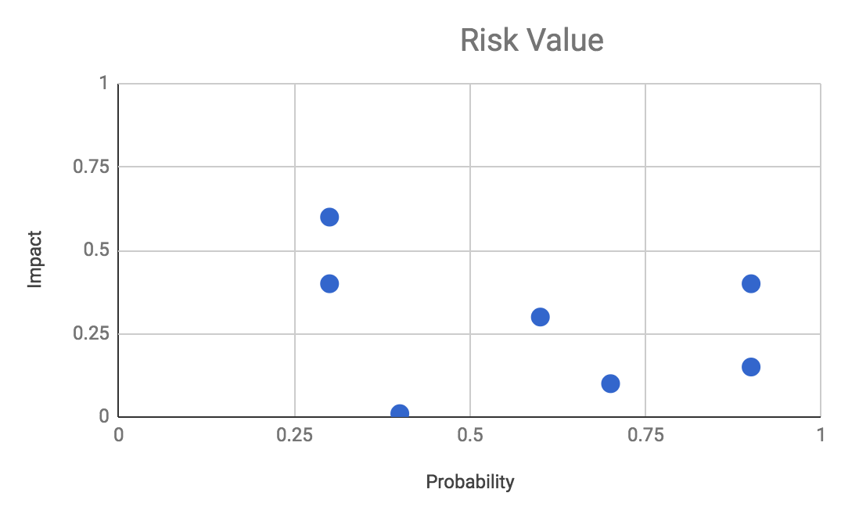

Change Management Plan
Introduction
The Change Management Plan is created for the Roller Coaster Project in order to manage unexpected and expected changes, handle changes, and document changes. All stakeholders will be expected to request and submit changes whenever they demand changes. Important changes are expected have sign off from project sponsor or clients.

Change Management Approach
The Change Management approach for the project will ensure that team members’ input when the change effort is still in the early planning phase. Making sure that all changes are well defined, processed, agreed/rejected, and documented is critical.

The Change Management approach consists of three areas:
- Making sure all changes are in the scope
- Determine implementation methods
- Manage changes during implementation

Definitions of Change
There are several types of changes which may be requested and considered for the project. Depending on different types of changes, the way we handle changes will be different.
Project managers must make sure that communicate changes to the stakeholders, and project managers also must make sure to document any changes updates in order to communicate with stakeholders if necessary.
- Scheduling Changes: changes which will impact the approved project schedule.
  - Fast tracking, crashing, or re-baselining the schedule.
- Budget Changes: changes which will impact the approved project budget.
  - Adjust funding from different tasks in order to implement changes.
  - Release contingency reserves if necessary.
- Scope Changes: changes which are necessary and impact the project’s scope, which are outside of initial plan.
  - Revise WBS, project scope statement, or other project documentation.
  - Get sign off from project sponsor/client.
  - Do not cut quality

Change Control Board
A Change Control Board (CCB) is a formally constituted group of stakeholders responsible for approving or rejecting changes to the project baselines. This group may meet on a predefined schedule or on an as needed basis. The table below provides a brief description of personnel acting as the Change Control Board (CCB) and their role/level of authority within that group.
Project Managers will update the change requests in the change log and the CCB will discuss and review them every Friday. If any change requests are needed for more information to process, the request will go back to the submitter for more information. All CCB members must vote to approve a change request, and all change requests’ decision must be sign off from the Project sponsor.
Name | Position | CCB Role
Marie-Christine Martin | Project Sponsor | CCB Chair
Michael Blum | Project Manager | CCB Member
Shuyue Ding | Project Manager | CCB Member

Roles and Responsibilities
- Project Sponsor:
  - Has the overall responsibility of every decision
  - Approve and sign off all changes to budget/funding allocations, schedule baseline, project scope
  - Participate on CCB
- Project Manager:
  - Responsible for implementing the change submitted by the Change Submitter.
  - Receive and log all change requests from project stakeholders
  - Ask for more information from change submitter if needed
  - Documenting every version of change requests and change decisions
  - Participate on CCB
- Project Team/Stakeholders:
  - Fill and submit all change requests form when changes are needed
  - Help with change implementation
  - Fill in change summary form

Change Management process
The Change Management process establishes an orderly and effective procedure for tracking the submission, coordination, review, evaluation, categorization, and approval for release of all changes to the project’s baselines.

Step | Description
Generate Change Request Form | A submitter completes a Change Request Form and sends the completed form to the Change Manager
Evaluate Change Request | - Project personnel review the change request and provide an estimated level of effort to process, and develop a proposed solution for the suggested change  - Evaluate steps  - Set up meetings to discuss change requests (CCB)  - Considering budget, time, impact, resources, risk, and scope  - Talk to project sponsor  - Approve/Reject
Authorize | Approval to move forward with incorporating the suggested change into the project.
Implement | - If approved, make the necessary adjustments to carry out the requested change.  - Incorporate into plan  - Communicate change status to the submitter and other stakeholders  - Add/reduce resources; Adjust related documents.  - Filling changes summary form.

Change requests
Any change requests made must be known by the entire project team and the project managers. Since these changes could affect a student’s schedule, the request must be made a day in advance of the meeting date. The project managers must know the reason for changing the communication method schedule and a specified reschedule date.

Change Request Form
SUBMITTER - GENERAL INFORMATION
CR#
Submitter Name
Brief Description of Request
Date Submitted
Date Required
Priority | Low | Medium | High | Mandatory
Reason for Change
Other Artifacts Impacted
Assumptions and Notes
Attachments or References | Yes | No
 | Link:

Decision | Approved | Approved w/Conditions | Rejected | More Info
Decision Date
Decision Explanation
Conditions

Change Summary form

Name
Date
CR #
What works well
What did not work well
What would you do differently

Quality Management Plan

IT Project Quality Management Plan
Project Title: On Track | Project Number: #43 Engineering a Roller Coaster
Project Leader/Manager: Michael Blum and Shuyue Ding | Anticipated Project Start Date: 9/4/201
Sponsor: Marie Christine Martin | Date Prepared: 12/11/2017

Quality Management Strategy
Quality management is performed throughout the project lifecycle with special attention to:
- Quality Planning – primarily during the project planning process.
- Quality Assurance (QA) – primarily during the project execution process.
- Quality Control (QC) – primarily during the project monitoring and controlling process.
- Independent Verification and Validation (IV&V) – ideally performed in all project processes except initiation. (Note: IV&V is required for very high risk, complex projects.)

1 Quality Planning
Quality is the degree to which the project fulfills requirements. Quality management planning determines quality policies and procedures relevant to the project for both project deliverables and project processes, defines who is responsible for what, and documents compliance.

2 Quality Assurance
The focus of quality assurance is on the processes used in the project. Quality assurance ensures that project processes are used effectively to produce quality project deliverables. It involves following and meeting standards, continuously improving project work, and correcting project defects.

The following table identifies:
- The project processes subject to quality assurance.
- The quality standards and stakeholder expectations for that process.
- The quality assurance activity – e.g., quality audit or reviews, code review - that will be executed to monitor that project processes are properly followed.
- How often or when the quality assurance activity will be performed.
- The name of the person responsible for carrying out and reporting on the quality assurance activity.

 | Project Process |  | Process Quality Standards/  Stakeholder Expectations |  | Quality Assurance Activity | Frequency/Interval |  | Who is Responsible
Review roller coaster development practices of safety testing. |  | Engineers have completely and accurately captured safety requirements. |  | Peer review of safety requirements specifications. |  |  | At regular intervals during the collection of requirements and a final review at the conclusion of requirements collection. | Engineering team members.

3 Quality Control
The focus of quality control is on the deliverables of the project. Quality control monitors project deliverables to verify that the deliverables are of acceptable quality and the customer is satisfied.

The following table identifies:
- The major deliverables of the project that will be tested for acceptable quality level.
- The quality standards and customer satisfaction criteria established for the project deliverable. Included are any organizational standards that need to be followed.
- The quality control activities that will be executed to monitor the quality of the deliverables.
- How often or when the quality control activity will be performed.
- The name of the person responsible for carrying out and reporting on the quality control activity.

Project Deliverable | Deliverable Quality Standards/  Customer Satisfaction | Quality Control Activity | Frequency/Interval | Who is Responsible
Dropped-mass pulley system performs desirable ride experience. | Dropped-mass pulley system must be free from defects.  End user does not experience errors or crashes and is happy with ride experience. | Non-developer (independent) testing of dropped-mass pulley system. | As released for testing by developer and before dropped-mass pulley system moves between alpha, beta, and production releases. | Engineering team

4 Quality Control and Assurance Problem Tracking
If you do not use some method to track quality issues, e.g., wiki, e-mail, ticketing system, JIRA, then the following logs can be used to itemize, document, and track to closure items reported through quality management activities. The table headings are examples of information you may wish to collect.

Quality Control Log
Exception ID Number | Review Date | Deliverable Reviewed | Findings | Resolution | Resolution Date

Quality Assurance Log
Exception ID Number | Review Date | Process Reviewed | Findings | Resolution | Resolution Date
RACI Chart
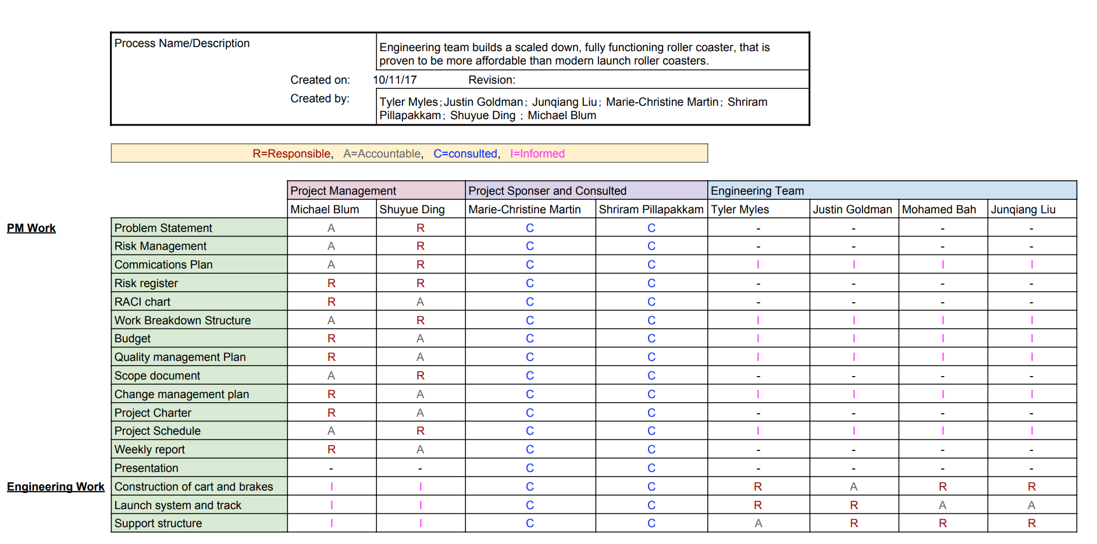

Work Breakdown Structure (WBS)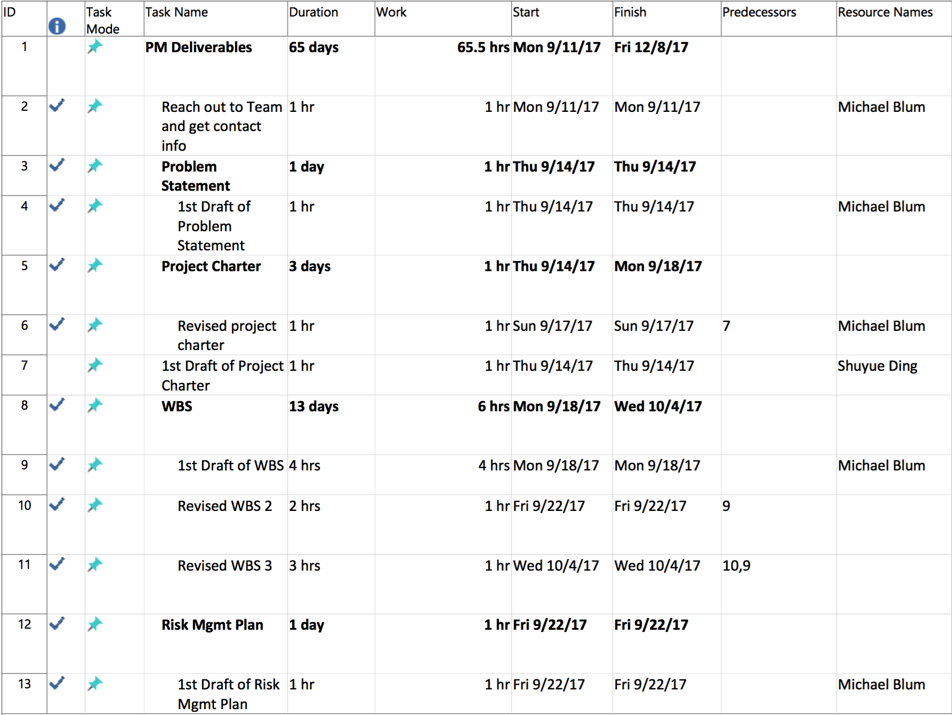
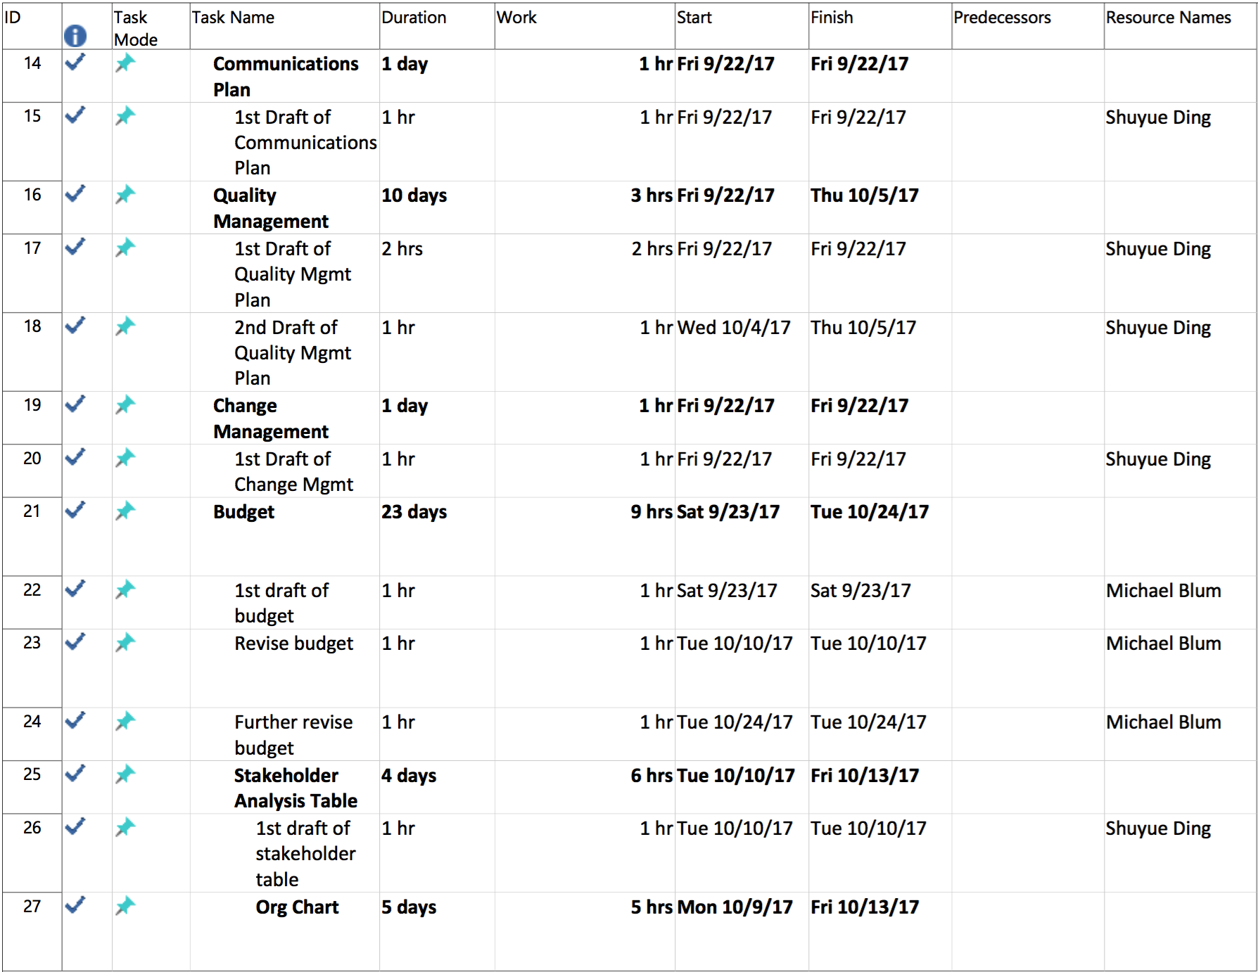
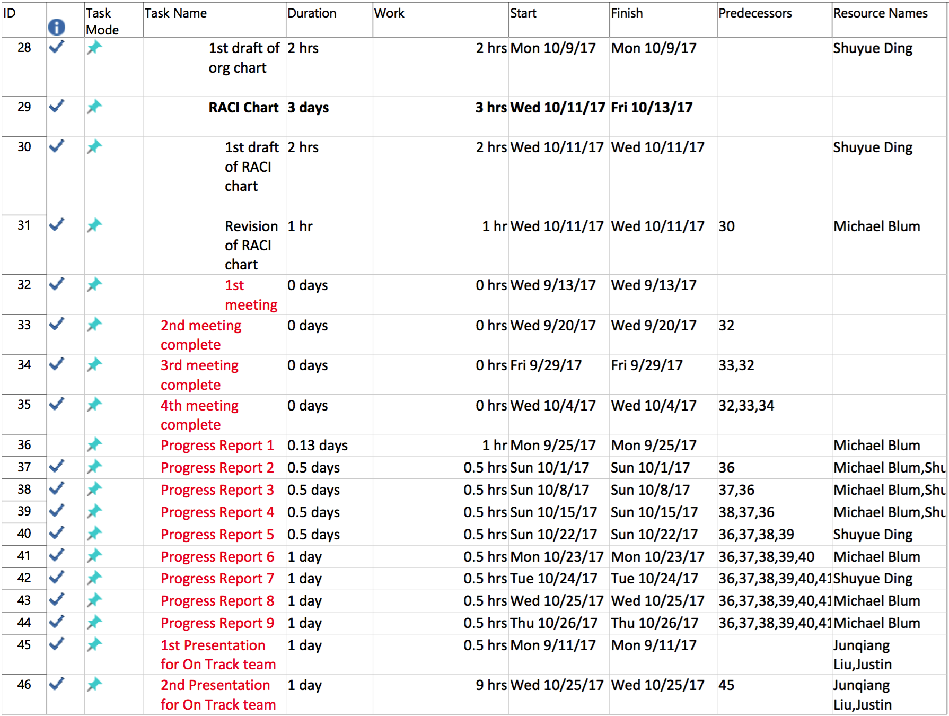
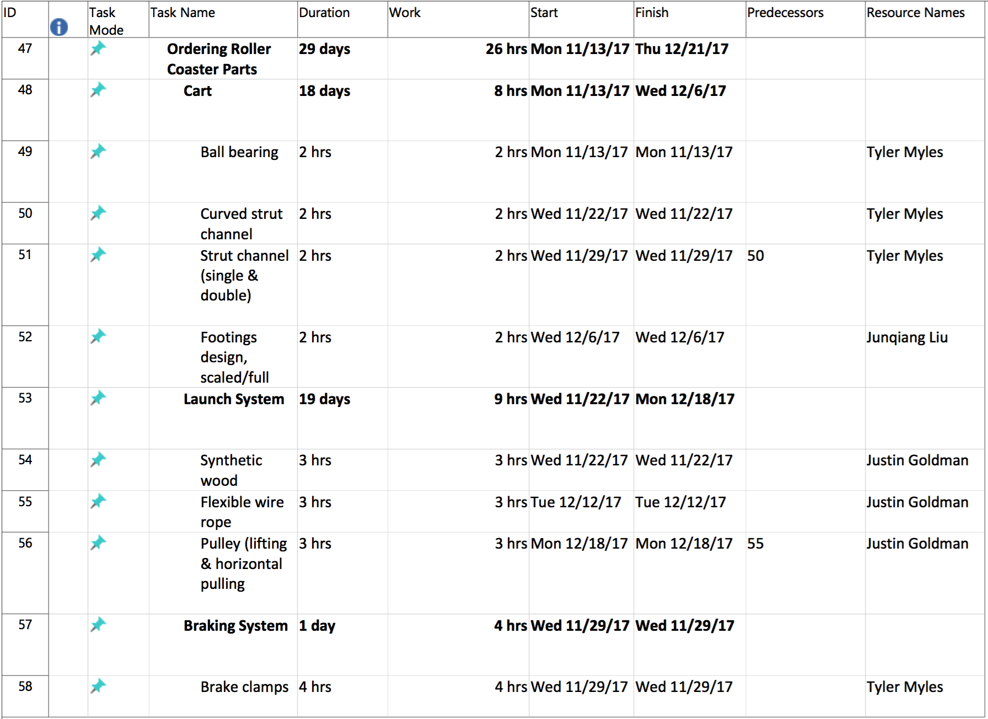
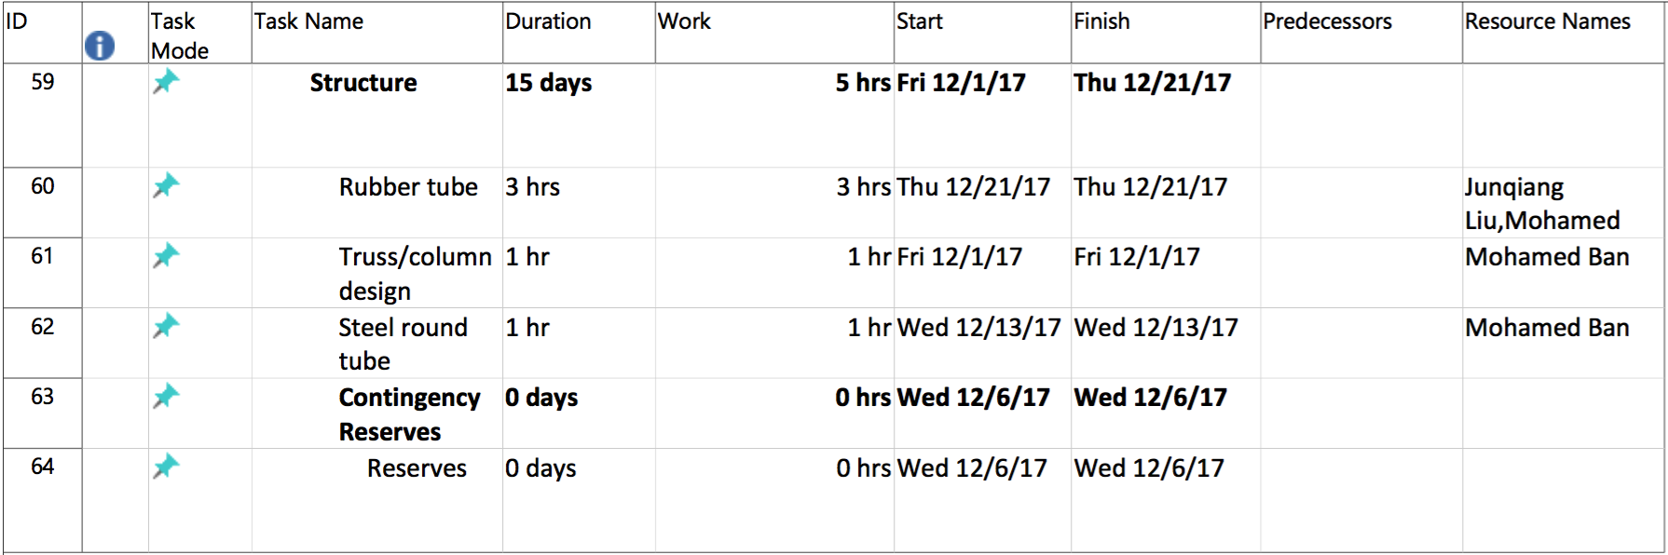

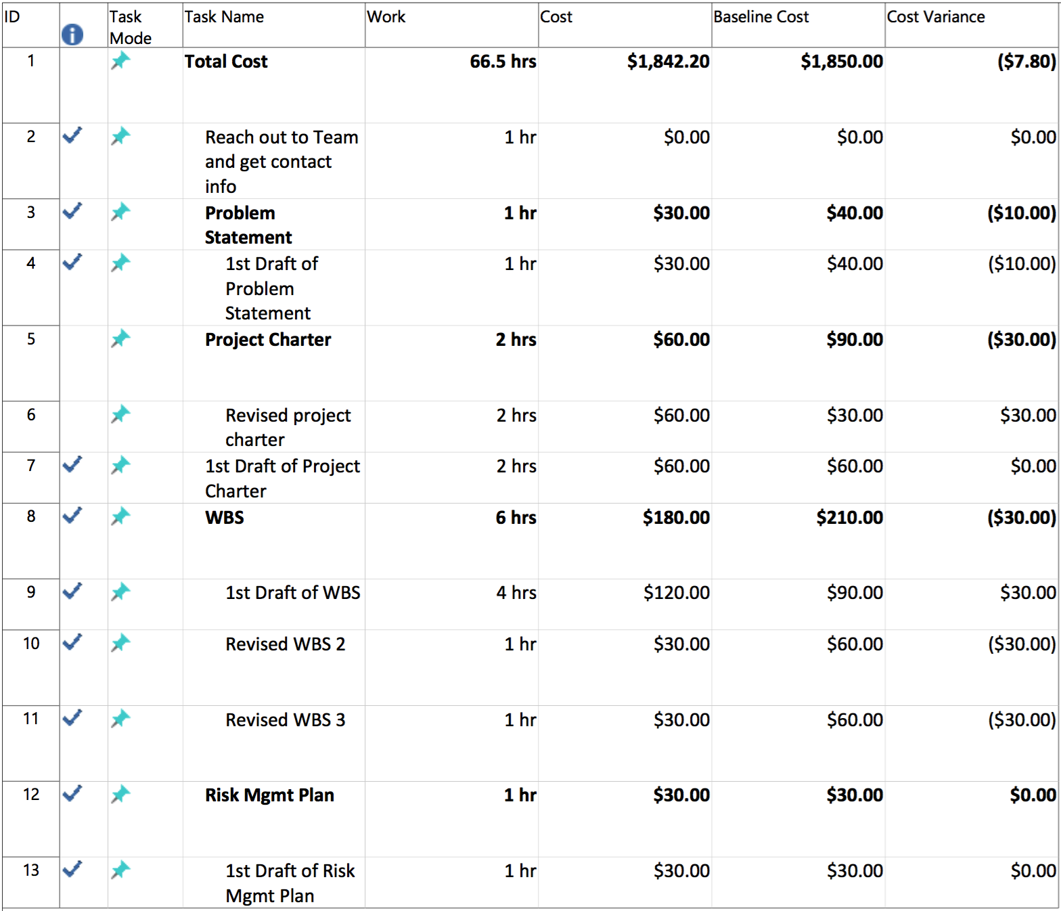
Budget

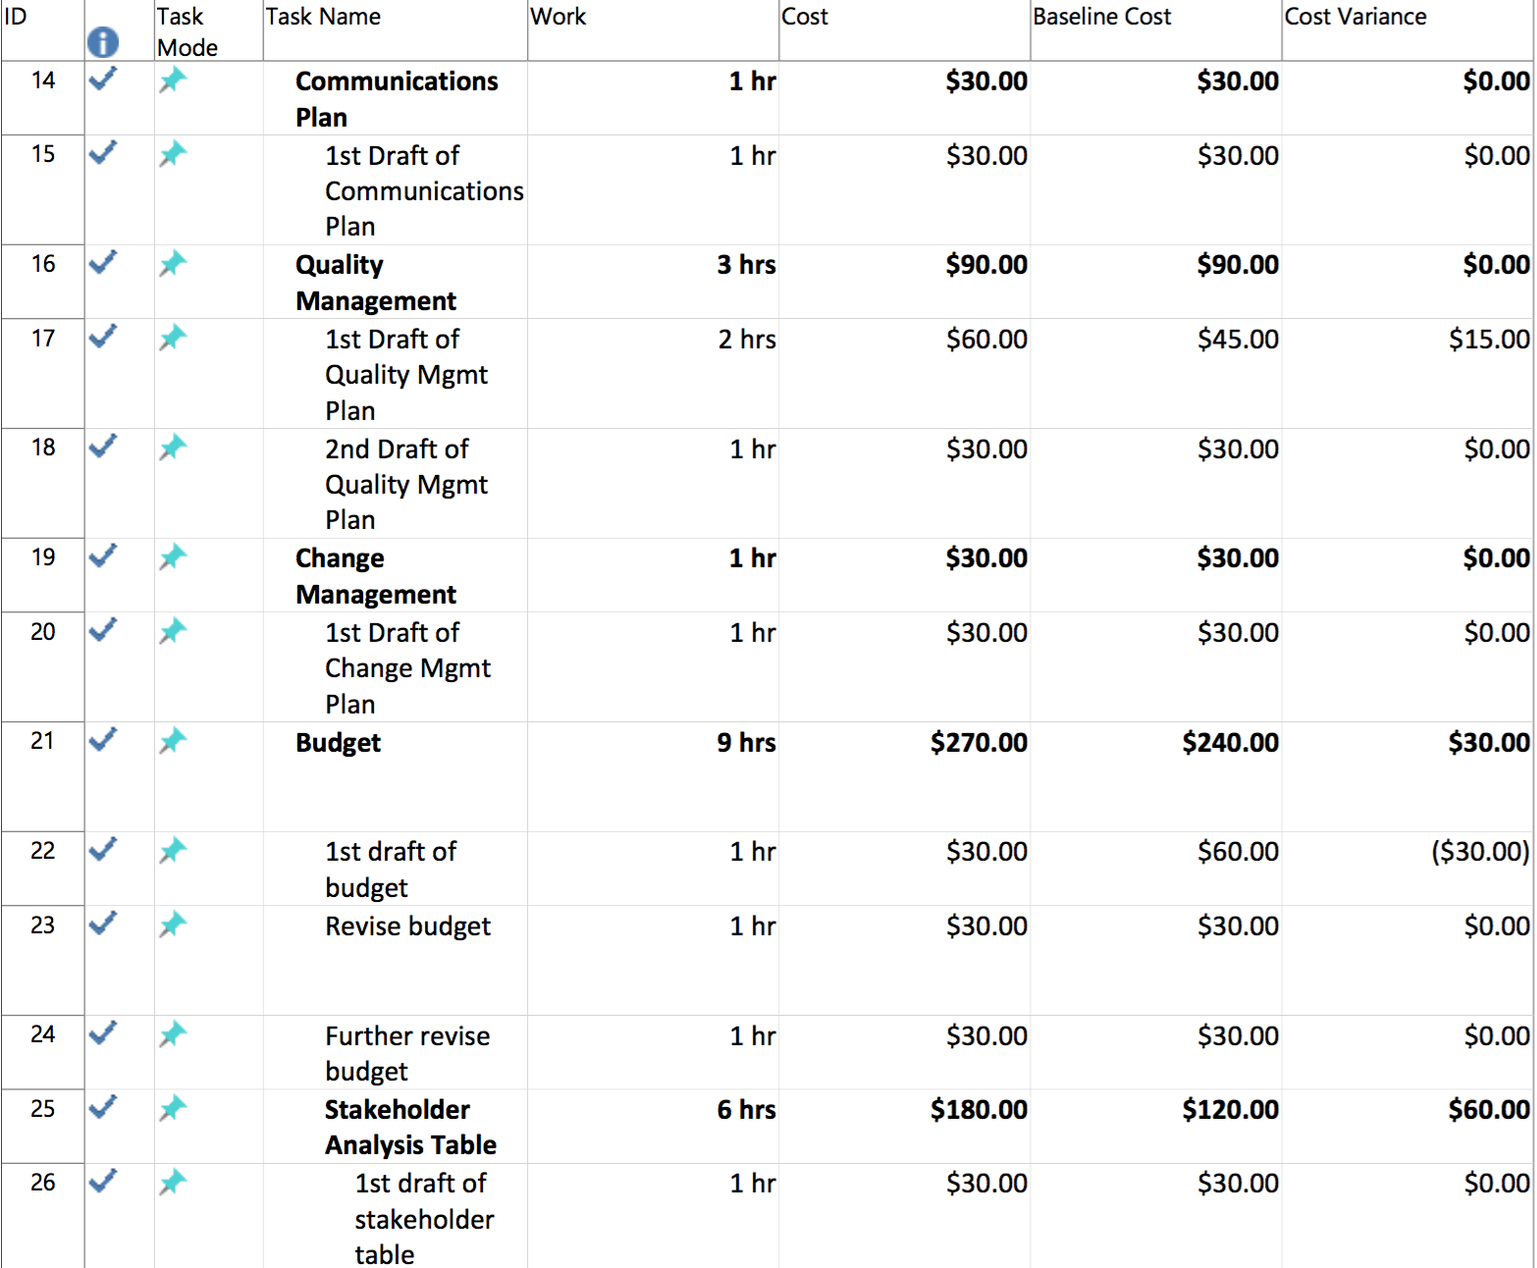
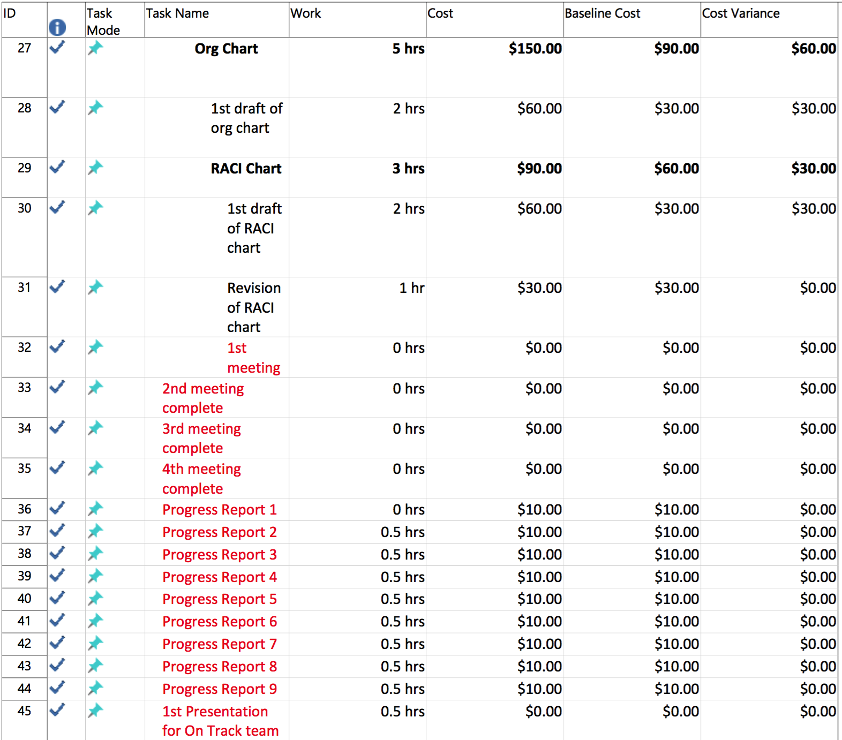
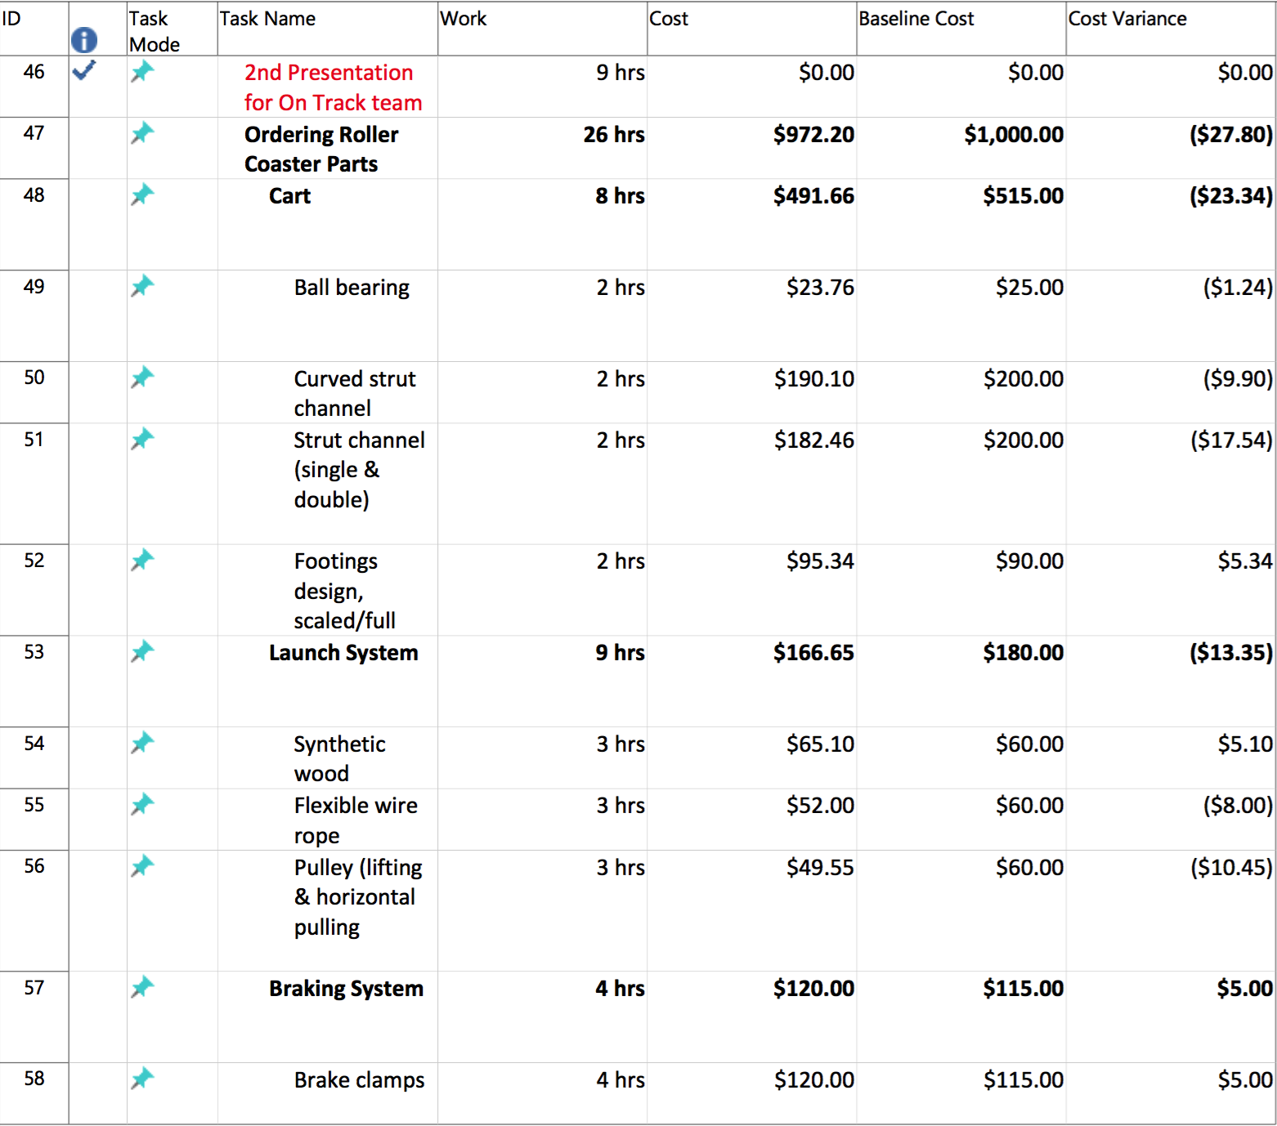
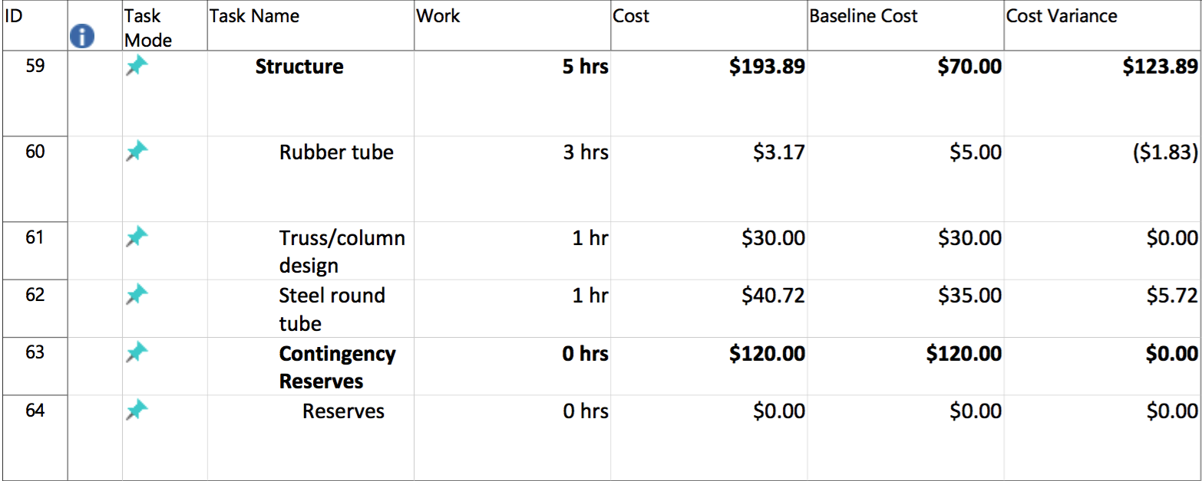

Status Report

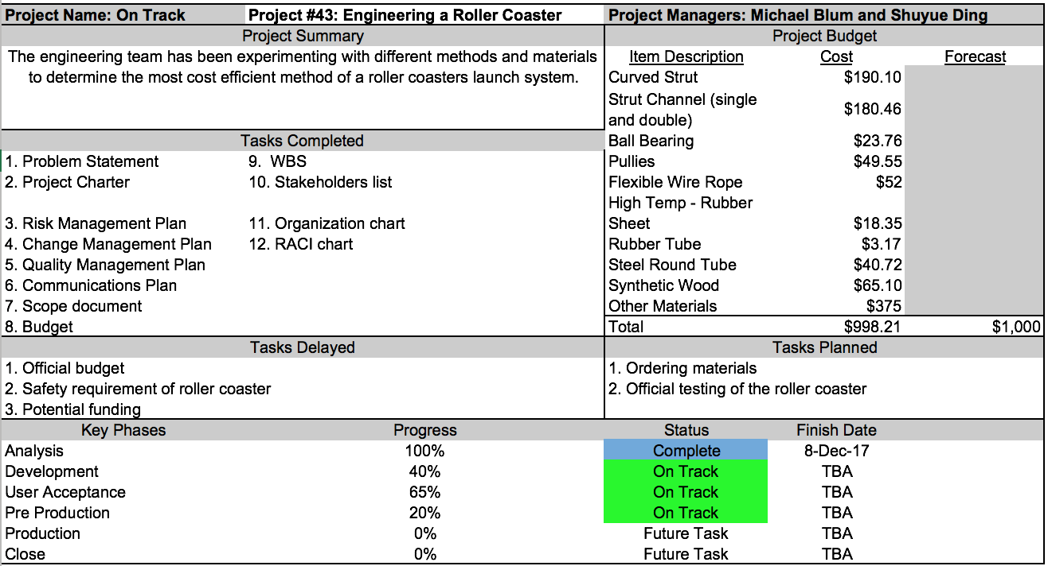

Close-Out Report

Summary
- The Roller Coaster project met its scope for this semester
  - Redesign today's common roller coaster by using drop-mass-pulley system in order to reduce cost
- The Roller Coaster project completed all the deliverables for this semester
  - Engineering team successfully finished the design of the cart, track, supports, braking system, and launching mechanism
  - This new roller coaster system can reduce the cost of today's common roller coaster system by 15%.
Scope
- Complete the goal of designing a new roller coaster system, and the calculations met the 15% goal.
- No significant changes in scope.

Cost and schedule

Engineering Team Budget | Total Baseline | Actual cost | Variance
$1,000 | $1,850 | $1842.20 | ($7.80)

Explanation of Variance: The project meet the schedule and budget overall. We are a little bit over budget because we underestimate the duration of documentation.

Issues and Risks
- Issue: The main issue we faced during the project was the inability to reach the project team due to unforeseen circumstances
  - We splitted up to meet project team members separately.
  - We found out their study schedule in order to meet with them outside of the group meeting schedule.

- Risks: New student engineer joins the On Track team
  - Accept
  - Identify the role and responsibility of the new member
Lessons learned
- What worked well:
  - Having a group chat with engineering team for constant communication. We received their input when we had trouble understanding the high level content of the project.
  - We evenly split up documentation.

- Items that would change
  - Engineering team didn’t have google drive folders and they did not communicate their work to us. One of team members had the most of calculation and others did not have a good knowledge of those numbers.
  - The engineering team changed their meeting schedule constantly. We should’ve found out the engineering team members’ schedule sooner by utilizing Doodle software. Therefore, we can find out what time works the best for everyone.

