Returns on Human Capital Investments in Offshore IT Services Industry: A Firm Level Analysis
Amit Mehra*, Nishtha Langer*, Ravi Bapna^, Ram Gopal#
(* Indian School of Business, ^ University of Minnesota, # University of Connecticut)
Abstract
The revenue growth model of IT services firms has been historically been based on scaling of firm size. However, as firms have become bigger, it has increasing become a pertinent question to examine whether some other lever to improve firm productivity may exist. In this paper, we use a panel data of Indian IT services firms to specifically examine how investments in training may impact firm productivity. We use a combination of econometric methodologies to eliminate the simultaneity bias so prevalent in studies of this type. We find that training is indeed a very important ingredient of achieving high firm productivity and may give returns that are orders of magnitude high compared to the investments. We also find that bigger firms enjoy much more benefits from training compared to the smaller firms.
Preliminary and incomplete extended abstract. Please do not cite or forward.
1. Introduction
It is well known that human capital is the crucial ingredient for the IT services industry and so firms spend a lot of resources and effort on training their employees in order to improve the productivity of their human resource. The Economic Times (18 Jan, 2010) reports that Infosys recently increased their training budgets by 24% over the previous year to a total amount of $230 million for the year 2010-11. In absence of hard ROI numbers the firms may under invest if they underestimate the ROI and may over invest if they overestimate the ROI of training. This knowledge is also of prime importance to policy makers who may be considering allocation of government resources to subsidize private investments in training. Unfortunately, however, the exact impact of training on human capital productivity is not well understood. Our analysis is that first one to provide a glimpse into how training translates into revenues for IT services firms.

An issue related to the ROI of training is that of managing revenue growth in the ITES industry. Historically, the companies followed the linear growth model to increase their revenues by boosting the employee numbers to generate additional billing and higher revenues. However, the problems with this model became quite apparent as the revenue per employee fell significantly over the years in the Indian IT Services companies (Business Today (February 11, 2007)). This happened not only because this is an inefficient growth model, but also because of the loss of productivity due to “benching” of employees where they do not contribute to revenues and yet are paid their salaries. Finally, such a model of revenue growth has inherent problems due to supply constraints of skilled IT programmers. The Business Today article also documents reactions of industry experts such as Sid Pai of TPI who pointed out the issue of inefficiencies in managing scale in Indian ITES companies with more than 100,000 employees.

Is there no recourse to falling productivity per employee with scale? There is hope as global giants like IBM and Accenture maintain similarly large workforces that are almost twice as productive per employee compared to their IT services counterparts in India. Several strategies have been suggested to improve employee productivity for Indian IT services firms. These range from growing the business in high margin areas such as consulting, improving the efficiency of code development through techniques such as agile development and solution accelerators (The Economic Times (28 April, 2008)) and investing in productization strategies where the core product is shared across different clients and only the interface is customized based on client requirements. Productization converts IT services into a high margin business by reusing major portions of the code and using cheaper labor to work on standardized templates for the interface layer (The Economic Times (19 March, 2010)). The crux of all these ideas is to improve the productivity per employee. In addition to such innovative business models, one fundamental way to improve the productivity of an employee is to shore up their skill levels. This is extremely important because rapid changes in technology necessitate constant updating and refreshing of technology skills that can be easily developed via formal classroom training in which firms are quite experienced. Further, the procurement of high-margin IT projects is also critically contingent on a workforce that has up to date technical and domain knowledge. That is why companies such as HCL Technologies are realizing the need to hire fresh graduates and train them for implementing a non-linear growth model (Press Trust of India (April 25, 2010)).

We conduct an empirical analysis of a panel data-set using a Cobb-Douglas production framework to assess the returns to scale and discern the impact of training on revenues. We also analyze the presence of any scale effects in training itself (i.e. is the training more or less useful with increase in training investment). Further, we look at the effectiveness of training in companies of different sizes (i.e. the relative improvement in revenues per dollar of training with different numbers of employees).

2. Literature Review
The returns of human resource management practices on worker productivity have been previously studied (Ichnniowski et al. (1997)). One of the most important HRM practices that impact worker productivity is in-house training provided by the firms. An excellent review paper that covers different aspects of this literature is by Bishop (1996). Most of the earlier work on returns to training was executed by survey data collected from workers. Hence the returns to training were measured by using wage increments as the dependent variable resulting in a measure of productivity at the worker and not the firm level. This issue was dealt with in later papers (e.g. Black and Lynch (1996)) when researchers could get firm level data such as the cost of training. Researchers also expanded on the scope of the research by analyzing questions such as the conditions when employer provided training has more impact (Lynch and Black (1995)). However, due to limitations of data or methodology the reported returns on training seemed to be systematically underreported (Bartel (2000)). Moreover, most of the papers including the recent work are in the context of non-knowledge sectors such as manufacturing (Almeida and Carneiro (2009)). Thus there is considerable uncertainty regarding the returns to training, especially in the IT services sector. This is the gap in literature that we seek to address.

The typical approach to estimating returns from training is by using a Cobb-Douglas production function (Zellener et al. (1966), Hoch (1958) and Mundlak and Hoch (1965)). The issue with this methodology is that the OLS estimates using production functions may turn out to be inconsistent due to various reasons. A good summary of these reasons is provided in Beveren (2007). The most important of these issues is the endogeneity of input choice or the simultaneity bias, first noted by Marschak and Andrews (1944). The reason for this bias is that the inputs in the production function are not independently chosen but are determined by the unobserved productivity of the firm. Since the unobserved variables form part of the error term, the explanatory variables (inputs) are correlated with the error term, thus biasing the OLS estimates. Several approaches have been suggested over the years to deal with this issue. These are the fixed effects method of Marschak and Andrews (1944) and the instrumental variables methods suggested by….However, each of these methods had their drawbacks. Hence some new approaches have recently been suggested by Olley and Pakes (1996), Levinsohn and Petrin (2003), Acerberg et al. (2006) and Gandhi et al. (2009). We utilize a variation of the method suggested in the last paper to deal with the endogeneity problem in our estimates.

3. Methodology
The basic productivity theory predicts that productivity of a firm depends upon factors of both capital and labor. We differentiate between intangible capital and tangible capital as intangibles like intellectual property and organizational processes are considered to be more effective in improving the productivity of human capital. We use a variant of the Cobb-Douglas production function suggested by Bartel (1991) to capture the impact of training on firm productivity. Specifically, the relationship between a firm i’s input and output in period t is represented as:
where 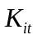 and 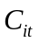refer to the tangible and intangible capital inputs and 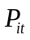 is an observed variable that captures the productive efficiency of firm i in period t. refers to the effective labor of firm i in period t as described by Bartel (1991). This captures the amount of labor services actually supplied by the workers. The extent of this labor depends upon the numbers of employees and their human capital generated through training. Thus 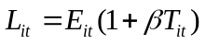, where 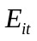 is the actual numbers of employees and 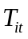 measures the training that the firm provides its employees. Note that this definition of labor accounts for the fact that the productivity of an employee is enhanced by the factor 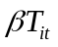due to training investments, . This accounts for the direct benefits (increase in productivity of the employee due to better knowledge and skills) and indirect benefits (increase in productivity of employee due to better support from peers since they too have better skills) of training on employee productivity. 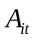is defined such that 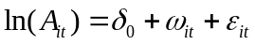. Here  refers to the mean efficiency level of all firms over time, 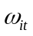represents unobserved firm specific productivity that is observed before the firm makes its period t input decisions and 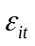captures unanticipated productivity shocks that firm does not observe before making its period t input decisions. Any measurement error is also included in the term.

The usual method for estimating the exponents of Equation (1) requires us to take natural logarithms of both sides which yields:
As per convention, we represent the lower case letters to represent the natural logarithms of the variables represented by the upper case letters. It is clear that if the firm’s choice of the input variables depends on, these will be correlated with the error term, 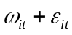, as it also contains . Consequently, the OLS estimators will be biased. This explains the root cause of the endogeneity problem. We used the fixed effects method to deal with this problem. This procedure works provided 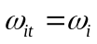, i.e., the unobserved part of the firm specific productivity shock that is observed before firm’s input decisions are made is time invariant. The equation we estimate is therefore:
The terms with the bars represent the average of the observations for firm i over all the years in the panel. As one can observe that is no longer in the right hand side of the equation. Consequently, the endogeneity problem is accounted for and the estimates are no longer biased. Note that we use the approximation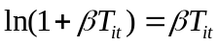. This approximation is similar to that used in Bartel (1991) and is valid if  is small. Finally, note to the extent we use some reasonable variables to capture 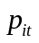, or observed variables that represent firm specific and time variant productivity shocks, the assumption of is not too strong since we capture some impact of the firm specific time variant productivity shocks as part of the observed variables. The specific variable we use to capture is the ratio of earning per share to face value per share. This ratio provides the earning for each rupee of the equity and hence is a measure of the firm’s productivity.

Theoretically, estimating this equation will allow us to identify our parameters of interest, i.e., and . However, we find that the coefficient of 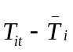 (i.e., 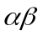) turns out to be insignificant while that of 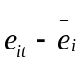 (i.e. ) is significant. This could happen because we expect the estimate of to be close to zero and given our small data-set the variances of the estimates are expected to be high. Thus, it is not clear whether the insignificant result for is due to the smallness of the data set or due to the fact that there is truly no impact of training. In order to deal with this issue we must either obtain a bigger data-set, or obtain a different equation to estimate. We take the later approach and adopt a variant of the procedure suggested in Gandhi et al. (2009) and Gandhi et al. (2008). This requires us to consider the maximization problem of the firm. Let the cost per employee to the firm is represented by the parameter . Then the profit function for the firm is as follows:
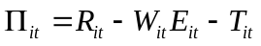
Taking the first order conditions of the firm’s profit with respect to the firm’s decision variables and , we get:
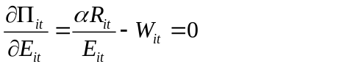
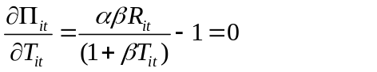
Using the above two equations and accounting for the errors committed by the firm in optimization (Maddala and Lahiri (2009)), we obtain:
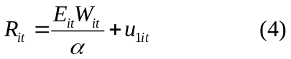
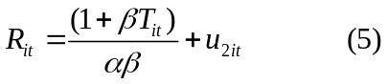
Here, 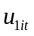and 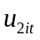 represent the error terms arising due to errors in optimization. Eliminating 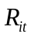 from equations (4) and (5), we get:
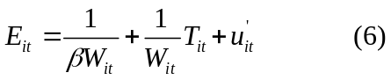
Here, we have the constant term and the coefficient of in addition to the error term, 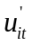which is equal to 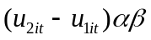. Notice that the revenue function,, of the firm contains the variable . However, this transformation results in elimination of and hence allows us to remove the source of the endogeneity problem in Equation (6). Thus this equation can now be estimated using OLS without getting a biased estimate for the coefficients. However, we still have to recover the estimate for using the estimates of the constant and the slope term. We do this by using the delta method (Oehlert (1992)) which is also implemented in Stata.

Note that we estimate equations (3) and (6 ) separately under the reasonable assumption that the errors due to optimizations and the errors due to the unanticipated productivity shocks are uncorrelated to each other (Maddala and Lahiri (2009)). However, if these errors are correlated to each other, we must estimate these equations using a seemingly unrelated regression approach. For a robustness check, we report the results of such an approach as well. These results show that there the estimates under OLS and the SUR approach are very similar. This gives us more confidence in our estimates.

Another issue is that since we use a system of two equations, one may think that we must use the econometric techniques to simultaneously estimate the two equations in order to avoid the estimation bias that results when some endogenous variables are also used as explanatory variables. However, our two equations constitute a recursive system of equations in which there is only a unidirectional dependency among the endogenous variables. Thus, while 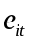 is the endogenous explanatory variable in Equation (3), there is no endogenous explanatory variable in Equation (6). Consequently the two equations can be ordered such that is determined only by exogenous variables and 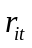 can be determined by. In effect, there is no feedback from Equation (3) into Equation (6). This rules out any contemporaneous correlation between error term and the explanatory variables. Hence we can separately estimate the two equations without any identification problems (Kennedy (2008)).

We now come to the issue of controls. Firm revenues may also be impacted by exogenous shocks to the economy that are common to all firms. Hence we use year dummies while estimation Equation (3). Further, while estimating Equation (6), we must account for the fact that the number of employees hired by the firm may depend upon the firm’s office locations. For instance, it is possible that certain locations are constrained in terms of the availability of programmers and firms with offices in such locations may not be able to ramp up its numbers easily. To control for such exogenous location based factors, we divide the country into four groups and create three dummy variables called West, North and East with South being the base group. Since, no new offices were opened by firms in the sample during the period 2006-2008, the value of location dummies are time invariant.

4. Data
We collected primary data by surveying representative firms from the IT services firms in India. This data set was created by a consultancy firm through a survey. The survey methodology was initial personal contact followed by telephonic reminders. The survey response rate was nearly 40%. We collected firm revenues, number of employees and training investment data through this method on a year to year basis from 2006-2008. We ended up with data from 33 IT services firms. Data for all three years for all variables was sometimes not available and so we have some missing values in the data.

In addition to the above, we used the prowess database maintained by the Centre for Monitoring Indian Economy which is an independent economic think-tank headquartered in Mumbai and has been in existence since 1976. Using the database we collected audited information on the firm’s Earnings per share, Face Value per share, Intangible assets (inclusive of Goodwill, software and others) and Tangible assets ( including Plant and Machinery, Land and Building, Computer equipment etc.). In addition we also collected firm revenues as well as number of employees and training investments whenever available. This served as a cross-check on the validity of the primary data collection process, and also helped us remove some missing values in the data. Finally, we visited the web-sites of each of these firms and studied their corporate histories and office addresses in order to collect location data. Table 1 and Table 2 in the Appendix provide summary statistics and correlation between variables.

5. Analysis and Discussion
The results of the estimation are reported in Tables 3, 4 and 5. In Table 3, we find that the adjusted EPS turns out to be significant and so we conclude that time varying firm specific productivity shocks have a significant impact on revenue. Thus use of this variable allows us to separate the firm specific effect from the macroeconomic productivity shocks common to all firms. The estimates for other factors of production in show a mixed result. While intangible assets come out to be significant, the tangible assets are insignificant. This is in accordance with previous studies that show that valuation and success of IT services firms depend more on intangible assets rather than tangible assets. Like in previous works on IT productivity, we use year dummies to control for the exogenous economy specific shocks that are common to all firms. Such shocks will have an impact on productivity of firms and so we must isolate their impact from the impact of the factors of production. However, the coefficients of the year dummies turn out to be insignificant at the 5% level. Thus macroeconomic reasons do not play a significant role in our data. The coefficient of number of employees is significant and this enables us to get an estimate of . On the other hand, the coefficient of training costs is insignificant and that is why we estimate Equation (6) to see whether is truly insignificant or it could not be estimated in Equation (3) due to high variance.

The estimate of the slope and the intercept turns out to be significant in Equation (6). We use these estimates in the delta method to recover the point estimate and standard error of which turns out to be significant. However, the coefficients for all the location controls turn out to be insignificant which shows that location may not be a significant driver of a firm’s number of employees. This points out that if certain locations may have a better and bigger programmer pool available, these locations may have larger numbers of potential employers and so there is no significant advantage or disadvantage of location as far as hiring of programmers is concerned.

The result of the running the regression on Equation (3) reveals that the estimate of α is about 0.46. Thus increasing the labor force can definitely increase revenues, as the conventional wisdom suggests. However, the revenue per employee is decreasing as the firm scales. This could be because scaling may involve increasing transaction costs or recruiting from a lower skilled labor pool. Figure 1 shows that the scaling reduces the revenues per employees from almost 1.2 million per employee to 0.2 million per employee as the firm size goes from 100 to 2500.
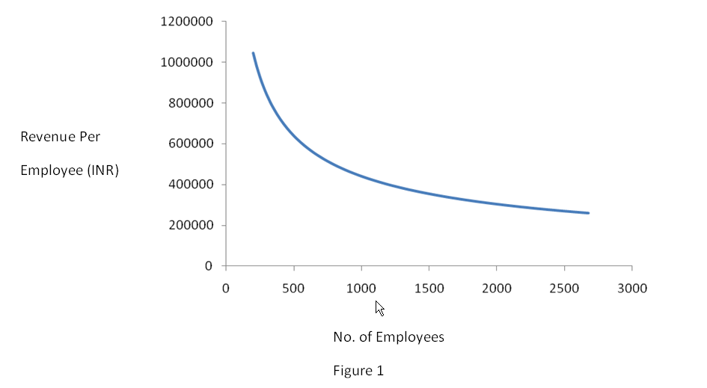
It is useful to examine whether training can mitigate the reducing impact of scale on revenues. In order to do this analysis, we vary the number of employees and fix the value of the other variables at their respective median values. We then find the marginal returns to training using the derivative of the firm’s revenue function from Equation (1). We see that the returns to training are very large. Each dollar of training investment returns 10 times the investment for employee size of 100. Thus we have ample evidence of the high impact of training investment on firm revenues. In addition, we notice from Figure 2 that the returns of training are increasing with increasing scale. Thus bigger firms are at an advantage over small firms in getting benefit from training.
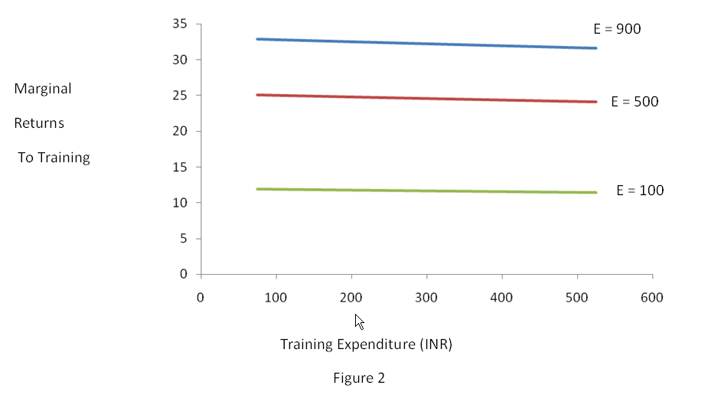
6. Conclusions and Future Work
While our work contributes by finding the returns to training and analyzing how these returns vary at different scales, this analysis can be extended by incorporating:
- The impact of training at different levels of the human resource pool.
- The relative impact of the different types of training such as soft skill training vis-à-vis project management.
3) Analyzing the impact of training on IT product firms. We conducted a preliminary analysis in this regard. Data for 40 IT product firms was obtained from a survey conducted by a consultancy firm. This data is, however, available for a single year and so we don’t have panel structure. Further, the names of the IT product firms were not revealed to us and hence we could not use the Prowess database and direct visits to company websites to augment our data. Consequently, we have data only for firm revenues, number of employees and training expenses for one year for these 40 firms. The summary statistics of the data along with correlation matrix of the variables are in Tables 6 and 7 in the Appendix. In absence of the panel data we cannot estimate Equation (3) using the fixed effects. Hence we cannot find an unbiased estimate of . However, the methodology used in setting up Equation (6) is unique in that it does not depend upon the panel structure to remove the endogeneity problem. Hence we can still estimate Equation (6) using the pooled OLS model. The results of the estimation are provided in Tables 8 and 9 in the Appendix. One can see that the estimate of  is insignificant for IT product firms. Thus it appears that training has an impact on revenues for IT services firms but not on the revenues for IT product firms. This suggests intriguing differences between factors that drive productivity of IT services and IT product firms. Further, either the IT product firms have not yet figured out how to do effective training or training does not drive revenues for IT product firms, and there are some other reasons why these firms still invest in training their employees. Thus further research is needed to understand the drivers of training in IT product firms.

References
Ackerberg, D. A., K. Caves and G. Frazer (2005) “Structural Identification of Production Functions.”

Almeida, R. and P. Carneiro (2009) “The Return to Firm Investment in Human Capital,” Labour Economics, Vol. 16, pp 97 – 106.

Barron, J. M., M. C. Berger, D. A. Black (1997) “How Well Do We Measure Training?” Journal of Labor Economics, Vol. 15, No. 3, pp 507-528.

Bartel, A. P. (1991) “Productivity Gains From the Implementation of Employee Training Programs,” NBER Working Papers, Working Paper No. 3893.

Bartel, A. (2000) “Measuring the Employer’s Return on Investments in Training: Evidence from the Literature,” Industrial Relations, Vol. 39, No. 3, pp 502 – 524.

Beveren, I. V. (2007) “Total Factor Productivity Estimation: a Practical Review,” LICOS Discussion Paper Series, Discussion Paper No. 182/2007.

Bishop, J. H. (1996) “What We Know About Employer-Provided Training: A Review of Literature,” CAHRS Working Paper Series, Working Paper No. 96-09.

Black, S. E. and L. M. Lynch (1996) “Human Capital Investments and Productivity,” The American Economic Review, Vol. 86, No. 2, pp 263-267.

Cermak, J. and M. McGurk (2010) “Putting a Value on Training,” McKinsey Quarterly.

Gandhi, A., S. Navarro and D. Rivers (2008) “Estimating Production Functions with Heterogeneous Firms.”

Gandhi, A., S. Navarro and D. Rivers (2009) “Identifying Production Functions Using Restrictions from Economic Theory.”

Griliches, Z. and J. Mairesse (1995) “Production Function: The Search for Identification,” NBER Working Paper Series, Working Paper No. 5067.

Hoch, I. (1958) “Simultaneous Equation Bias in the Context of the Cobb-Douglas Production Function,” Econometrica, Vol. 26, No. 4, pp 566-578.

Ichniowski, C., K. Shaw and G. Prennushi (1997) “The Effect of Human Resource Management Practices on Productivity,” The American Economic Review, Vol. 87, No. 3, pp 291-313.

Kennedy, P. (2008) “A Guide to Econometrics” 6th Edition, Blackwell Publishing, Malden, Massachusetts, USA.

Levinsohn, J. and A. Petrin (2003) “Estimating Production Functions Using Inputs to Control for Unobservables,” The Review of Economic Studies, Vol. 70, pp 317-341.

Lynch, L. M. and S. E. Black (1995) “Beyond the Incidence of Training: Evidence from a National Employers Survey,” NBER Working Paper Series, Working Paper No. 5231.

Maddala and Lahiri (2009) “ Introduction to Econometrics” 4th Edition, Wiley, West Sussex, England.

Mundlak, Y. and I. Hoch (1965) “Consequences of Alternative Specifications in Estimation of Cobb-Douglas Production Functions,” Econometrica, Vol. 33, No. 4, pp 814-828.

Oehlert, G. W. (1992) “A note on the delta method,” American Statistician, Vol. 46, No. 1, pp 27–29.

Olley, G. S. and A. Pakes (1996) “The Dynamics of Productivity in the Telecommunication Equipments Industry,” Econometrica, Vol. 64, No. 6, pp 1263-1297.

Zellener, A., J. Kmenta and J. Dreze (1966) “Specification of Cobb-Douglas Production Function Models,” Econometrica, Vol 34, No. 4, pp 784-795.

Appendix
Table 1: Mean and Standard Deviation of the variables
Variables | Number of observations | Mean | Standard Deviation
Revenue (in 10 millions of INR) | 85 | 217.3207 | 540.0574
Employee | 84 | 1942.738 | 5754.559
Training (in ‘000 of INR) | 84 | 4884.212 | 30795.1
Adjusted EPS | 79 | 1.453443 | 2.054511
Intangible assets (in 10 millions of INR) | 55 | 21.02164 | 38.03389
Tangible assets (in 10 millions of INR) | 84 | 67.33976 | 169.3537
Table 2: Correlation Coefficient among the variables
 | Revenue | Employee | Training | Intangible assets | Tangible assets | Adjusted EPS
Revenue | 1
Employee | 0.9710 | 1
Training | 0.8487 | 0.9413 | 1
Intangible assets | 0.7192 | 0.7237 | 0.4295 | 1
Tangible assets | 0.9438 | 0.9481 | 0.8324 | 0.8437 | 1
Adjusted EPS | 0.8525 | 0.7871 | 0.6801 | 0.6649 | 0.7714 | 1
Table 3: Estimating Equation (3)
 | Coefficient (Standard Error)
 | OLS | SURE
 | .0971728  ( .171409) | .0959265  (.1568262)
 | .2895878  (. 063511)*** | .2888237  (.0583836)***
 | .1922272  ( 0556783)*** | .1954225  (.0511322)***
 | .4620398  ( .2092521)** | .4623173  (.1921216)**
 | -1.07e-07  ( 3.74e-07)  P-value = 0.776 | -4.81e-08 (4.80e-07)  P-value=0.920
Y2 | .0111896  (.0369648) | .009497  (.0343742)
Y3 | .0867284  (.0565246)# | .0907957  (.0520332)*
Constant | Dropped | Dropped

Table 4: Estimating Equation (6)

 | Coefficients (Standard Error)
 | OLS | SURE
 | .1118393  ( 0047208)*** | .1137628  (.1137628)***
East | 103.9684  (400.729) | -1328.272  (552.8551)**
North | 326.223  (313.2806) | 858.3541  (458.3692)*
West | 199.4336  (296.6804) | 145.6602  (418.7545)
Constant | 653.4977  (251.6789)** | 888.6762  ( 376.062)***

Table 5: Estimates of and
 | α (from Equation 3) |  | β (from Equation 6)
 | OLS | SURE | OLS | SURE
Value | .4620398  ( .2092521)** | .4623173  (.1921216)** | .0001711  (.0000672)** | .000128  ( .0000553)**

Table 6: Mean and Standard Deviation of the variables for IT Product firms
Variables | Number of observations | Mean | Standard Deviation
Revenue (in $ Mn) | 40 | 888.6802 | 2080.715
Employee | 40 | 238.275 | 361.1669
Training (in $) | 40 | 60438.09 | 92267.07

Table 7: Correlation Coefficient among the variables for IT Product Firms
 | Revenue | Employee | Training
Revenue | 1
Employee | 0.7240 | 1
Training | 0.6923 | 0.9262 | 1
Table 8: Estimating Equation (6) for IT Product firms

 | Coefficients (Standard Error)
 | OLS (taking normal T) | OLS (taking T in $)
 | .0000806  ( 5.32e-06)*** | .0036254  ( .0002395)***
Constant | 19.1647  (26.18022) | 19.1647  (26.18023)

Table 9: Estimate of
 | OLS
Value | .0001892  (.0002656)  p-value = 0.481

