Shane Fowler

MIS 2501 Sec 001

Our company should implement a Tier III data center because currently our data center operates at a loss of $25,670,304 a year because of downtime. We should to a Tier III data center because a Tier III is concurrently maintainable; this would significantly reduce our organization’s downtime. By investing in a Tier III data center, our company can save millions because of the reduction of downtime.

A Tier III data center’s key capability is it is a concurrently maintainable infrastructure. It has redundant components so each one can be removed, if needed, without impacting the critical environment. For example, there is an extra engine generator, pump, cooling units, and other components on site in case the active component needs to be removed from service for any reason. If we invest in a Tier III data center our company will increase our availability from our current 99.67% to 99.98%.

The three-year cost of building a Tier III data center is $35,000,000. If we switch to a Tier III data center the 3-year benefits are $48,229,056; this benefit is the difference of the Tier I downtime cost and the Tier III downtime cost. Last, the 3-year net benefit of investing in a Tier III data center will be $13,229,056.

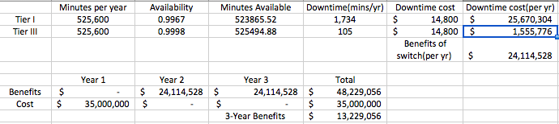

Works Cited

Malik, Bill. "How Much Does An Hour Of Downtime Cost?" Gartner. Gartner, 29 Sept.

2009. Web. 08 Feb. 2017.

Shimel, Alan. "The Real Cost of Downtime." *DevOps.com*. Mediaops, 23 Feb. 2015.

Web. 08 Feb. 2017.

Uptime Institute Professional Services, LLC. Data Center Site Infrastructure Tier

Standard: Topology. New York: Uptime Institute, 2012. Print.