Shane Fowler
MIS 2501 Sec 001

Our company should implement virtualization technology on our servers so we could save $9,200,000 over the next 3 years. Virtualization is the creation of a virtual version of a device, such as a server or operating system on a physical machine. If we invest in virtualization, we will reduce our costs without compromising overall efficiency.
A key capability virtualization is server consolidation. Server consolidation is the ability to have separate systems available on one server. For example, you will be able to have the accounts payable system, accounts receivables system, email, and any other systems all running on one machine. With server consolidation, 80% of our physical servers could run as virtual machines therefore reducing the amount physical servers needed for our data center.
The 3-year benefit is $14,000,000; this comprises of replacing the physical servers. The 3-year cost is $4,800,000; this comprises of the 200 physical servers without VMware and the 80 physical servers with VMware. The 3-year net benefits of server consolidation with VMware are $9,200,000.

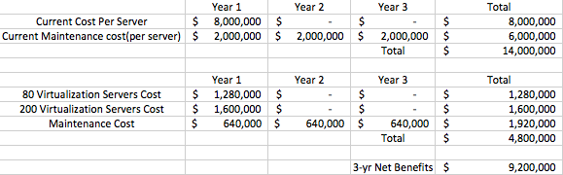

Works Cited

Dinesh. "Server Consolidation Benefits - With Real World Examples." Sysprobs Not
Another Tech Blog. Sysprobs, n.d. Web. 26 Feb. 2017.
Kirsch, Brian, and Margaret Rouse. "What Is Virtualization? - Definition from
WhatIs.com."SearchServerVirtualization. Tech Target, Oct. 2016. Web. 26 Feb.
2017.
"Virtualization Technology & Virtual Machine Software." Virtualization Technology &
Virtual Machine Software. VMware, Inc, 24 Feb. 2017. Web. 26 Feb. 2017.

