Shawn Niederriter

Sharepoint

Our company should invest in Microsoft’s Sharepoint to help automate document workflow for our Project Management Professionals. This software will save each manager hundreds of hours and allow them to manage more projects. Investing in SharePoint will lead to a reduction in time spent per project and lead to more revenue generated for our company.

Currently, our managers struggle to efficiently collect and store client documentation, wasting valuable time trying to manage this process. By utilizing Sharepoint’s key capabilities of centralized file management, our managers can save an estimated 400 hours per year. In addition, one of our PMPs is an expert in Sharepoint, greatly reducing the software implementation curve for our business.

This reduction in time spent managing documents will increase revenue by $666,750 per year. By implementing Sharepoint into our business, we can increase time spent managing projects from 75 to 90%, greatly increasing revenue for our company. More projects will lead to more clients, helping us to generate a $1.846 million net benefit over the next three years.

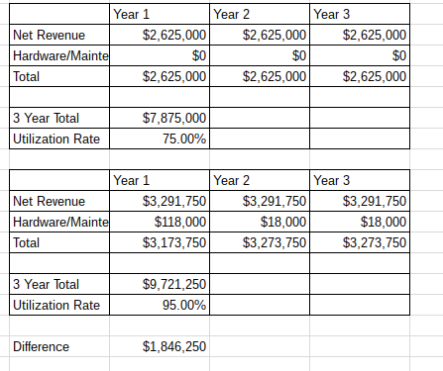

Sharepoint

Implementing Sharepoint in our company can completely