Organizational Innovation

Eddystone Rail Company

10/31/14

Temple University

Steven Turnbull/ Schuyler Crippen/ Amar Govani

**Introduction**

The portion of Enbridge that we decided to look into is Eddystone Rail Company which is the transportation of light sweet crude oil from the Brakken region of North Dakota and then from there it is transported to the Eddystone Rail yard. The light sweet crude oil that is transported is currently one of the most desired forms of crude available today due to its popularity in gasoline production. The company has approximately 50 employees that are responsible for market sales, plant operations, and maintenance contractors. It recently opened its state of the art facility in April 2014 and is now receiving 80,000 barrels per day of crude oil which is stored and offloaded on to barges. From here the oil is transported to local refineries for gasoline production.

**Value Chain Activities**

The consumers of Eddystone Rail Company largely consist of oil refineries along the Delaware River (i.e. Sunoco, Sinclair Oil Company, Monroe Energy). These corporations mainly produce high-test fuel for combustion engines (i.e. automobiles, airplanes, high-performance vehicles) and consequently demand several things from their crude oil:

1. High quality -- gasoline has to be made from light oil that maintains a certain standard of purity. A measure too low will yield poor gas quality.
2. Large quantities -- These corporations all operate on a mass scale. In order to maintain services of operation, they need high volumes of crude oil delivered daily.
3. Prompt delivery -- With an unreliable or easily disrupted supply chain, it is hard to maintain your own plant’s schedules.

Eddystone rail creates value for their customers by striving to satisfy these three demands. They utilize a strict quality testing process for their product that maintains a guaranteed level of purity for their customers. If the product does not meet standards, it is “spot” sold to consumers who do not have an outstanding sales arrangement with Eddystone.

The rail company also moves a high amount of oil every day. Employees work around the clock to make sure they meet the daily demand of shipment. Great attention to detail is paid to efficiency so that their customers do not experience a supply chain interruption.

Eddystone also coordinates seamlessly with CCX (the train company that physically moves the containers on the track) to ensure one delivery per day. This ensures a smooth and consistent product flow that translates to timely deliveries and efficient supply chains.

Beyond the provision of value to customers, Eddystone creates value for its employees by maintaining state of the art facilities, and coordinating with employee unions. They maintain a clean and safe working environment, and have historically been the lowest-incidence rail yard in the Philadelphia area.

|  |  |
| --- | --- |
| **Activity** | **Value(s) Created** |
| **Inbound Logistics** (These are all the processes related to receiving, storing, and distributing inputs internally. Your supplier relationships are a key factor in creating value here.) |  |
| * **Oil is harvested in Brakken, ND and placed in storage containers.** * **Storage containers are moved to the railyard where it is transferred into railcars.** * **It is then transferred to the Eddystone Rail Company and shipped to Eddystone, PA.** | * The Eddystone Rail Company creates value by providing the market with a highly desirable product. The light oil that is harvested in Brakken is refined into energy for combustible engines (i.e. cars, trucks, airplanes, racecars) and is very high demand. * After the oil is harvested it is put into storage containers where it waits to be picked up and taken to the rail yard where it can be transferred. It would be much more efficient if there was a direct way to transfer the oil from the ground and onto the train. |
| **Operations** (These are the transformation activities that change inputs into outputs that are sold to customers. Here, your operational systems create value.) |  |
| * Once the Eddystone Rail receives the crude oil from the train, it unloads it and transfers it into storage containers. | * Eddystone Rail creates value by conducting the operations process with great attention to efficiency and safety (the site has been accident-free since its inception in May 2014). |
| **Outbound logistics** (These activities deliver your product or service to your customer. These are things like collection, storage, and distribution systems, and they may be internal or external to your organization.) |  |
| * Barges transport the oil down the Delaware River to nearby refineries * Refineries transform crude oil into pure gasoline | * Eddystone uses barges as a transport method because they are both more efficient and reliable, and more sustainable. Consumers can have greater assurance that their product will be delivered on time. |
| **Marketing and sales** (These are the processes you use to persuade clients to purchase from you instead of your competitors. The benefits you offer, and how well you communicate them, are sources of value here) |  |
| * They enforce strict standards of quality control to ensure that the oil they are delivering is consistently of the best quality. * Eddystone uses the evidence gathered by this quality control to prove to their clients that they are unrivaled in purity standards. * Eddystone also emphasizes its promptness of delivery. Every process conducted by Eddystone is seamless and efficient which ensures timely delivery of product. * Eddystone’s sales model consists almost entirely from long-term arrangements with third-party refineries/consumers. If there is an excess in oil, Eddystone will conduct a “spot” sale which usually accounts for all of the oil within its journey from ND to PA. | * Value is created for the consumer by consistently providing the best crude oil and most efficient transport. Peace of consumer’s mind is a byproduct of Eddystone’s dedication to excellence. * Eddystone also provides stakeholders with reasonable certainty of the future by working off of long-term, advance sales contracts. |
| **Service** (These are the activities related to maintaining the value of your product or service to your customers, once it's been purchased) |  |
| * Eddystone employs a number of marketing associates who consistently create value through efficient PR models. * Eddystone also employs a “Quality Guarantee” that guarantees their products will be delivered with a standard level of purity. | * Eddystone maintains their relationship with their consumers by consistent engagement and marketing appeal. * A quality assurance guarantee also exemplifies their commitment to quality product. |
| **Support Activities** (These are covered to some extent in the other parts of this assignment – management systems and business model so you don’t need to cover them in this section unless you would like to or already have) |  |

**Management Systems**

· Setting goals and laying out plans- Every morning the plant manager sits down with his department heads and they talk about what has been done up to know and how they are working towards their goals. After this they talk about what needs to be done during the three shifts that day  
which may include what repairs are undergoing, and when the next train is due. The neat thing that they participate in and what is under the belief of the plant manager is that once the daily plan is set they then go over what is actually capable for the day so they can set realistic goals.

·        Accumulating and allocating resources- The process of accumulating the resources which only consist of oil at this point along with the rail cars that are used to transport the oil from North Dakota to Eddystone is simple. Currently Eddystone contracts the transportation to CSX locomotive. The train leaves North Dakota and travels to the Chicago interchange and from there to Eddystone. Oil is the other key resource and that is drilled by drillers and bought by Enbridge. From there it becomes very simple Eddystone finds a buyer through crude traders and once the oil reaches the yard it is transferred to the appropriate brage for shipment to refineries.

·        Acquiring and applying knowledge- A large part of this business is the acquisition of knowledge in oil pricing. Management is in constant contact with the parent company Enbridge through crude traders. These employees work like stock traders in New York buying oil low and selling high. This information is relayed from the parent company to the plant manager who then transfers this information to his traders who can sometimes even have offers made and payment acquired before the train even makes it to the yard.

·        Understanding and balancing the demands of outside constituencies- It is tough to balance the demands of all the refineries especially right now due to the lowering gas prices. The name of the game in the oil business the one with the money gets the goods. Crude traders are constantly in contact with one another to buy and sell crude at a fair price. All of this is reported back to the plant manager who then shares this to his higher up to ensure they are dealing with the right buyers.

**Business Model**

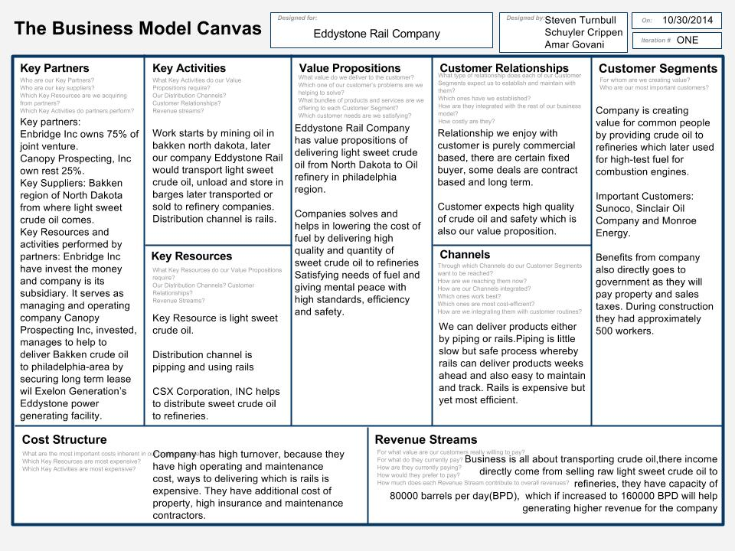

Eddystone Rail Company business model is transport light sweet crude oil from the Bakken region of North Dakota to the Eddystone. Company facility acts as transhipment facility. Company is wholly subsidiary of Enbridge Inc, who own 75 percent of the joint venture with rest percentage with Canopy Prospecting Inc, Enbridge is liable to serve as construction manager and operator during construction and now as operation of facility. Both Partners are committed to the Eddystone Project and will make sure for safety measures given a company a value proposition. Benefits they provide to community and customers is that they are new sources of transporting crude oil to Philadelphia regions, cutting down extra import cost from other areas of world, they provided employment for 500 construction workers and now continue giving opportunity for contractor and hired assist to design, safety controls and surveys and with that current facility of 80000 barrels per day to expandable to 160000 barrels per day gives increased access to long term, reliable and economical supplies of domestically produced crude oil which helps to meet region's energy needs. They have huge cost structure, as they spend huge invests in operation and maintenance cost, transporting and safety measures, there revenue model is to bring light sweet crude oil and sell it to refineries like Sunoco, Sinclair Oil Company, Monroe Energy in Delaware River Region. They get delivery of crude oil over rails/pipes which is done by CSX Corporation Inc. Delivering via rails is most cost efficient and help to process and delivery product much faster. Company helps to solve high cost of fuel by providing abundant quantity to refineries, which mean more the quality less the prices of fuel, company also pays sales tax and property taxes. With high standards Eddystone Rail Company joins mines of North Dakota to Philadelphia regions, by which it provides high end of sweet crude oil to refineries and with standard safety measures,  and gives value to proportion to common people and also to its stakeholder who would believe in their business it is serving purpose of lower fuel cost, with that company would hope to keep providing economical, domestic supply of crude oil to east coast refineries that are currently dependent on foreign imports.

**Problem Formulation / Root Cause Analysis**

Eddystone Rail Company adds value to its consumers by providing high quality low cost light sweet crude that will be refined into gasoline that will be consumed by the final customer. Both of these problems will inhibit the company from keeping this value to their consumer. Employee motivation is key to the efficiency of the operation. Without key employees doing their jobs properly then the whole basis of delivering a quality product on time goes out the window. The reason we chose Union contracts was because this is an ongoing issue within the company. Because of the contract, employee pay rate and compensation is low which brings down the total moral along with the turnover rate. The next section we chose was low pay scale. According to our source the pay scale on the last contract was actually reduced to help combat against the diminishing economy along with rising health care prices. The company is doing their best to compensate with partial health care coverage along with 401k plans. Economy is the largest key issue in this analysis because it is the biggest effect on the business model. Unfortunately for the oil business with the way the economy is right now and how low the price per barrel is, it’s hard to make money. Oil business flourishes when operating expenses are lower than selling price. Right now prices are down and opex is up. This is a potentially large issue for the company.

Plant efficiency is the other major problem that we decided to analyze. Again looking at the value Eddystone wants to provide to its consumer is quality crude in a timely fashion. Rail transport within the country is much faster than using marine transport. Facility utilization is the first why we questioned. We chose this because it is an area of innovation for us and because the opportunity to improve efficiency of the unloading process is big. This leads us to the why on offloading procedure. Again because of the opportunity that is present in making the process more efficient will not only help the value created to the consumer along with improvement to the business plan.

Employee motivation

Union Contracts** Bad Contract Bad Contracts

Long Hours No support Bad Leaders

Tough Work Union Contracts Low Pay Scale** Low Pay Scale Economy**

Weird Schedules Medicare

Low pay rate

Inflation

Government Debt

Economy Taxes

Lack of American Products

Plant Efficiency

Class One Rail Service Offloading Procedure**

Rail Provider Turnover Rate

Turnover rate Facility Utilization Training Program

Facility Utilization** Technology

Technology

Offloading Procedure Capacity

One car at a time