SharePoint
Implementing SharePoint will provide a 3-year net benefit of $1,846,250. Sharepoint is a tool that allows for website-based collaboration that will allow us to share, store and organize our documents effectively, and access them throughout the company. It will increase our billable hours from 1,500 to 1,900.
The key capability of SharePoint is that it will help our company create team sites for projects that are more organized than before. Throughout the shared sites, teams can share files, resources, and updates, which allows for simpler collaboration. SharePoint does not require extensive training due to its simple and unique configuration and management tools. Since SharePoint can be used remotely, we can provide the company and our customers their own secured portal. SharePoint will reduce time spent with customers who request invoices or statuses through phone or email. This way they can work with more perspective clients selling and negotiating new business.
The cost of implementing and maintaining SharePoint over three years is $253,750. By increasing our PMP’s billable hours to 1,900 per year because of eliminated backlog hours, our revenue will increase by $2,100,000 over three years. The net benefit of implementing SharePoint is $1,846,250 over three years.

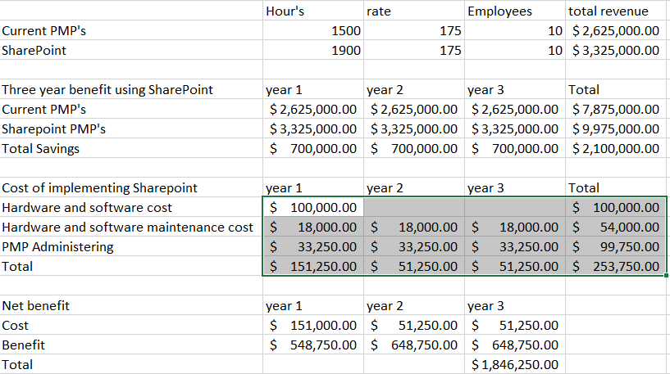
Citation
Solutions, http://www.thinkebiz.net eBbiz. “Microsoft SharePoint Is Beneficial for Any Organization.” Ebiz Solution, 3 Nov. 2018, www.thinkebiz.net/microsoft-sharepoint-benefits/.
What Is SharePoint? What Are The Benefits Of Using Microsoft SharePoint In Software Development, www.manektech.com/blog/what-is-sharepoint-what-are-the-benefits-of-using-microsoft-sharepoint-in-software-development.
Solutions, NH Learning. “Blog.” 4 Key Benefits of Desktop Virtualization, blog.nhlearningsolutions.com/blog/top-10-business-benefits-of-microsoft-sharepoint.

