VMware
Purchasing high-end virtual machines and and reducing our current servers will result in a net savings of $9,200,000 over a three-year period. Implementing this consolidation will consist of using VMware to reduce our servers from 1,000 servers in the data center to 280 total servers.

Consolidating to high-end virtual machines will dramatically reduce the amount of physical machines by 80% because we can run 10 virtual machines on a single VMware server which utilizes the machines full potential. Virtual machines are also less expensive and easier to maintain than our traditional servers. As a result, we will save space and reduce our total costs.

Investing in consolidation will cost $4,880,000 over a three-year period for 80 high-end virtual machines, 200 traditional servers, and for maintaining costs. Maintaining costs cover, software maintenance, hardware maintenance, power, cooling, and technical support. At the end of year three, our combined net savings would result in an amount of $9,200,000.

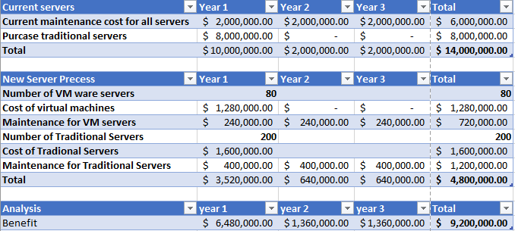

Davis 06/20/2011, David. “Top 10 Benefits of Server Virtualization.” Virtualization Review, Virtualization, 20 June 2011, virtualizationreview.com/articles/2011/06/20/top-10-benefits-of-server-virtualization.aspx.

Server Virtualization & Consolidation.” VMWare, VMWare, 28 Sept. 2018, www.vmware.com/solutions/consolidation.html.

Peterson, Curtis. “What Is Server Consolidation? Why Should You Do It?” SmartFile, 14 July 2016, www.smartfile.com/blog/what-is-server-consolidation-and-why-should-you-do-it/.

