Wordpress

Implementing Wordpress will provide a three-year net benefit of $875,000. Wordpress is an open source website creation tool that improves productivity. By using this platform we can realize a 77.8% improvement in efficiency.

Wordpress’s key capability is ease of website creation that will allow us to effectively manage and edit our content in our website without the need of programming. Our developers will only need basic training on learning this technology, but it will improve productivity overall. With this platform we can easily create responsive designs that enable our website to be viewed on any device. Wordpress will allow us to build optimized pages for specific user features in a fraction of the time that our current development team does. Its customization tools include easy to use themes and plugins that makes it the most flexible system for our company to take advantage of.

The costs of Wordpress over three years is $2,049,000 comprising of implementing, maintenance, training and salary. Over three years Wordpress will have a benefit of $875,000 from headcount reduction.

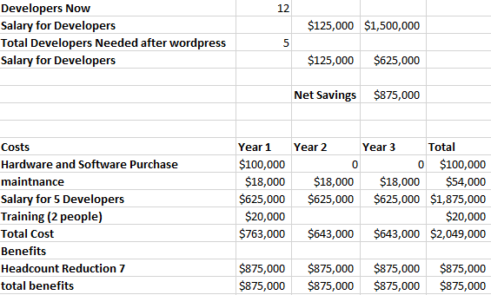

**Citation**

**Cousins, Carrie. “10 Key Features of Popular WordPress Themes.” *Design Shack*, Design Shack, 1 July 2013, designshack.net/articles/inspiration/10-key-features-of-popular-wordpress-themes/.**

**“What Is WordPress?” *IThemes*, ithemes.com/tutorials/what-is-wordpress/.**

**Jackson, Brian. “What Is WordPress? Explained for Beginners.” *Kinsta Managed WordPress Hosting*, Kinsta Managed WordPress Hosting, 16 Oct. 2018, kinsta.com/knowledgebase/what-is-wordpress/.**