# System Architecture

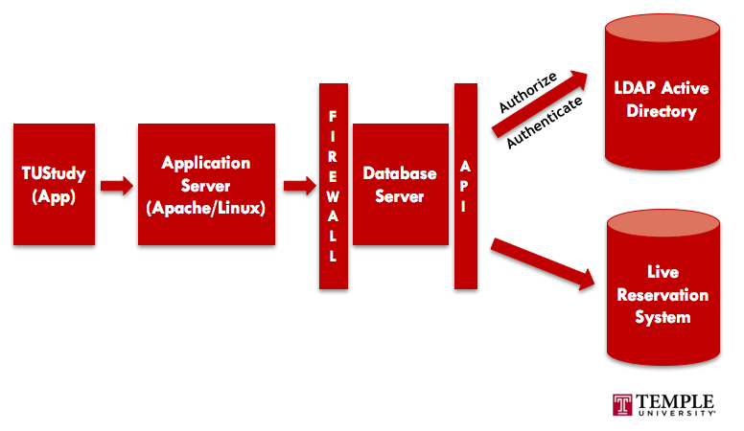

1. When one logs in to the **TUStudy Application**, a request is passed through the **Application server (either Apache/Linux)** which serves as an extra layer of database protection.
2. Then, an already in-place **firewall** prevents unauthorized access to the database server.
3. Getting back to the request, when it is allowed by through the firewall, an **API** initially connects to the **LDAP Active Directory** to authorize and authenticate the credentials put in by the user.
4. Now, with the user having access to the App, he/she will reserve a resource, which then passes through the same process but instead of the API connecting with the LDAP, it will recognize that authorization and authentication has already been done so all it will do is check in to the **Live Reservation System** to check on availability and return the result to the user.

# Data Model

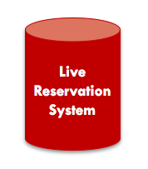

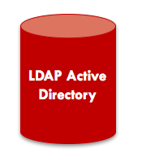

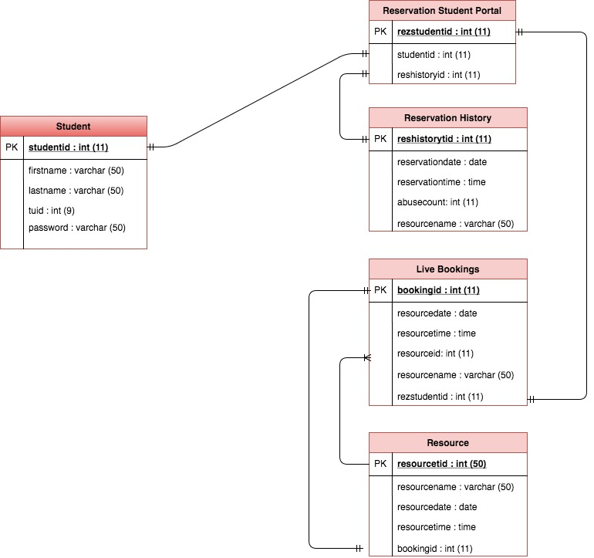

* This data model will show the relationship between the 2 main data stores involved.