How Temple University Saves More than Just Water Bottles
  - Tyler R. Wilson, B.B.A
December 15, 2014

Contents
Abstract 3
Introduction 3
Background 3
Problem Statement 4
Analysis 4
Conclusion 5
Appendix 1 6
Appendix 2 7
Appendix 3 8
Appendix 4 9
Appendix 5 10
Appendix 6 11
References 12
Contact information 13

Abstract
The objective of this paper is to quantify the benefit of water bottle dispensing units at Temple University in order to account for external costs economically and socially. Metrics such as number of plastic water bottles saved from consumption, impact of natural resources and disposal, the costs of operating these dispensers, and a look at the social return on investment. The results aim to illustrate the benefit of these dispensers and suggest recommendations so Temple can achieve sustainability.

Introduction
The water bottle dispensers is a noticeable indication of Temple maximizing its resources by implementing environmentally friendly technology. As a graduating senior, I wonder how Temple’s sustainability initiatives impacts our planet. One of the main pleasures about spending time on Temple’s campus is its water bottle fill-up stations. Best of all, it’s totally free. What lured me to the subject of these water dispensers was a tiny digital counter on the top-right corner on the machine. The water bottle counter measures how Temple’s progress towards sustainability.

Background
The invention of plastic material revolutionizes the way consumers purchase beverages. Consumers benefit from light-weight containers, hold many variation of liquid volumes, and costs less than substitute material like glass or aluminum. Consumers can buy a cool, refreshing beverage on demand for as little as $0.99. The best part about plastic beverage containers is renewability. One could perpetually use a plastic container, usually until it becomes malleable and brittle—which is then thrown away. Plastic beverage containers offer convenience and consumer value, but the problem with plastic beverage containers are two: method of production and disposal—it doesn’t break, decompose, or easily crushed recycled.
The consequences of producing plastic beverage containers is depletion and inefficient use of valuable natural resources. Producing and transporting plastic beverage containers requires massive amounts of energy. Seventeen million barrels of oil were used to produce plastic water bottles, alone, in 2006 (Goldschein). Manufacturing plastic water bottles produces more than 2.5 million tons of carbon dioxide, while the U.S carbon dioxide gas emission 6 billion metric tons, in 2006, so 0.04% of the total U.S carbon emissions in 2006 were produced from the manufacturing plastic water bottles (EPA). Production, alone, has a scalable impact on the environment, which is deepening the U.S’ ecological footprint. U.S consumers drank nine billion gallons of bottles water in 2008, assuming they were all 16.9 oz. bottles, 68 billion water bottles were produced, which would cost $40 billion to recycle all 2.3 billion tons of plastic water bottles produced in 2008 (appendix 6). Not only does one year of plastic bottle production cost $17 million barrels and produces almost 1% of total U.S carbon output, it produces $40 billion in recycling annually. If consumers and manufactures worked together, 17 million barrels and $40 billion dollars could be put to better use.
How the U.S disposes plastic water bottles is dismal. Most plastic container waste ends up in landfills despite recovering plastic for recycling or burning it for energy combustion. Additional energy is wasted to transport plastic waste to landfills or for incineration. Respectively, plastic doesn’t breakdown easily for it takes 1,000 years to decompose (Cho). Only 6.5% of plastic beverage containers are recycled each year and 7.7% is combusted for energy. Despite the efforts of U.S government agencies, organizations, and consumers, the U.S recycling effort converts 14.2% of all plastic waste produced in one year (EPA).

Problem Statement
Consumers of plastic water bottles are not recycling every time a plastic water bottle is bought. 100% of the plastic bottles produced each year isn’t recycled despite new technologies that could put plastic waste to good use (Cho). There is not enough oil left nor enough oil to sustain production of new plastic containers. As oil supply inverts from the increasing demand of oil products, the value of plastic liquid containers to consumers will cease to exist. Changing the way Americans recycle plastic containers is difficult; implementing change is difficult in of itself. Yet, Temple University has found an alternative solution: by easing consumers into ditching the nasty habit of purchasing plastic liquid containers, all together.

Analysis
Since 2009, Temple University has utilized Elkay Manufacturing’s water dispensing devise called the EZH20 for delivery of drinking water. This devise is a combination water fountain and water dispenser for quick bottle fill-ups. Water fountains are a tradition at Temple, like the fountain in Mitten Hall (Appendix 1, exhibit 1) or the more modern refrigerated fountains (Appendix 1, exhibit 2). The EZH20 dispensers sought to upgrade Temple’s aging system while introducing new technology that can service empty water bottles on the fly and maximize the usefulness of Temple’s water fountains.
Water bottle dispensers are popular among Temple’s students and faculty. As of 2014, 33 EZH20 and 27 Halsey units can be found in thirty-nine buildings on Temple’s Philadelphia campus (Health Science buildings, Ambler campus, and the Podiatry campus were omitted from the analysis). From 2011-2014, 8.1 million 12 oz. water bottles were saved from consumption (Appendix 4). In four years, Temple went from twenty-three dispensers saving 374,629 bottles to sixty dispensers saving a combine four million plastic bottles per year. From 2011 to 2014, the use of water bottle dispensers increased by 91% each year. There is no doubt that as more dispensers are added to Temple’s campus, the rate of 12 oz. reduction of water bottle consumption will increase. Yet, the equilibrium point of dispenser to fill-ups is unknown. Temple plans to grows its array of water bottle dispensers with add seven more dispensers by 2015 to meet popular demand.
At least one water bottle dispenser is available in every lobby of Temple 39 main campus buildings. Seven buildings have multiple dispensers (Appendices 2&3). The architecture building has an impressive nine dispensing units, two on each floor, which the fourth floor is most popular. Pearson McGonigle comes in a close second with seven dispensing units. Two units are on each floor except three on the first floor, which the most popular floor to fill-up is the first. Klein Hall’s single water dispenser saves the most water bottles of all 39 building at Temple. To date, Klein Hall saves the environment 704,629 (12 oz.) water bottles. Moreover, Johnson & Hardwick saves the most water bottles out of all Temple student residency, but Morgan Hall is omitted (I attempted to search Morgan for dispenser, but could not gain access nor do I suspect dispenser in the newly built building).
From 2011 to 2014, Temple’s 39 buildings combine saved 8,149,513 (12 oz.) water bottles (Appendix 4). In 2014, alone, Temple’s 39 buildings saved 4,015,101 (12 oz.) water bottles or (when adjusted to 16.9 oz. water bottles) 0.00048% of all plastic beverage bottles produced in the U.S in 2008. Temple saves the environment one five-hundredth of the total plastic water bottles used by U.S consumers in one year.
Preventing water bottles from entering landfills benefits society. Based on the combine data from Temple’s office for Sustainability, Temple’s Department of Facilities Management, and the customer service representatives of Elkay Manufacturing I created an income statement to illustrate the costs and social benefits operating a class of water bottle dispensers (appendix 5). The cost of running 60 machines for one year costs Temple University, roughly, $69,973.88. Based on the total number of water bottles saved in 2014, assuming they’re all 12 oz. bottles and cost $0.99 to consumers, Temple’s dispensers produced $3,974,949.99 in social revenue. After costs is considered, $3,904,976.11 in net profit produces a 98% social return on investment. A 98% return on investment is something to be proud of because it indicates efficient use of resources and a, close to, maximum return, but only reflects a social impact and not a monetary one. Temple’s array of dispensers shows the right technology can maximize resources and produce societal good in the name of plastic recycling.

Conclusion
Temple’s office for sustainability is leading the way towards sustainability. Strong steps are being made towards the eradication of plastic water bottle consumption and the promotion of recycling. The impact of these water bottle dispensers has is small at the macro level, yet given the dispenser program will continue, Temple’s sustainability effort will grow in perpetuity. The fact that 60 water dispensers has a quantifiable impact on U.S’ total plastic beverage container consumption is amazing and is worthy of increase funding.

Appendix 1
Exhibit 1 Exhibit 2
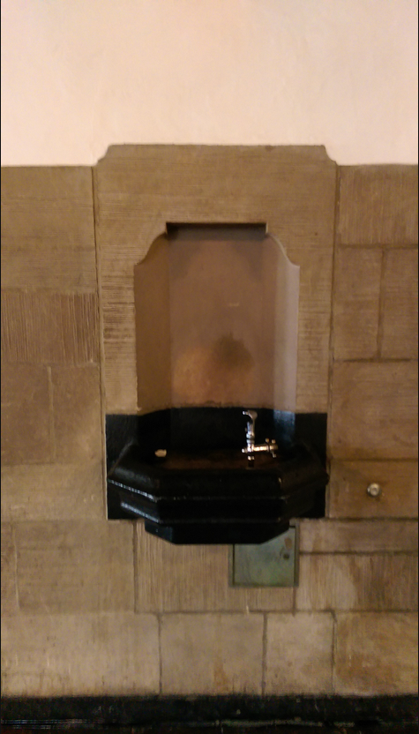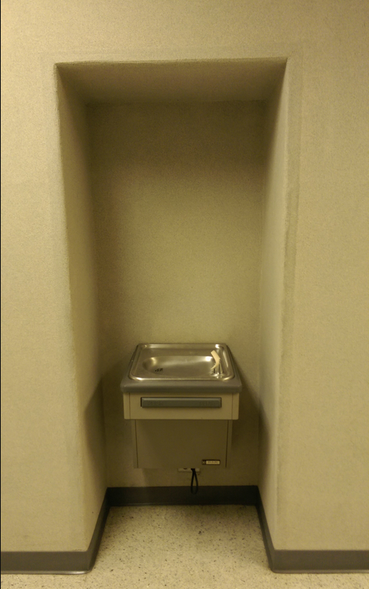

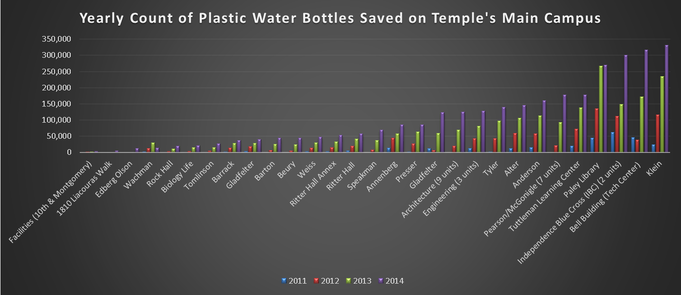
Appendix 2

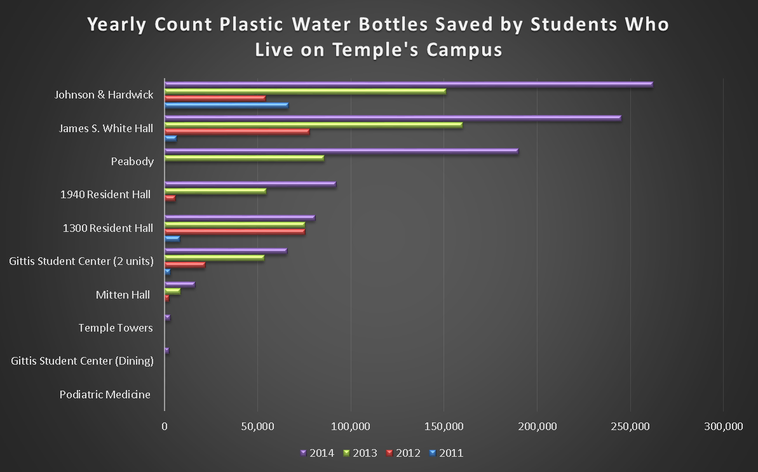
Appendix 3

Appendix 4

Water Bottle Refilling Stations Savings as of 05/16/2014 for year 2014
 |  | # of  Bottles Saved  12 oz. | # of  Bottles Saved  16.9 oz. | # of filters used | Pounds Bottle  Waste Saved  16.9 oz. | Recycling Cost Savings  16.9 oz.
 | Main Campus (45 units) | 3,054,964 | 2,169,205 | 159 | 74,125 | $639
 | Student Life (15 units) | 960,137 | 681,754 | 50 | 23,297 | $201
 | Adjustments | 0 | 0 | 0 | 0 | $0
 | TOTAL | 4,015,101 | 2,850,959 | 209 | 97,422 | $839

Water Bottle Refilling Stations Savings from 2011-2014
 | # of  Bottles Saved  12 oz. - 2011 | # of  Bottles Saved  12 oz. - 2012 | # of  Bottles Saved  12 oz. - 2013 | # of  Bottles Saved  12 oz. - 2014
Main Campus | 277,571 | 915,832 | 2,014,297 | 3,054,964
Student Life | 97,058 | 239,078 | 590,576 | 960,137
TOTAL | 374,629 | 1,154,910 | 2,604,873 | 4,015,101

Appendix 5
Income statement 2014
$ 3,974,949.99 | water bottle sales from EZH20 dispenser
$ 15,455.55 | cost of filters for one year
$ 25,714.29 | cost for one year of depreciation
$ 25,730.95 | cost of water
$ 2,233.80 | cost of electricity
$ 839.29 | cost to recycle one year's worth of plastic bottles (16.9 oz. bottles)
$ 69,973.88 | Total cost
$ 3,904,976.11 | net profit
98.24% | ROI

Appendix 6

Important metric assumptions
Cost of one 12 oz. plastic water bottle | $ 0.990
Cost of one filter | $ 73.950
# of filers used per unit per year | 3
cost of water per 1 gallon | $ 0.004
marginal cost of water per 1 gallons | $ 0.003
cost of electricity for one unit per day | $ 0.090
cost to recycle one ton of plastic | $ 17.230
# of 16.9 oz. plastic bottles per one ton | 58528
cost of depreciation for one year per dispensing unit | $ 428.570
Total dispensing units | 60
One filter lasts for 3,000 gallons of water or 19,200 - 12 oz. bottles
Straight-line depreciation period starts at 2009
Manufacturer states typical useful life if 20 years if one filter is used per year
128 oz./1 U.S Gallon | One 16.9 oz. bottle weighs 15.5 grams | 453.59 gram = 1 U.S ton

References
Cho, R. (2014). What Happens to All That Plastic? – State of the Planet. [online] Blogs.ei.columbia.edu. Available at: http://blogs.ei.columbia.edu/2012/01/31/what-happens-to-all-that-plastic/ [Accessed 28 Nov. 2014].
Dell'Amore, S. (2014). Why Tap Water Is Better Than Bottled Water. [online] National Geographic. Available at: http://news.nationalgeographic.com/news/2010/03/100310/why-tap-water-is-better/ [Accessed 28 Nov. 2014].
Goldschein, E. (2011). 15 Outrageous Facts About The Bottled Water Industry. [online] Business Insider. Available at: http://www.businessinsider.com/facts-bottled-water-industry-2011-10 [Accessed 28 Nov. 2014].
Epa.gov, (2014). Carbon Dioxide Emissions | Climate Change | US EPA. [online] Available at: http://www.epa.gov/climatechange/ghgemissions/gases/co2.html [Accessed 25 Nov. 2014].
Ntepa.nt.gov.au, (2014). Environmental Impacts - NTEPA. [online] Available at: http://www.ntepa.nt.gov.au/waste-pollution/plastic-bag-ban/enviroimpacts [Accessed 25 Nov. 2014].
Data provided by:
Temple University Office of Sustainability
Temple University Facilities Management
Elkay Manufacturing

Contact information

Tyler R. Wilson
Tyler.RWilson@Temple.edu
(215)-584-7552
Field research photos:
(Link) http://imgur.com/a/ZHtYi
Google doc of data tables:
Original data-
https://drive.google.com/a/temple.edu/file/d/0B838y5r3UY_qclZzbXFEM0ZKLTA/view?usp=sharing
Altered Data-
https://drive.google.com/a/temple.edu/file/d/0B838y5r3UY_qRUhhNWotMER4VkU/view?usp=sharing

