E-Commerce Site Tool Development
Project Managers: Xueming Guo, Liang Wu
Business Analysts: Ajah Puryear, Tyler Skeeters, Jurgen Aliaj, Anthony Wong, Amy Njuguna

Table of Content

Project Introduction: 3
What is a Project Charter? 4
What is a Project Scope? 8
What is an Organizational Chart? 10
What is a RACI? 11
What is a Stakeholder Register? 13
What is a WBS and Schedule? 14
What is a Change Management Plan? 18
What is Budget? 19
What is Communications Plan? 21
What is Quality Management Plan? 23
What is Risk Management Plan? 25
What is Project Closeout Report? 28

Project Introduction:

Pound Cake is a new cosmetic company in Philadelphia started by two Temple students, Camille Bell and Jonathan Velazquez, whose focus is to provide authentic cosmetic products and revolutionize the way people think about beauty. Currently, the company lacks a social and web presence and digital tools required to serve potential and current customers. They are also missing a community or blog section for all users who to be a part of the Cake Club and interact with other Cake Club members. Hence, our project will focus on developing technology enable web and mobile tools for its E-Commerce. The project prototype will include account management tools that will enable customers to create accounts, save preferences and login. In addition, it will also create tools for displaying products, shopping, buying and subscribing to certain the online cake club and newsletter.

What is a Project Charter?

Project Charter provides an overview of the project and why it's necessary. It also communicates the project manager's level of authority. It gives a brief detail of the goals, roles and responsibilities for our team members. The charter also states who our stakeholders are, who assigned the project, a description of the project, and the scope.

- Project General Information

Project Title: E-Commerce Site Tools Development
Start Date: February 1, 2017
Target Completion Date: May 1, 2017
Duration: 3 months
Company name: Pound Cake

- Project Description and Scope:
Pound Cake is a brand new cosmetic company in Philadelphia. The company lacks a social and web presence and digital tools required to serve potential and current customers. They are also missing a community or blog section for all users who to be a part of the Cake Club and interact with other Cake Club members. Hence, our project will focus on developing technology enable web and mobile tools for E-Commerce focus on the problems mentioned previously. The project prototype will create account management tools that will enable customers to create accounts, save preferences and login. In addition, it will also create tools for displaying products, shopping, buying and subscribing to certain the online cake club and newsletter.
After implementing the final deliverable, we will expect:
1. Increase user traffic by 25% after the first month of release.
2. Sell 200 products in the first month.
3. Average 50 Cake club subscribers for the next 6 months of release.
4. Experience a 25% growth in 3 years.
5. Send complementary products to the top five beauty gurus of choice.

- Key Stakeholders:
Clients: Jonathan Velazquez, Camile Bell
Project Sponsors: Marie-Christine Martin, Steve Sclarow
Project Managers: Liang Wu, Xueming Guo
Business Analysts: Ajah Puryear, Amy Njuguna, Tyler Skeeters, Jurgen Aliaj, Anthony Wong

All mentioned roles will be our stakeholders. In our project, project sponsors will only oversee and support the entire project. Project managers have the responsibility of executing and managing the project. Business analysts will be responsible for gathering requirement and creating the prototype.

- Authority for Project Managers
Liang Wu and Xueming Guo are the project managers for the Pound Cake project. As project manager, Ms. Wu and Ms. Guo are responsible for working with the business analyst team to develop the initial direction for the project. We will work with business analyst team to develop a project plan that describes the objectives for the project, the results that the project delivers, and the overall plan for running the project.
Ms. Wu and Ms. Guo will lead the project, monitor its progress and performance, and decide how to keep the project on track. For significant problems and major change requests, we will work with the business analyst team to choose a solution. This project is our priority, so we ask the business analysts to provide Ms. Wu and Ms. Guo with any resources we ask for. For the duration of the project, Ms. Wu and Ms. Guo will prepare and present status reports every one week to the project sponsor.
To ensure the success of the project, Ms. Wu and Ms. Guo has the authority to manage the project and assign resources. Our authority for the project includes:
- Communicating directly with the business analyst team about the project.
- Communicating directly with all sponsors and clients about the project.
- Assigning resources to project tasks.
- Requesting assistance from business analyst team as needed.

- Key Milestones

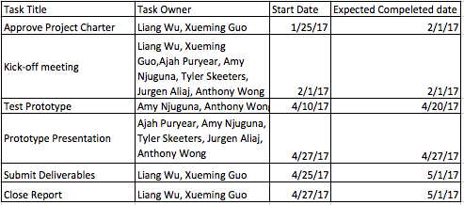

- High-Level Cost Estimate
The high-level budget summarizes labor cost during the life of the project. The high-level budget is at a summary level. The detail estimates supporting each cost type are maintained by the project manager.

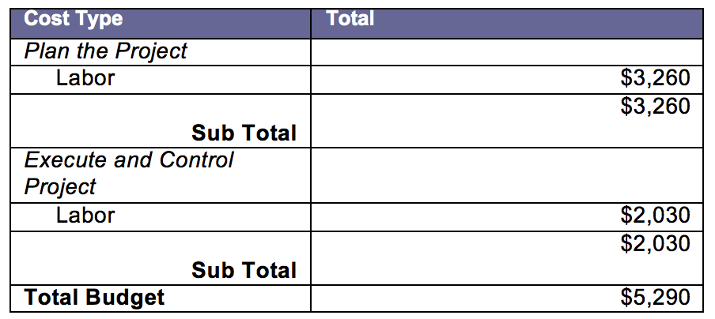

What is a Project Scope?

The purpose of the Project Scope is to provide a baseline understanding of the scope of a project to include the project’s scope and deliverables, the work required to complete the deliverables, and ensure a common understanding of the project’s scope among all stakeholders. It also includes the project objectives that we expected the deliverable will deliver. In addition, it also includes the assumptions and constraints of the project.

- Statement of Purpose:

Pound Cake is a Philadelphia cosmetic company started by two Temple students, Camille Bell and Jonathan Velazquez, whose focus is to provide authentic cosmetic products and revolutionize the way people think about beauty. Pound Cake’s products are marketed specially towards individuals with darker skin tones and offer a variety of cake-inspired matte lipstick colors in a variety of different shades, from extremely light to extremely dark. The company wants to represent those who truly enjoy make up but are underrepresented in the industry and make everyone feel included.

Since Pound Cake is a brand new company and have not been fully established, certainly there are problems that must be addressed. The company lacks a social and web presence and digital tools required to serve potential and current customers. They are also missing a community or blog section for all users who to be a part of the Cake Club and interact with other Cake Club members. As of now, their website can only allow prospective customers to sign up to their listserv to receive email newsletter updates about the company. Currently with only one prototype, Pound Cake looks to release their first products by the middle of summer 2017.

As a result, Pound Cake is looking to develop technology enable web and mobile tools for e-commerce. We will interview subject matter experts, stakeholders, and potential consumers. We will research other cosmetic companies and stores to see what customers like and dislike about the shopping process, then analyze the pros and cons of their technological enabled web and mobile tools. We will use existing software to create prototypes to help them establish a social and web presence along with the proper digital tools to help market and sell their merchandise. Our prototype will consist of account management tools for consumers and tools to display products, shopping, buying aiding e-commerce, and subscriptions to newsletters and Cake Club. After collecting the requirements for developing technology for web and mobile tools, we will design a solution, build a prototype, and present the prototype to our sponsor.

- Objectives:
- Increase user traffic by 25% after the first month of release.
- Sell 200 products in the first month.
- Average 50 Cake club subscribers for the next 6 months of release.
- Experience a 25% growth in 3 years.
- Send complementary products to the top five beauty gurus of choice.

- Assumptions:
- Consumers and company employees will be the users of these tools.
- All company products will be bought from these tools.
- All users will be able to utilize all tools once account is created. (Create
profile, set preferences/ common interests, view upcoming events, etc.)
- Team is capable of producing necessary requirements to achieve the goals.

- Constraints:
- There are no products to put on display or market
- The system must be secure to hold customers personal information
- Client may not be receptive to suggestions

What is an Organizational Chart?

An Organizational Chart is a diagram that shows the structure of an organization and the relationships and relative ranks of its parts and positions/jobs.

Project Title: | E-Commerce Site Tools Development
PM: | Liang Wu, Xueming Guo
Start Date: | 3/06/2017
Revised Date: | 3/15/2017

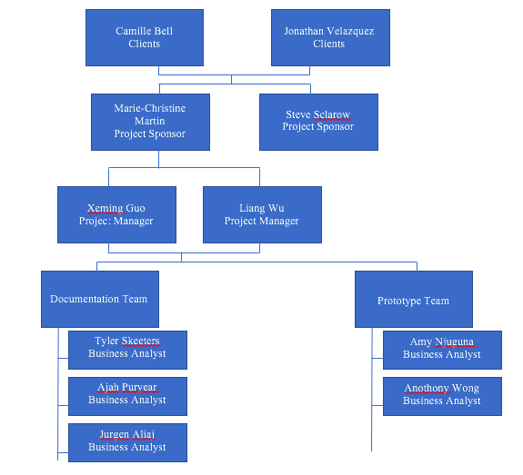

What is a RACI?
RACI is a matrix of the activities and decisions of all the people or roles involved in the project. This matrix helps lessen errors and confusion for the people involved in the project.
Project Title: | E-Commerce Site Tools Development
PM: | Liang Wu, Xueming Guo
Start Date: | 3/06/2017
Revised Date: | 3/12/2017

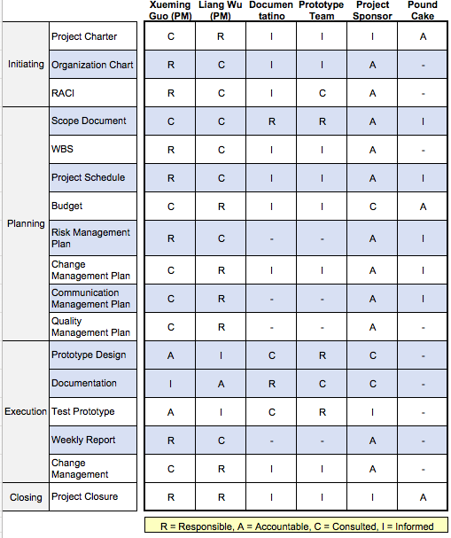

What is a Stakeholder Register?

A stakeholder register is a project management document which contains the information about the project’s stakeholders. It identifies the people, groups and organizations that have any kind of interest in your project. In this register you can find their names, titles, roles, interests, power, requirements, expectations, and type of influence, etc.

Project Title: | E-Commerce Site Tools Development
PM: | Liang Wu, Xueming Guo
Start Date: | 3/06/2017
Revised Date: | 3/12/2017

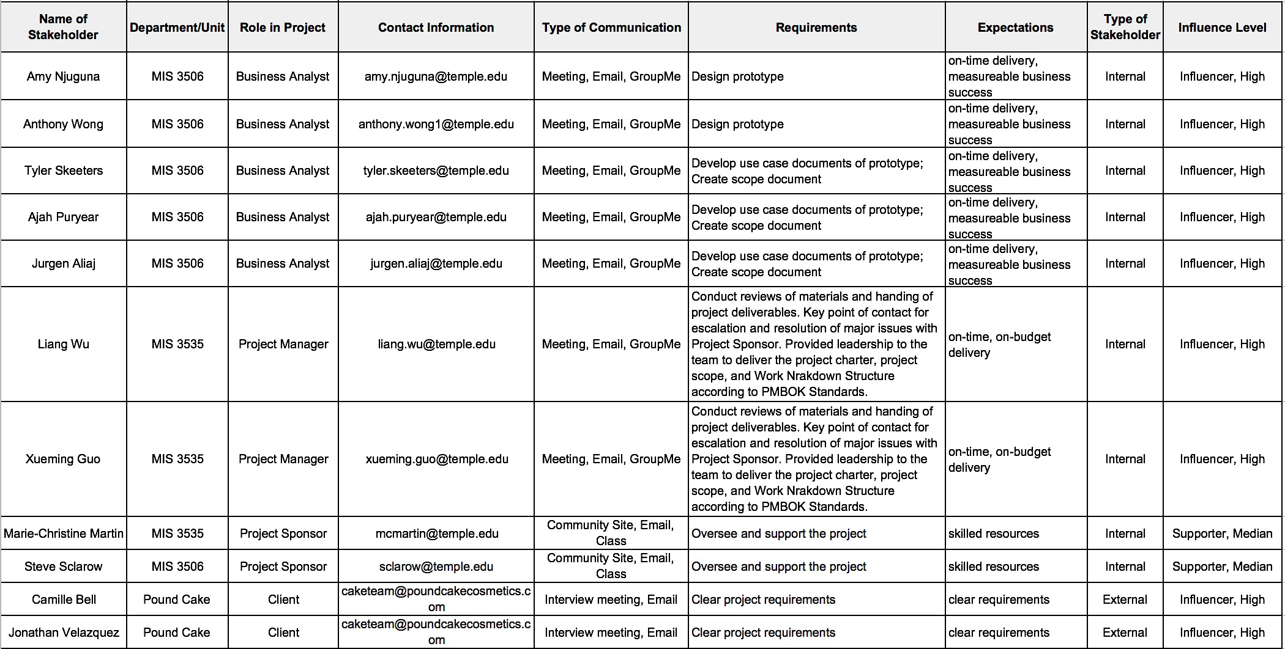

What is a WBS and Schedule?

A work breakdown structure (WBS) is a chart in which the critical work elements, called tasks, of a project are illustrated to portray their relationships to each other and to the project as a whole. The project schedule is the tool that communicates what work needs to be performed, which resources of the organization will perform the work and the timeframes in which that work needs to be performed. The project schedule should reflect all of the work associated with delivering the project on time.

Project Title: | E-Commerce Site Tools Development
PM: | Liang Wu, Xueming Guo
Start Date: | 2/02/2017
Revised Date: | 2/13/2017

ID | TASK TITLE | TASK OWNER | START DATE | DUE DATE | DURATION (DAY)
 | Documentation
1 | Approve Project Charter | Liang Wu, Xueming Guo | 1/25/17 | 2/1/17 | 8
2.1 | Draft individual scope documents | Ajah Puryear, Amy Njuguna, Tyler Skeeters, Jurgen Aliaj, Anthony Wong | 2/1/17 | 2/9/17 | 9
2.2 | Combine scope document | Ajah Puryear, Amy Njuguna, Tyler Skeeters, Jurgen Aliaj, Anthony Wong | 2/9/17 | 2/16/17 | 8
2.3 | Revise Scope Document | Ajah Puryear, Amy Njuguna, Tyler Skeeters, Jurgen Aliaj, Anthony Wong | 2/16/17 | 3/1/17 | 14
3.1 | Create WBS | Xueming Guo | 2/2/17 | 2/8/17 | 7
3.2 | Revise WBS | Liang Wu, Xueming Guo | 2/13/17 | 2/15/17 | 3
4.1 | Create Proejct Schedule | Liang Wu | 2/15/17 | 2/20/17 | 6
4.2 | Revise Project Schedule | Liang Wu, Xueming Guo | 2/25/17 | 2/28/17 | 4
5.1 | Create Organization Chart | Xueming Guo | 3/6/17 | 3/11/17 | 6
5.2 | Revise Organization Chart | Liang Wu, Xueming Guo | 3/15/17 | 3/20/17 | 6
6.1 | Create RACI Chart | Liang Wu | 3/6/17 | 3/11/17 | 6
6.2 | Revise RACI Chart | Liang Wu, Xueming Guo | 3/12/17 | 3/15/17 | 4
7.1 | Create Budget | Liang Wu | 2/15/17 | 2/20/17 | 6
7.2 | Revise Budget | Liang Wu, Xueming Guo | 3/1/17 | 3/8/17 | 8
8.1 | Create Risk Management plan | Xueming Guo | 2/6/17 | 2/11/17 | 6
8.3 | Revise Risk Management Plan | Liang Wu, Xueming Guo | 3/10/17 | 3/12/17 | 3
9.1 | Create Quality Management Plan | Liang Wu | 2/6/17 | 2/11/17 | 6
9.2 | Revise Quality Management Plan | Liang Wu, Xueming Guo | 2/15/17 | 2/16/17 | 2
10.1 | Create Change Management Plan | Xueming Guo | 2/6/17 | 2/11/17 | 6
10.2 | Revise Change Management Plan | Liang Wu, Xueming Guo | 2/15/17 | 2/20/17 | 6
11.1 | Create Communication Management Plan | Liang Wu | 2/6/17 | 2/11/17 | 6
11.2 | Revise Communication Management Plan | Liang Wu, Xueming Guo | 2/13/17 | 2/20/17 | 8
12.1 | Create Stakeholder Register | Liang Wu | 3/6/17 | 3/11/17 | 6
12.2 | Revise Stakeholder Register | Liang Wu, Xueming Guo | 3/12/17 | 3/15/17 | 4
13.1 | Create the Critical Path | Xueming Guo | 3/29/17 | 4/1/17 | 4
13.2 | Revise the Critical Path | Liang Wu, Xueming Guo | 4/2/17 | 4/5/17 | 4
14 | Weekly Reports | Liang Wu, Xueming Guo | 2/12/17 | 4/26/17 | 74
 | Prototype
15.1 | Create Prototype | Anthony Wong | 3/11/17 | 4/1/17 | 22
15.2 | Revise Protoype | Amy Njuguna, Anhony Wong | 4/1/17 | 4/20/17 | 20
15.3 | Test Prototype | Amy Njuguna, Anhony Wong | 4/20/17 | 4/25/17 | 6
 | Deliverables
16 | Create Scope Document | Ajah Puryear, Tyler Skeeters, Jurgen Aliaj | 2/9/17 | 2/16/17 | 8
17 | Create Use Cases | Ajah Puryear, Tyler Skeeters, Jurgen Aliaj | 3/17/17 | 3/23/17 | 7
18 | Create Scenarios | Ajah Puryear, Tyler Skeeters, Jurgen Aliaj | 3/23/17 | 3/28/17 | 6
19 | Create Data Schema | Ajah Puryear, Tyler Skeeters, Jurgen Aliaj | 3/28/17 | 4/4/17 | 8
20 | Create Personas | Ajah Puryear, Tyler Skeeters, Jurgen Aliaj | 3/28/17 | 4/5/17 | 9
21 | Create Business Rules | Ajah Puryear, Tyler Skeeters, Jurgen Aliaj | 4/6/17 | 4/13/17 | 8
22 | Create Presentation PPT | Ajah Puryear, Amy Njuguna, Tyler Skeeters, Jurgen Aliaj, Anthony Wong | 4/20/17 | 4/27/17 | 8
23 | Create Document Binder | Xueming Guo, Liang Wu | 4/25/17 | 4/30/17 | 6
 | Meetings
24.1 | Prepare Interview Questions#1 | Liang Wu, Xueming Guo, Ajah Puryear, Amy Njuguna, Tyler Skeeters, Jurgen Aliaj, Anthony Wong | 1/25/17 | 2/1/17 | 8
24.2 | Prepare Interview Questions#2 | Ajah Puryear, Amy Njuguna, Tyler Skeeters, Jurgen Aliaj, Anthony Wong | 2/9/17 | 2/15/17 | 7
24.3 | Prepare Interview Questions#3 | Ajah Puryear, Amy Njuguna, Tyler Skeeters, Jurgen Aliaj, Anthony Wong | 3/1/17 | 3/6/17 | 6
25.1 | Attend First interview | Liang Wu, Ajah Puryear, Amy Njuguna, Tyler Skeeters, Jurgen Aliaj, Anthony Wong | 2/2/17 | 2/2/17 | 1
25.2 | Attend Second interview | Ajah Puryear, Amy Njuguna, Tyler Skeeters, Jurgen Aliaj, Anthony Wong | 2/16/17 | 2/16/17 | 1
25.3 | Attend Third interview | Ajah Puryear, Amy Njuguna, Tyler Skeeters, Jurgen Aliaj, Anthony Wong | 3/7/17 | 3/7/17 | 1
26.1 | Participate First Meeting | Liang Wu, Xueming Guo, Ajah Puryear, Amy Njuguna, Tyler Skeeters, Jurgen Aliaj, Anthony Wong | 2/1/17 | 2/1/17 | 1
26.2 | Participate Second Meeting | Liang Wu, Xueming Guo, Amy Njuguna, Anthony Wong | 2/24/17 | 2/24/17 | 1
26.3 | Participate Third Meeting | Liang Wu, Xueming Guo, Ajah Puryear, Amy Njuguna, Tyler Skeeters, Anthony Wong | 3/9/17 | 3/9/17 | 1
26.4 | Participate Fourth Meeting | Xueming Guo, Ajah Puryear, Amy Njuguna, Tyler Skeeters, Anthony Wong | 4/6/17 | 4/6/17 | 1
26.5 | Participate Fifth Meeting | Liang Wu, Xueming Guo, Ajah Puryear, Amy Njuguna, Tyler Skeeters, Anthony Wong | 4/13/17 | 4/13/17 | 1
 | Present to Clients
27 | Prototype presentation | Ajah Puryear, Amy Njuguna, Tyler Skeeters, Jurgen Aliaj, Anthony Wong | 4/27/17 | 4/27/17 | 1

What is a Change Management Plan?

The Change Management Plan establishes how changes will be proposed, accepted, monitored, and controlled. The change control procedures identified in the Change Management Plan will govern changes to the baseline project scope including changes to the work breakdown structure and requirements from project inception through to completion.
Project Title: | E-Commerce Site Tools Development
PM: | Liang Wu, Xueming Guo
Start Date: | 2/06/2017
Revised Date: | 2/15/2017

ID | Description | Cost ($) | Date Requested | Requested By | Status | Managed By | Date Resolved | Resolution/Comments
1 | Change of Kick-off meeting time and location | None | 02/01/2017 | BA | Approved | PM | 02/01/2017 | Recheck the teammebers' available time. Book a new breakout room, and revise the meeting agenda

What is Budget?

A project budget is the total sum of money allocated for the particular purpose of the project for a specific period of time. The goal of budget management is to control project costs within the approved budget and deliver the expected project goals.

Project Title: | E-Commerce Site Tools Development
PM: | Liang Wu, Xueming Guo
Start Date: | 2/15/2017
Revised Date: | 3/01/2017

Tasks | Title | Budget of Labor |  |  | Actual Labor |  |  | Under/Over
 |  | Hours | Rate | Total | Hours | Rate | Total
1. Plan the Project
Develop Project Charter/Description | PMs | 4 | $100 | $400 | 3 | $100 | $300 | -$100
Develop scope document | BAs | 4 | $80 | $320 | 3 | $80 | $240 | -$80
Revise scope document | PMs | 3 | $100 | $300 | 2 | $100 | $200 | -$100
Develop WBS | PMs | 5 | $100 | $500 | 5 | $100 | $500 | $0
Develop Risk Management Plan | PMs | 3 | $100 | $300 | 3 | $100 | $300 | $0
Develop Communications Plan | PMs | 2 | $100 | $200 | 2 | $100 | $200 | $0
Develop Quality Management Plan | PMs | 3 | $100 | $300 | 2 | $100 | $200 | -$100
Develop Change Management Plan | PMs | 2 | $100 | $200 | 2 | $100 | $200 | $0
Develop Organization Chart | PMs | 1 | $100 | $100 | 1 | $100 | $100 | $0
Develop RACI Chart | PMs | 3 | $100 | $300 | 2 | $100 | $200 | -$100
Develop Stakeholder Register Plan | PMs | 3 | $100 | $300 | 2 | $100 | $200 | -$100
Finalize Project Plan | PMs | 3 | $100 | $300 | 3 | $100 | $300 | $0
5 Project Meetings | BAs | 5 | $80 | $400 | 2.5 | $80 | $200 | -$200
 | PMs | 5 | $100 | $500 | 2.5 | $100 | $250 | -$250
Executive 3 interviews with the client | BAs | 3 | $80 | $240 | 3 | $80 | $240 | $0
 | PMs | 3 | $100 | $300 | 3 | $100 | $300 | $0
Project closeout documents | PMs | 2 | $100 | $200 | 2 | $100 | $200 | $0
2. Execute and Control Project
Practice JustInMind | BAs | 3 | $80 | $240 | 4 | $80 | $320 | $80
Coach JustInMind | PMs | 3 | $100 | $300 | 2 | $100 | $200 | -$100
Plan Prototype | BAs | 3 | $80 | $240 | 2.5 | $80 | $200 | -$40
 | PMs | 3 | $100 | $300 | 2 | $100 | $200 | -$100
Design Prototype | BAs | 6 | $60 | $360 | 7 | $60 | $420 | $60
Review Prototype | BAs | 4 | $80 | $320 | 2 | $80 | $160 | -$160
 | PMs | 3 | $100 | $300 | 1 | $100 | $100 | -$200
Test the Prototype | BAs | 4 | $60 | $240 | 2 | $60 | $120 | -$120
Implement the Prototype (Presentation) | BAs | 1 | $60 | $60 | 1 | $60 | $60 | $0
Submit team Progress Reports | PMs | 2.5 | $100 | $250 | 2.5 | $100 | $250 | $0
Draft Deliverables | PMs | 2 | $100 | $200 | 2 | $100 | $200 | $0
Review Deliberables | PMs | 3 | $100 | $300 | 3 | $100 | $300 | $0
Total |  | 91.5 |  | $8,270 | 74 |  | $6,660 | -$1,610

What is Communications Plan?
A communications plan, in project management, is a policy-driven approach to providing stakeholders with information about a project. The plan formally defines who should be given specific information, when that information should be delivered and what communication channels will be used to deliver the information. An effective communications management plan anticipates what information will need to be communicated to specific audience segments.
Project Title: | E-Commerce Site Tools Development
PM: | Liang Wu, Xueming Guo
Start Date: | 2/6/2017
Revised Date: | 2/13/2017

Communication Type | Objective of Communication | Medium | Frequency | Audience | Owner | Deliverable | Format
Kickoff Meeting | Introduce the project team and the project. Review project objectives and management approach. | Face to Face | Once | PMs&BAs | PMs | Agenda; Meeting Minutes; Email | Soft copy archived on Google Drive
Project Team Meetings | Review status of the project with the team. Revise last week performance. Plan tasks for the following week. Report the project status to Project Managers. | Face to Face; WebEX | Weekly | PMs&BAs | PMs | Agenda; Meeting Minutes; Email | Soft copy archived on Google Drive
Project Status Reports | Report the status of the project including activities, progress and issues to Project Sponsors. Adjust the schedule if needs. | MIS Community Site | Weekly | PMs | Project Sponser | Project Status Report | Soft copy archived on MIS Community Site
Justinmind Coaching | Coach the Just In Mind Software and scope document | Face to Face; WebEX | As needed | Teacher Assistant & BAs | PMs | Agenda; Meeting Minutes; Email | Soft copy archived on MIS Community Site
Deliverables Meeting | Check and review all documents which the team has to deliver | Face to Face | Once | PMs | PMs | Agenda; Meeting Minutes; Email | Soft copy archived on MIS Community Site
Deliver Presentation Meeting | Review the team's final presentation slides. Give the feedbacks to BAs team. | Face to Face | Once | PMs&BAs | PMs | Agenda; Meeting Minutes; Email | Soft copy archived on MIS Community Site
Project Close Out Meeting | Report to the project team and review deliverables of the project. | Face to Face | Once | PMs&BAs | PMs | Agenda; Meeting Minutes; Email | Soft copy archived on MIS Community Site

What is Quality Management Plan?
The Quality Management Plan defines the acceptable level of quality, which is typically defined by the customer, and describes how the project will ensure this level of quality in its deliverables and work processes.

Project Title: | E-Commerce Site Tools Development
PM: | Liang Wu, Xueming Guo
Start Date: | 2/06/2017
Revised Date: | 2/15/2017

Deliverables | Required Value | Control Activity | Frequency | Target Delivery Date
Scope Document | • Ensure all requirements are met • Follow scope to elimite scope creep | Reviewed by Project Managers | Weekly | 05/01/2017
Business Rules | • Rules must pertain to the project and not leave the scope • Double checking the BAs Business Rules and making sure they are reasonable | Reviewed by Project Managers | Weekly | 04/24/2017
Use Cases | • Each case must describe each step accurately | Reviewed by Project Managers | Weekly | 04/25/2017
Scenarios | • The examples must be relevant to the application system between a student and a MIS administrator •Each scenario must bedetailed well | Reviewed by Project Managers | Weekly | 04/26/2017
Prototype | • Prototype must be functional • Prototype must outline the key business objectives | Reviewed by Project Managers | Weekly | 04/27/2017
Project Schedule Management | • Plan is base lined  • All tasks (excluding summary & milestone) have resources assigned  • All project phases realistically represented | Reviewed by Project Managers | Daily | 05/01/2017
Design Review | • Approvals obtained and documented in the design or a corresponding document  • Design free of spelling and grammar errors | Reviewed by Project Managers | Weekly | 04/27/2017
Change Management Plan | • Updated weekly with next actions and due dates  • Change Orders are properly documented and contain all necessary impact assessments and approvals  • Approved change orders are reflected in the schedule | Reviewed by Project Managers | Weekly | 05/01/2017
Risk Management Plan | • Risks are properly documented in the tracking tool  • Risks properly categorized | Reviewed by Project Managers | Weekly | 05/01/2017

What is Risk Management Plan?

A risk management plan is a document that a project manager prepares to foresee risks, estimate impacts, and define responses to issues. It also contains a risk assessment matrix. A risk is "an uncertain event or condition that, if it occurs, has a positive or negative effect on a project's objectives."

Project Title: | E-Commerce Site Tools Development
PM: | Liang Wu, Xueming Guo
Start Date: | 2/6/2017
Revised Date: | 3/10/2017

Risk ID | Risk Description | Probability | Cost Impact | Overall Risk Score | Action | Risk Response | Risk Owner
1 | Client may not have enough funding | Very Likely | L | 5 | Acceptance | Our project is to create a prototype, which is not required fund to execute. Because it is not a real website, the cost will be low. | Project Sponsor
2 | Client is not really clear about the expections of website | Likely | H | 20 | Mitigation | We will communicate with stakeholders by using our skills to help them get a clear requirements for the project | Project manager and Business analysts
3 | less communication with stakholders/clients | Very Likely | MH | 15 | Acceptance/Mitigation | We only have 3 interviews with 2 clients, and it can not be changed, but we can try to communicate with emails. | Project manager and Business analysts
4 | Fixed finish deadline | Very Likely | H | 25 | Acceptance | It's a fixed deadline, there is no change we can make. | Project Sponsor and Clients
5 | BAs are lack of experience with Justinmind | Very Likely | M | 15 | Mitigation | BAs will do exercises to help them familiar with the tool | Business Analysts
6 | Ineffective communication with BAs | Likely | H | 20 | Mitigation | Change to another communication tools | Project manager and Business analysts
7 | Overtime | Fair likely | H | 10 | Mitigation | Catch up with the schedule by using fast-tracking, if it is still not work, we will consider crashing | Project Manager
8 | Scope Creep | Likely | M | 12 | Mitigation | Record all the changes and updated it to the related documents, and using appropriate way to catch the schedule, or reduce scope if we don't have other choices. | Project Manager
9 | Team member left | Likely | H | 10 | Acceptance | Reassign the work | Project Manager
10 | Other work uses human resources (i.e. other classes) | Very Likely | M | 15 | Acceptance | Help others with time management | Project manager and Business analysts

What is Project Closeout Report?

The purpose of project closeout is to assess the project, ensure completion, and derive any lessons learned and best practices to be applied to future projects. It also confirms the project has met all sponsor, customer, and stakeholder requirements. Verifying that all deliverables have been delivered and accepted.

Project Summary:
Our team’s goal was to create an account management tool for our clients and a community within the website for subscribers to communicate with each other.

Our prototype was successful presented to our client.

This achievement is due to two factors:
- Using project management processes to plan and executive the prototype
- Adjusting processes based on lessons learned from improved communication and streamlining work.

Risk Identified:
The main risk in which we identified within our project was fixed finish deadline and lack of experience with JustInMind software. A risk register was developed, and the risks were formally tracked on a weekly basis to determine whether they could be retired or if corrective action was required. The complete risk register is in the risk management plan.

Cost and Schedule
The final cost ($6,660) was 19% lower than the approved budget ($8,270).

Approved budget: $8,270
Actual Cost: $6,660
Variance: $1,610
Variance %: 19.4

Lessons Learned
Throughout this project, we as a group did not many specific difficulties besides scheduling. Some of the project takeaway are: the important of scheduling and looking toward future deadlines, delegating tasks evenly and fairly, and always begin with a template.

Communication was key component within our project. We utilized the application GroupMe, Email and face to face meeting as mainly communication tools for both the BAs and the PMs. Though the beginning of the project was difficult due to an unclear project requirement. After executing three client interviews, we were able to construct and execute a plan to complete the project on time and within budget.

Project Acceptance Form:

PROJECT OVERVIEW:
This project focused on creating a technology enable web and mobile tools for e-commerce. This document officially ends the project and gains formal approval from the project sponsors and authority.

APPROVALS:

Prepared by __Liang Wu, Project Manager_________ Date _____05/01/2017__________

Prepared by __Xueming Guo, Project Manager _____ Date _____05/01/2017__________

Approved by _________________________________ Date _____05/01/2017__________
Administrators, Client

