Xueming Guo

MIS 2501

Mart Doyle

Data Center – Flash Research Assignment

Our company should implement Tier III, a concurrently maintainable site infrastructure. Our existing “Tier I” data center experienced 10 outages to its ERP system last year, which decreased our efficiency and caused revenue loss. However, Tier III will provide a more stable environment and lead to a net benefit of $13,229,056 over three-year period.

Tier III is a concurrently maintainable data center which will provide a more stable working environment for both customers and our company. Tier III’s key capability is reducing system downtime by preparing backup plans, which uses redundant capacity components and multiple independent distribution paths as backup to keep data center running when planned activities happen. Firstly, each capacity component in the distribution paths can be removed on a planned basis without influencing our operation, which means we could maintain our system without shutting it down, which increases efficiency. Secondly, only one distribution path is required to serve the critical environment at any time and the rest of paths are the backup.

Installing Tier III requires 1 year long and approximately $35,000,000 cost. However, it will increase data center availability from 99.67% to 99.98%. According to the downtime cost, $14,800 per minute, Tier III reduced 1629.36 minutes and $24,114,528 cost of down time each year. The total profit from 3-year period decreased downtime is $72,343,584 and the net profit will be negative until the third year, which is $13,229,056. Tier III will provide a more stable working environment for our company and customers with a net profit $13,229,056 over 3 years.

Diagram 1: Cost-benefit analysis

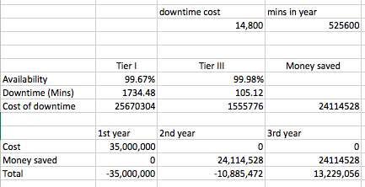

References:

Institute, LLC, U. (n.d.). Data Center Site Infrastructure Tier Standard: Topology.

Lerner, A. (2014, July 16). The Cost of Downtime. Retrieved February 08, 2017, from http://blogs.gartner.com/andrew-lerner/2014/07/16/the-cost-of-downtime/

OVH. (n.d.). Retrieved February 08, 2017, from https://www.ovh.com/us/dedicated-servers/understanding-t3-t4.xml