Xueming Guo

Flash Paper – Virtualization and Cloud Computing

Professor Doyle

Implementing virtualization will result in a net benefit of $9,200,000 after a 3-year period. Our company are running 1,000 physical servers and each server associated with maintaining, energy, and support expense every year, which means a lot of money to purchase and operate all 1000 severs. By implementing virtualization, we can use 280 servers replacing 1000 physical to consolidate server workloads and cut significantly cost.

The process of virtualization means we could create a virtual representation to replace our existing physical server. More importantly, it can consolidate 10 physical servers onto a single virtual machine to cut cost. Because we can virtualize 80% of our servers, we will replace our 1000 servers with total 280 servers including 80 virtual machines and 200 physical servers. Overall, virtualization will reduce hardware and operating costs because of less number of servers.

The cost of running 1000 servers is $10 million per year, and $14,000,000 for a 3-year period. Instead of running 1000 servers, 80 virtual machines and 200 physical servers will only cost $4,800,000 over three years. The cost consists of $2,880,000 purchasing cost and $1,920,000 operating over there years. If we implement virtualization, we will have a net benefit of $9,200,000 over three years and more benefits in the future.

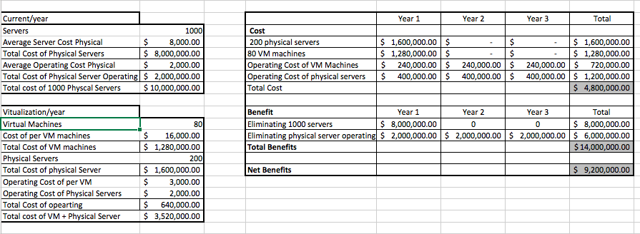

Work Cited

Server Virtualization & Consolidation. (2017, February 24). Retrieved February 27, 2017, from http://www.vmware.com/solutions/consolidation.html

Virtualization Technology & Virtual Machine Software. (2017, February 24). Retrieved February 27, 2017, from http://www.vmware.com/solutions/virtualization.html

Hardware upgrade and server refresh guide. (n.d.). Retrieved February 27, 2017, from http://searchdatacenter.techtarget.com/guides/Hardware-upgrade-and-server-refresh-guide

10 Tips for Planning your Hardware Refresh Cycle - IT for IT Blog. (n.d.). Retrieved February 27, 2017, from http://getnerdio.com/blog/10-tips-planning-companys-hardware-refresh-cycle/