Xueming Guo
WordPress – Flash Research Paper
Prof. Doyle
April 17, 2017

Implementing WordPress will create a net benefit of $2,451,000 over a 3-year period. We could increase efficiency of our current work by using the WordPress platform. WordPress provides thousands of themes, templates and plugins. Our Web Development team do not need to start from scratch, which increases team’s efficiency.

WordPress is a content management system providing thousands of free plugins and other features to save time and increase efficiency. For example, our web developers can use its available plugins and themes to easily create and manage the content and website. Currently, we have 12 developer working on web development. WordPress could ultimately increase efficiency of our web developers by 77.8%. The headcount will decrease from 12 to a total of 5, including 3 developers working traditionally and 2 developers using WordPress. Overall, implementing WordPress increases efficiency by providing available resources, like plugins and themes.

The decreased headcount by implementing WordPress will cause a net benefit of $2,451,000 for a 3-year period. The total cost of implementation will be $174,000 over 3 years, including hardware and software purchase, yearly maintenance, and training costs. The total benefit of carrying out WordPress is $2,625,000 over a 3-year period.

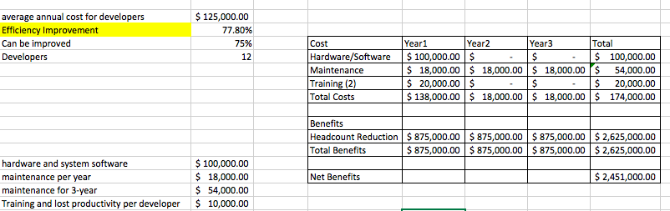
References:
WordPress.org. (n.d.). Retrieved April 26, 2017, from https://wordpress.org/about/

What Is WordPress? (n.d.). Retrieved April 26, 2017, from https://ithemes.com/tutorials/what-is-wordpress/

About the Editorial StaffEditorial Staff at WPBeginner is a team of WordPress experts led by Syed Balkhi. Page maintained by Syed Balkhi. (2016, September 08). Why is WordPress Free? What are the Costs? What is the Catch? Retrieved April 26, 2017, from http://www.wpbeginner.com/beginners-guide/why-is-wordpress-free-what-are-the-costs-what-is-the-catch/

