Xueming Guo
SharePoint Research Paper
04/25/2017

Implementing SharePoint will result in a net benefit of $1,846,250 over a 3-year period. Currently, our PMPs waste a lot of time on managing multiple repetitive documents that not creating value for our clients. SharePoint would increase PMPs’ billable hours, which will increase productivity by helping us to eliminate the backlog of work and increase revenue.

The key capability of SharePoint is efficient document management that enables our PMPs and clients access documents from any device. It keeps our clients and employees working in parallel and on same page. In addition, uploaded documents on SharePoint can be edited by different users that reduces multiple repetitive documents. It will add 400 billable hours per PMP per year. Currently, we are billing out 75% of PMPs’ time. It will bill out 95% after implementing SharePoint, which increase PMPs’ productivity.

The total cost of implementing SharePoint over a 3-year period will be $253,750, including purchasing, yearly maintenance, and yearly expert costs. SharePoint will add a total of 4000 billable hours per year. The total benefit over three years will be $2,100,000, resulting a net benefit of $1,836,250 in the same period.

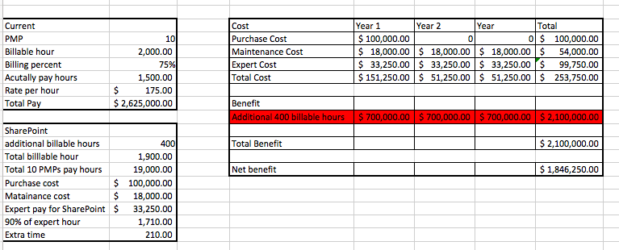

References:
Leverdier, G. (n.d.). Top Benefits of Using a SharePoint Intranet for Corporations. Retrieved April 26, 2017, from https://en.share-gate.com/blog/benefits-sharepoint-intranet

SharePoint Server 2016. (n.d.). Retrieved April 26, 2017, from https://products.office.com/en-us/sharepoint/sharepoint-server

(n.d.). Retrieved April 26, 2017, from https://sharepoint.uservoice.com/

