Pound Cake prototype
Home page:
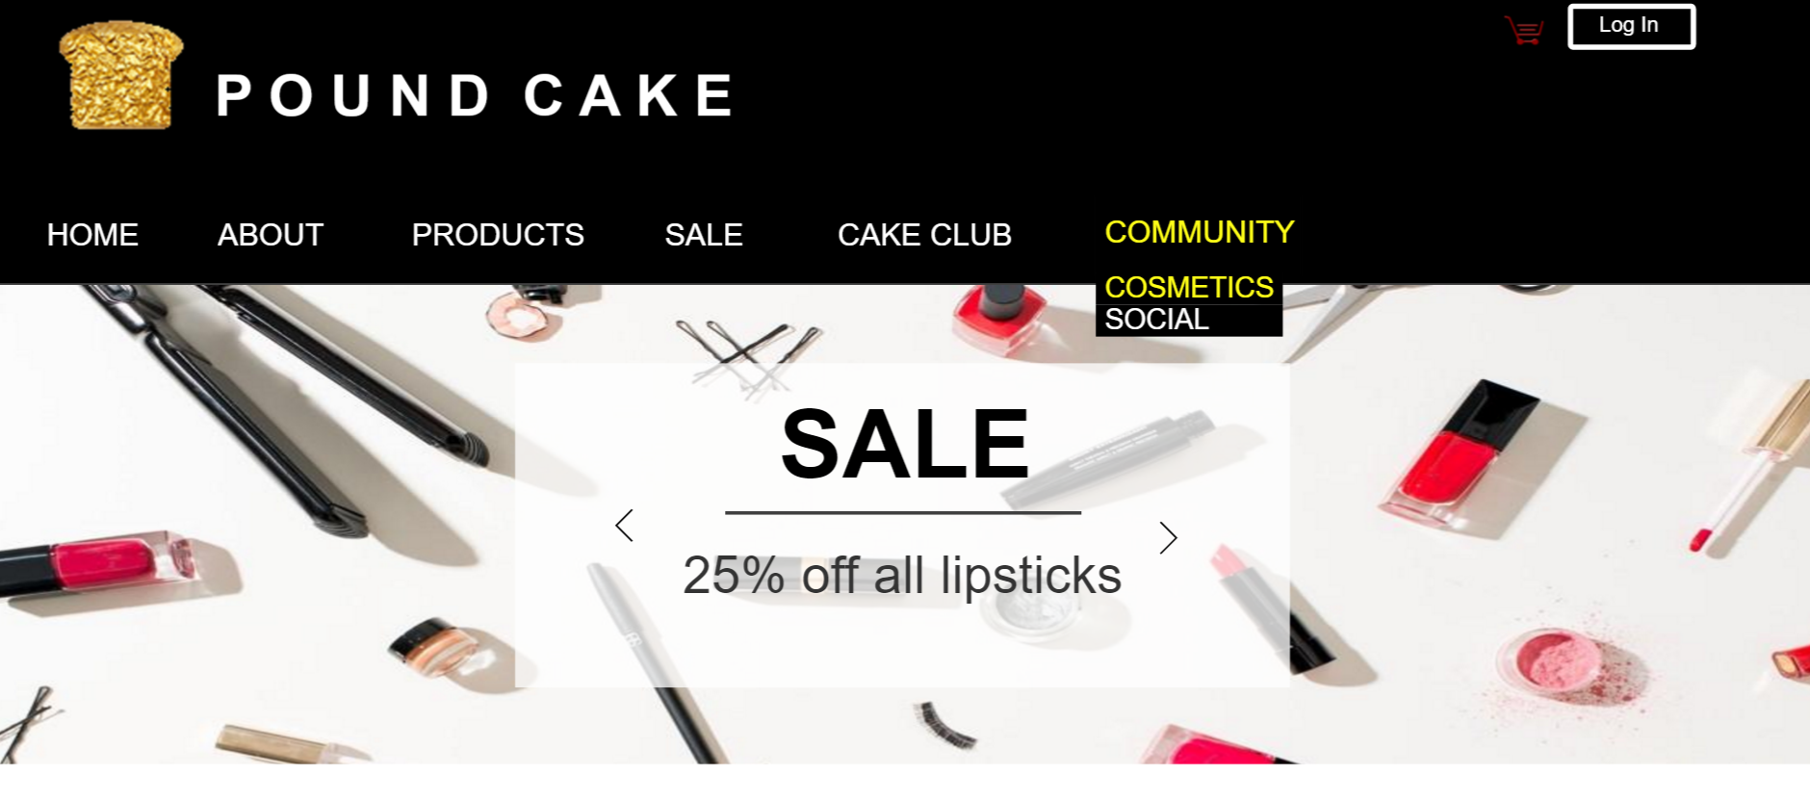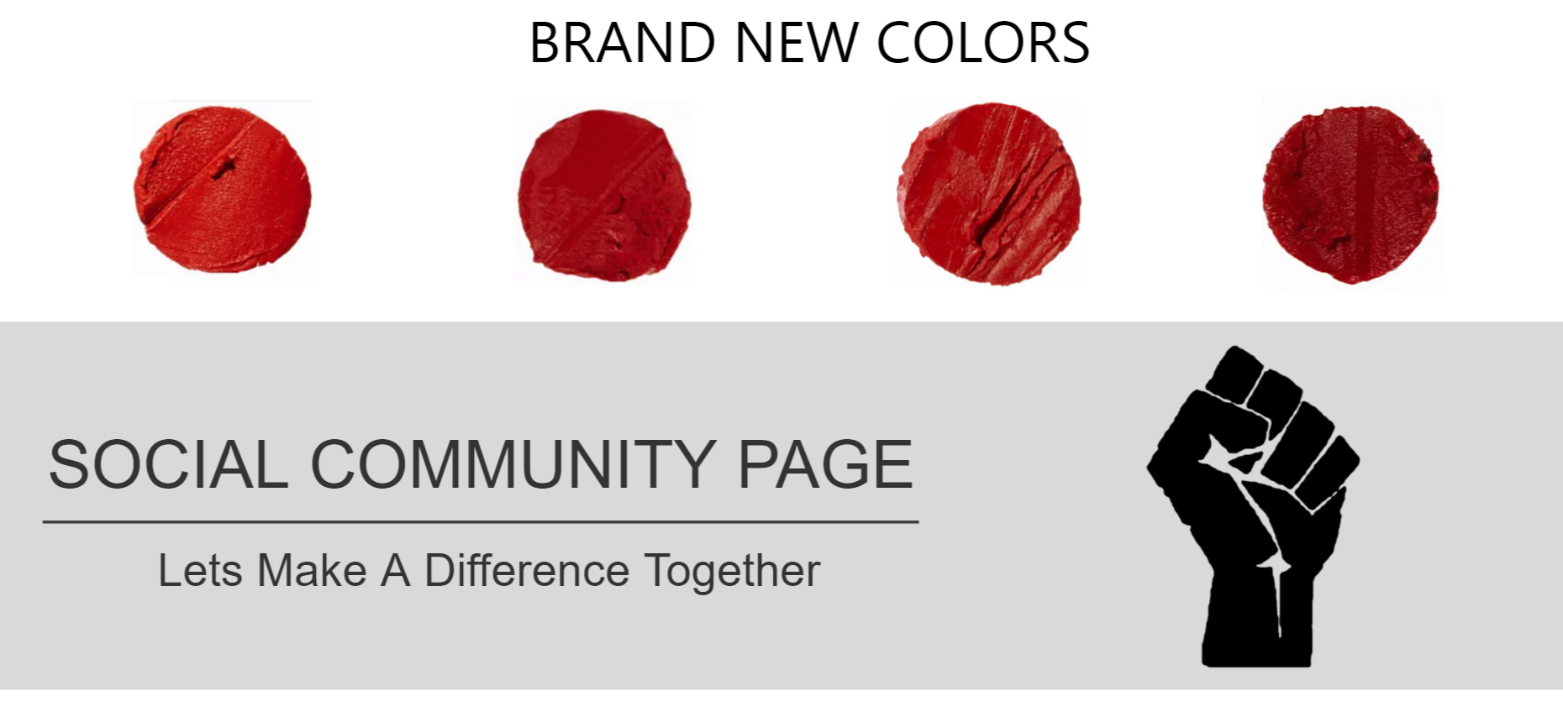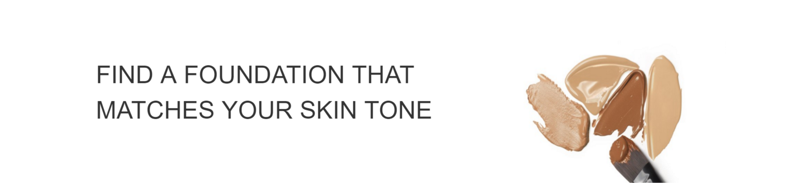

First persona: Zoie logged in: She is a returning customer. She likes keeping up with fashion trends, so she went through the cosmetics blog.
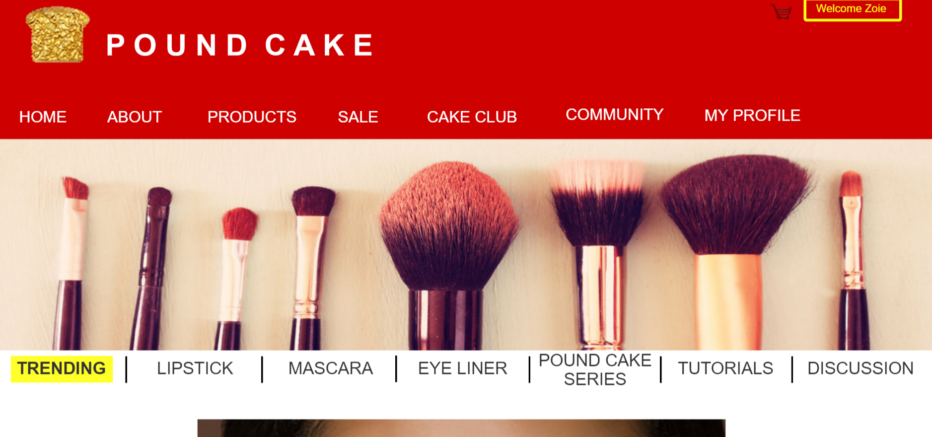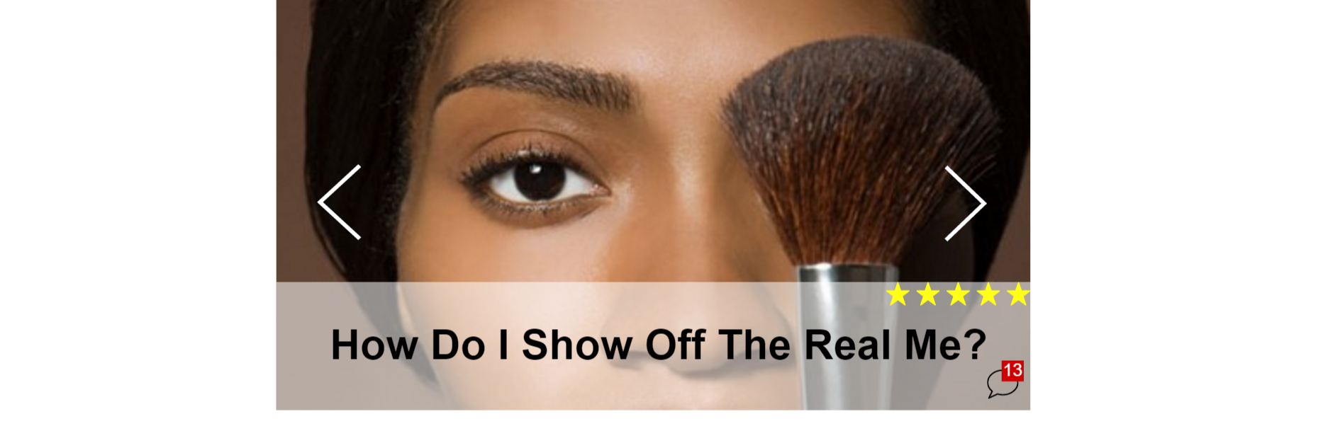This is the Lipstick page. Zoie can rate the article and leave a comment.
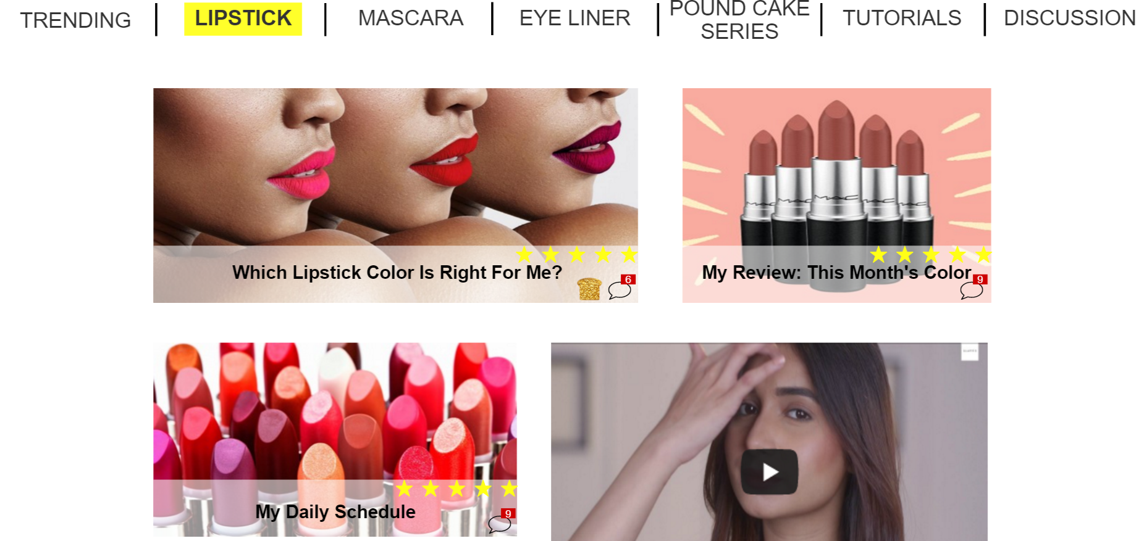
She can also click on the video button, which will skip to the tutorial site.

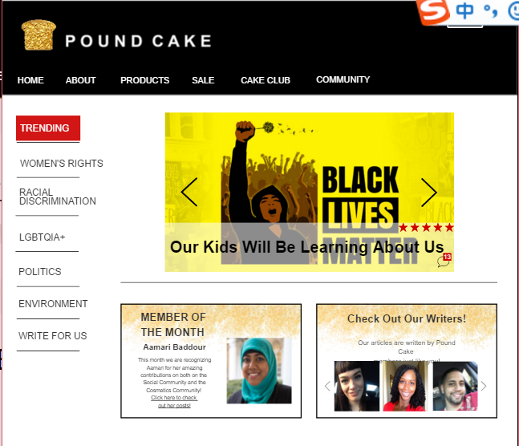
Second persona: Cindi: she is a new user. She was looking through the social blogs. Then she was interested to post something on the site, then she clicked the write for us tab.

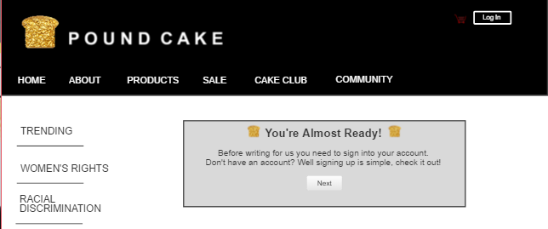
She was directed to sign up for an account.

She filled in all information and finished the sign-up process.
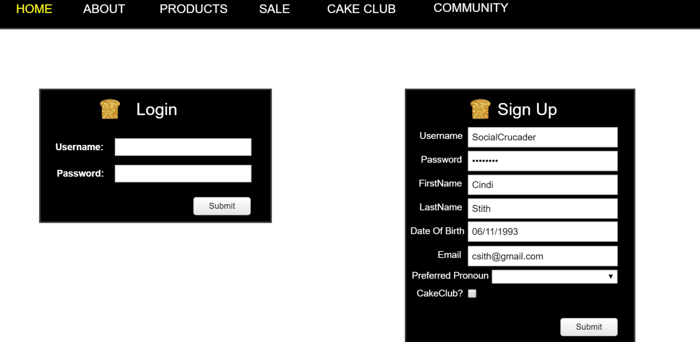

She entered her profile to see her info. Then she can click the Write A Post tab listed in the navigation bar.
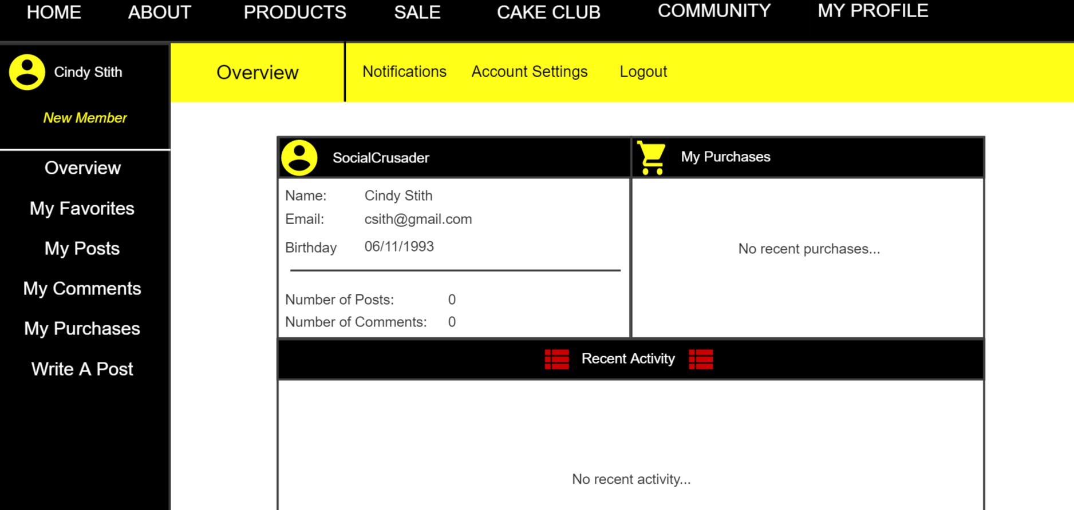

Now she can write her post and engage in Pound cake’s community.
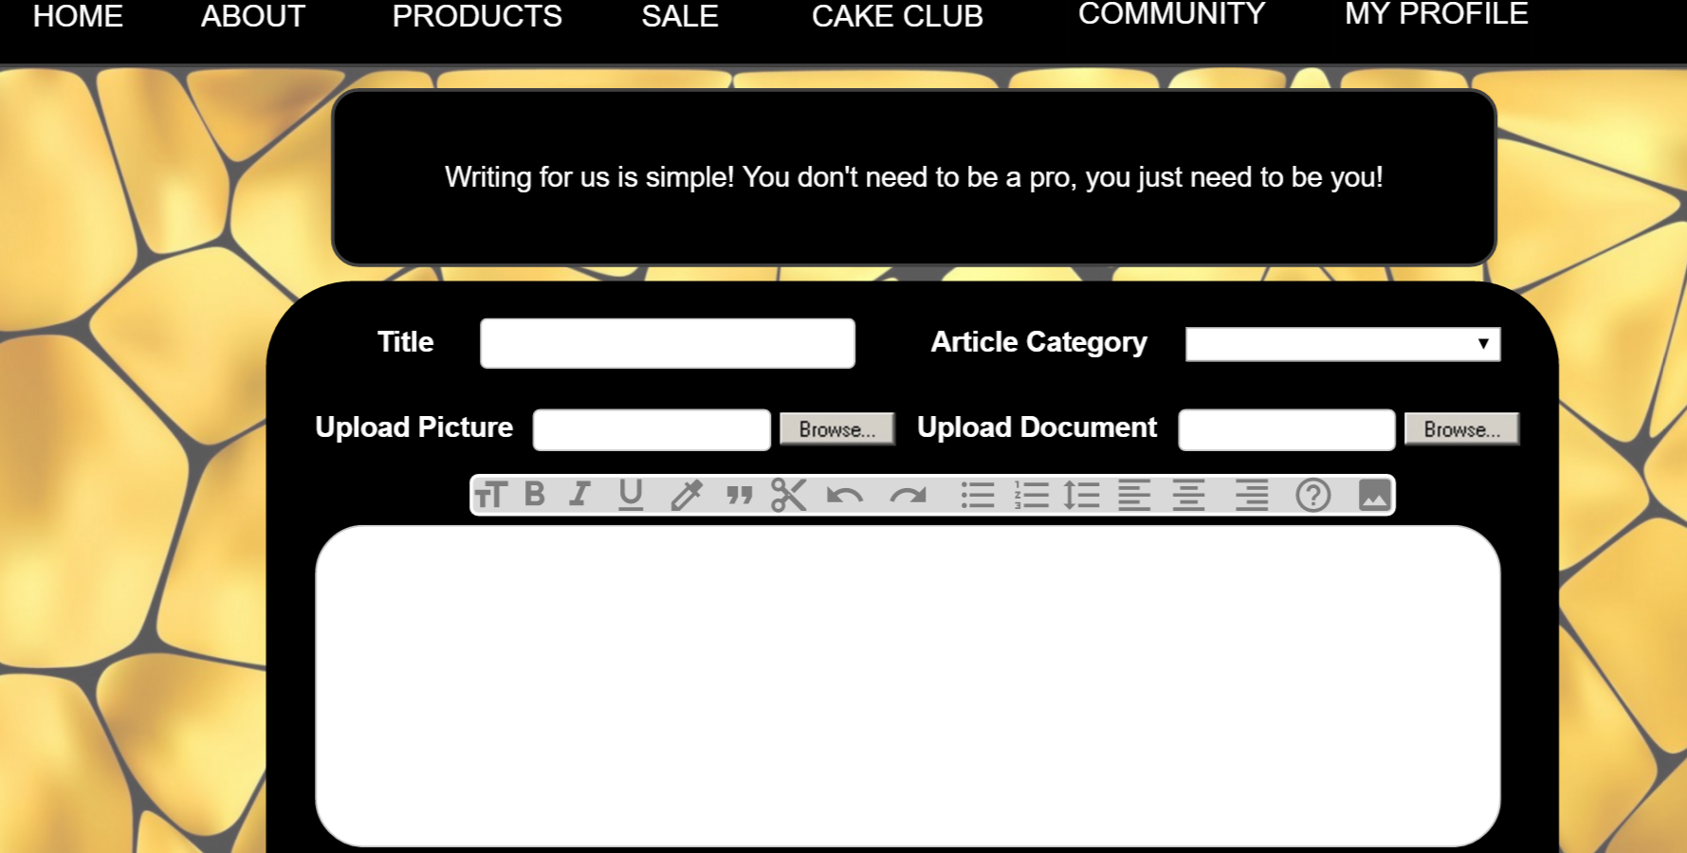
Thank you very much for looking for my document!

Appendix -- Scope
Statement of Purpose:
Poundcake Cosmetics is a start-up company looking to create an e-store that specializes in cosmetics. They are hoping to make an impact in the cosmetics market by catering to consumers with darker skin tones. Over the next 5 years, they are planning on expanding their products to lotions, brushes, etc. Their main demographic is people of color. Poundcake Cosmetics also wants to make a societal difference through their online store by posting updates and relevant material on social issues as well as advice on how to use/apply makeup.
Currently, PoundCake is still in the development stage. They are currently implementing matte lipstick products at a price of $20, which will soon be available to consumers. The company envisions a community to bring people together and educate them on a variety of topics. PoundCake sees an opportunity to give people who are passionate about makeup and social issues a place to feel safe and informed. PoundCake’s essential problem is that it needs more exposure to the cosmetics market in order to gain a good following by consumers. They currently have a Twitter following of 33 and an Instagram following of 45. PoundCake is trying to gather a following by collecting emails on their website in order to create a mailing list.
In order design a solution, we are going to research their competitors to see how they run their e-stores, as well as research their target market. Through various sites such as TeenVogue and Mic.com, we will find out the interests of these younger people when its comes to social issues and what they are would like to see on PoundCake’s community page. We are going to provide users with a site where anyone and everyone can feel welcome no matter their race or gender. We will provide a prototype to meet the requirements set forth by co-founders Camille and Johnny.
Objectives:
•Increase company site use by 60% within a year of the blog’s launch by tracking the number of community home page views.
•Have 10 different social issues being discussed within 6 months of the blog’s launch
•Increase the number of Poundcake customer accounts to 250 within 8 months of the blog going public.
•Have 20 guest bloggers appear on the blog within one year of completion.
Assumptions:
•People of color are Poundcakes primary target for the blog.
•Poundcake is currently selling one type of product, lipstick
•Create and/or find content for social issues and educational pages.
•We must create an interactive blog from scratch
•Users will be able to interact with posts.
Constraints:
-Lack of customer data
-No original PoundCake created content
-Little online following.

