Web solution for Children’s Hospital of Philadelphia Yu Zhou
The project aims to create a web application for CHOP’s physicians and caregivers to better collaborate with each other and serve the patients. We accomplished everything from scratch! I was serving as a team lead to delegate tasks for team members and complete most of the codings. We started from creating the data schema, MVC structure and the use cases. Then we coded an unfunctional web solution mainly using HTML,CSS and PHP. Lastly,We designed a database and connected it to the applications using a combination of SQL, Bootstrap, JavaScript/ jQuery and Responsive web design. I spent most of my time on the functionality to make sure each function worked as intended. It was really like the kniting work, not only having the idea, but also working it out. And it was also a process to verify the plausibility of your idea. I was continuously trying and modifying my database and functions the entire time. It was the most challenging project, but it also gave me the most sense of achievement. I admit that there are still a lot to improve and to make it “smarter”. If given me more time, I have the confidence to make it better!
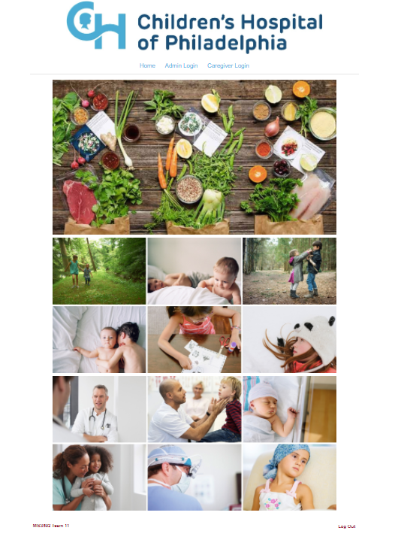
Home page.

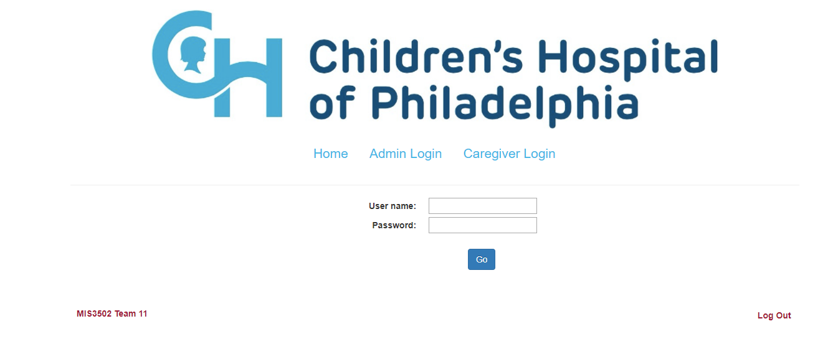
Log in page

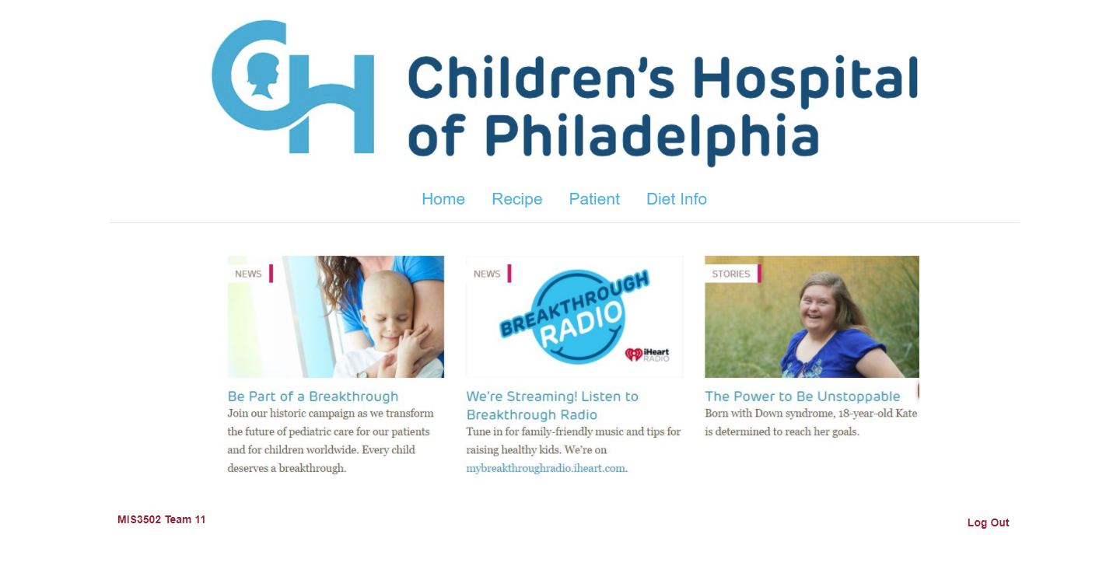
Admin, which is physician’s page. He/She can check recipe and patient’s info.

Recipe home page: Physician can view exist recipes, add ingredients into database and create a new recipe for a patient.
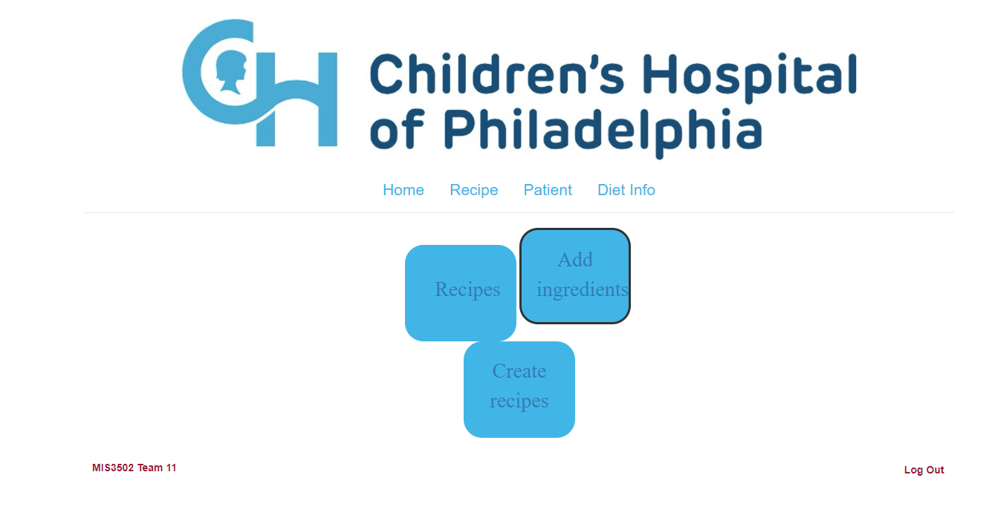

Add ingredients:
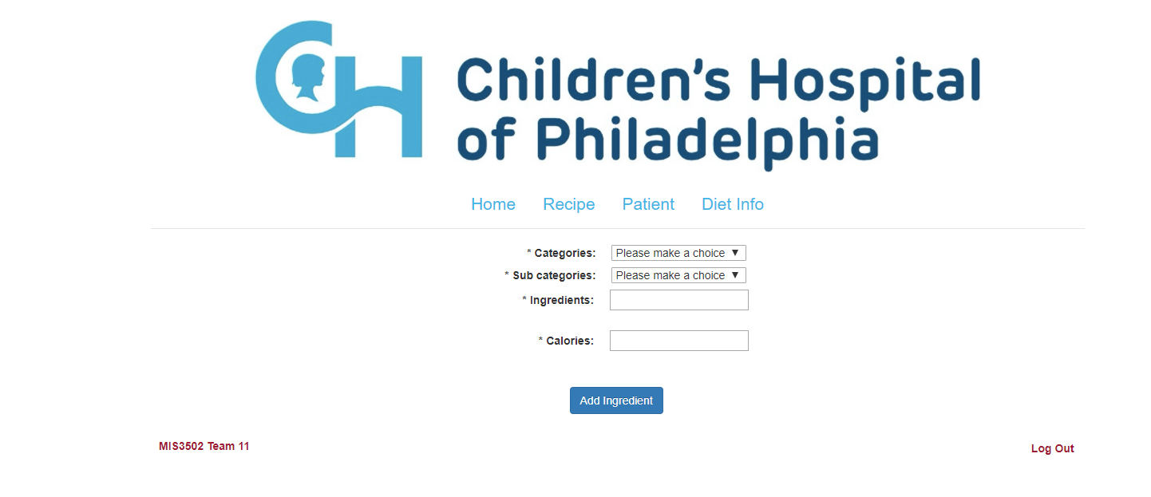

Create a new recipe:
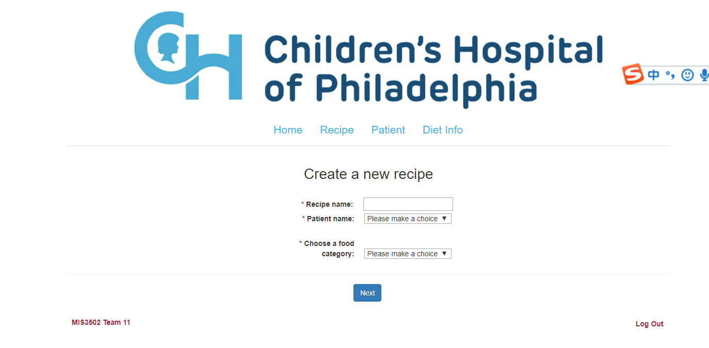
See what options under the specific food category.
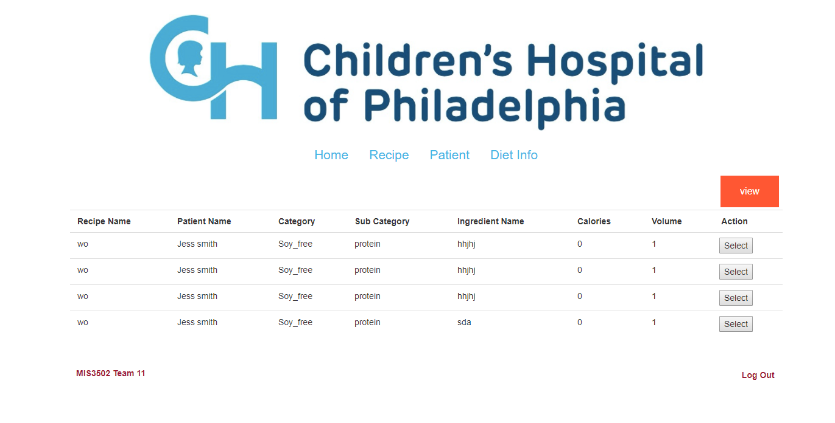

After you clicked the “select” button, you will be notified you have selected that specific ingredient. You can select multiple times on the same ingredient or select another one.
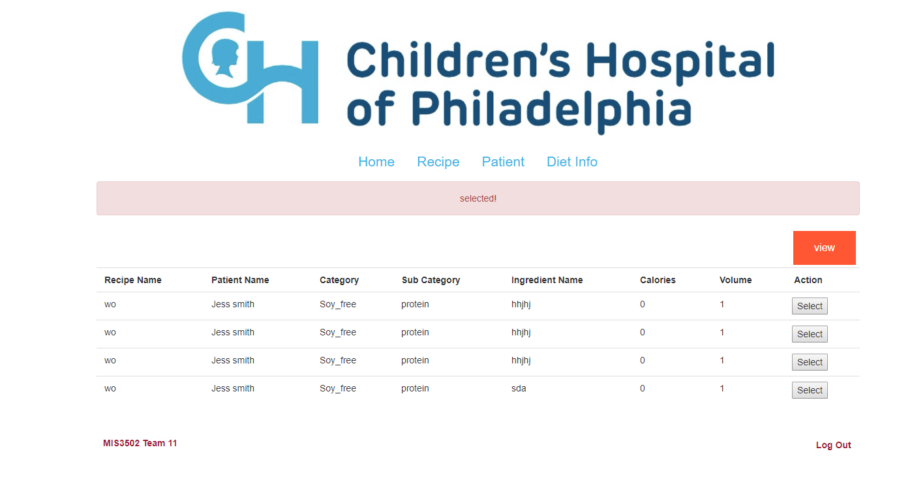
When you clicked the “view” button, a list of ingredients you have selected just now appeared. And this is the new recipe you just created. You can check it through the “Recipes” square on the recipe home page.

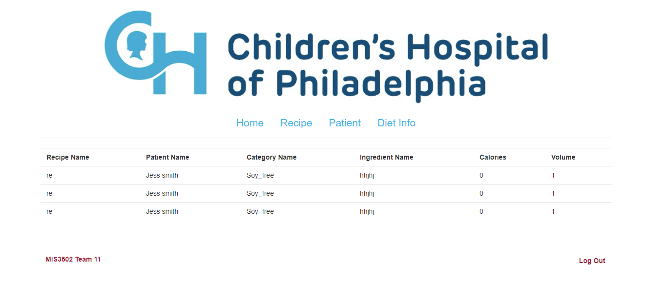

Other things want to highlight: JavaScript
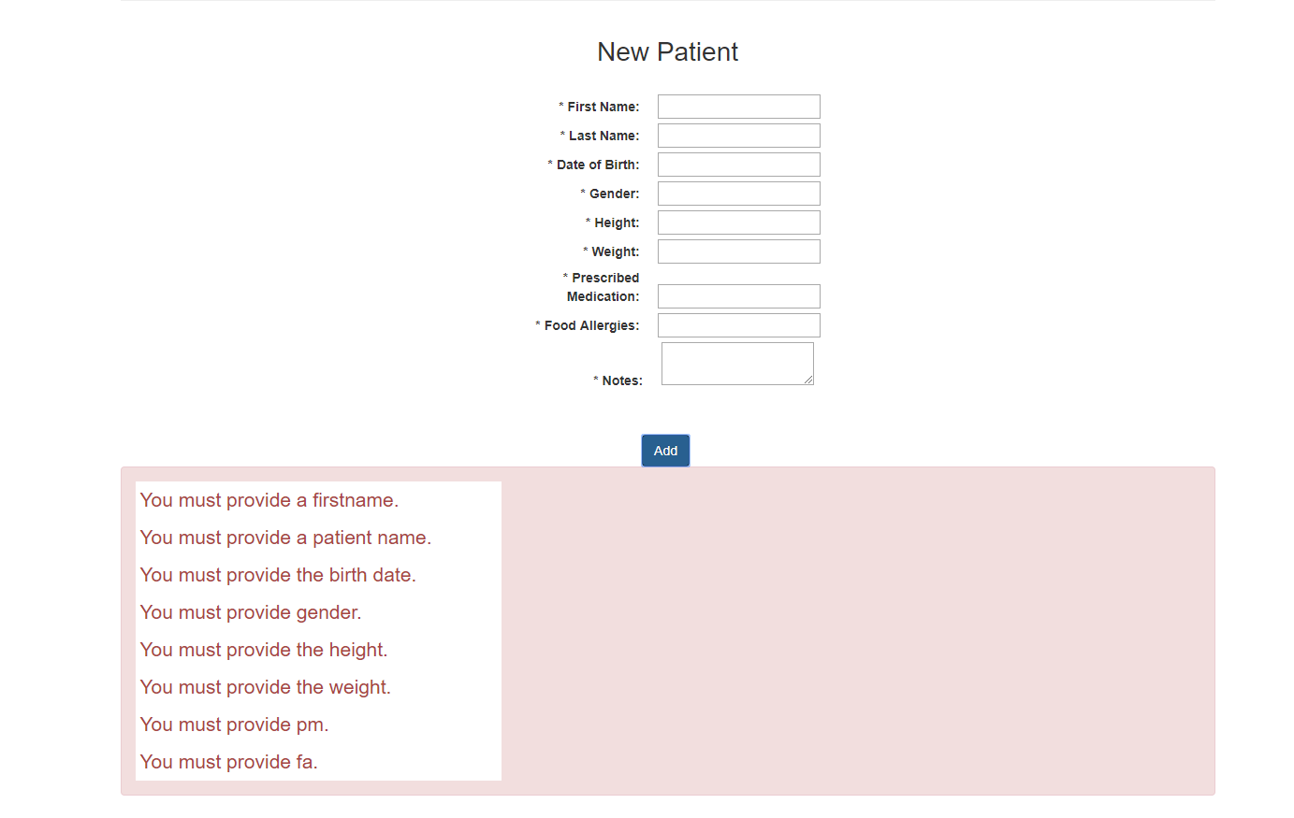

Thank you for viewing my project work! If you have any questions or would like to have a conversation with me, please feel free to reach out me at tuf77274@temple.edu. I will be excited to connect with you!
Sincerely,
Yu Zhou

