Brandon Nelson

Professor Shin MIS 2052

Extra Credit Write-up

11/9/2021

Social Network Analytics and Data Analytics

Social media is a part of a majority of American’s daily lives. This has made the ability to capture and present data from social networks a valuable asset. Large corporations are constantly looking for new ways to push the envelope in this ever-growing industry. Many social media platforms give business owners the option to set up “business accounts” which make it easy for us to view important data inside the app. The most simple form of data that can be found on almost any social media site is engagement. Engagement not only tells us how many people our posts reach, but also lets us look at the demographic of the people who it reached, and the demographic of the people who engaged with the post. This information from Twitter, Facebook, or Instagram allows companies to post strategically to grow their accounts. But how do we present this kind of data in a meaningful way? This is one of the important skills we learned in MIS 2502.

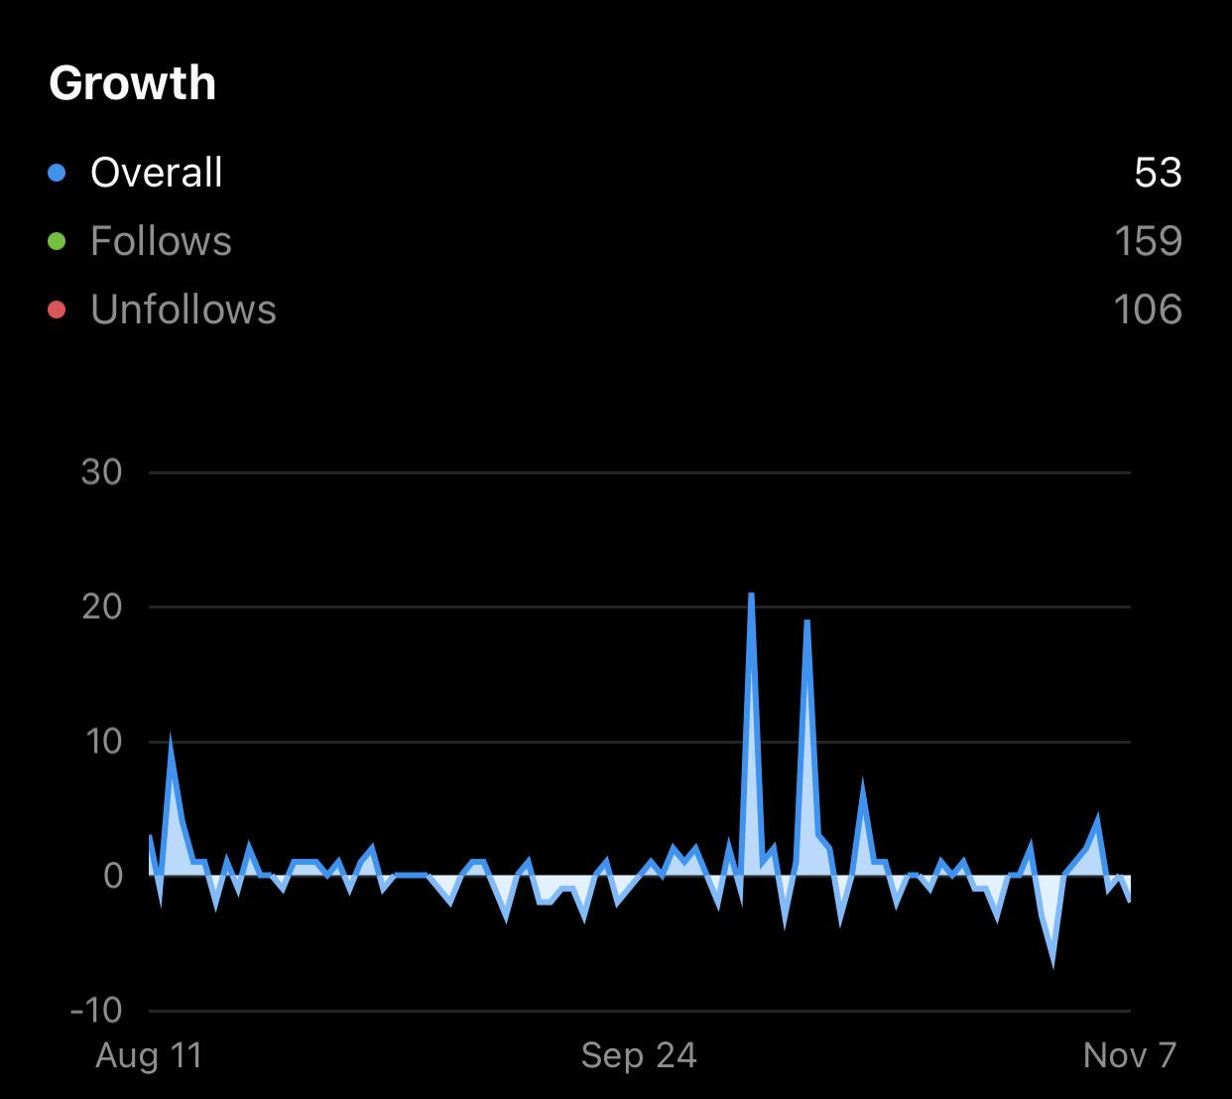

Source: Instagram

This graph is one of Instagram’s insight graphs inside their app. This graph is a great example of how social network data should be presented, because it follows the rules we learned in MIS 2502. It tells a good story about the follower growth, it is honest, and the data is organized in a clear and concise way. We can infer from this graph that although there have been ups and downs in the follower count, this account is still experiencing a net growth. From the looks of this graph, the owners of this account may look for ways that they can keep their current followers while still maintaining that net growth.

Social Network Analysis is a very important skill in 2021. Social media companies are making their data more and more accessible and readable for business owners big and small. As we push towards even more digitization I expect social media skills to only grow in value to companies across the globe.

Works Cited

D.says:, Jim, et al. “How Many People Use Social Media in 2021? (65+ Statistics).” *Backlinko*, 10 Oct. 2021, https://backlinko.com/social-media-users.

“11 Ways to Increase Instagram Engagement in 2021.” *Later*, https://later.com/blog/how-to-increase-instagram-engagement.

Instagram App. “Engagements”

https://www.instagram.com/