Learn IT #3 Grading Rubric

Part 1 – Sales Order Process | Yes/no
a) First 4 processes say “Completed”
b) Line 5 says “Complete”
c) Line 6 says “FI doc. Generated”
d) Line 7 says “Cleared”
Part 2 – Labor Scheduling
a) 2nd to last line says “## Production Manager”
b) Last Line says “## Scheduler”

** ”##” refers to the student’s FS number. It can be different between the 2 parts because some students had to get new login information.

Pass High: all screenshots are accurate
Pass: one screenshot is not accurate/missing
Fail: Both screenshots are not accurate/missing

See Screenshots for further clarification:

Screen shot 1: Sales Order Process
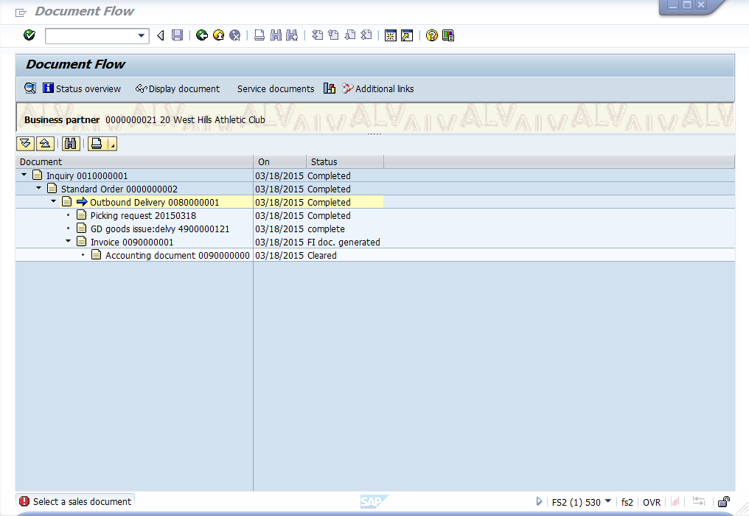

Screen shot 2: The HR Exercise
