Go to Lucidchart.com

There are paid and free versions. We will use the free one. You can only work on three diagrams, but this should be sufficient for our class. You may have to delete all the information in one if you run out of diagrams.

Select Sign up free

Under plans, Select Continue with free

(See below) Select Education; Student; Build; Flows, sequences and processes

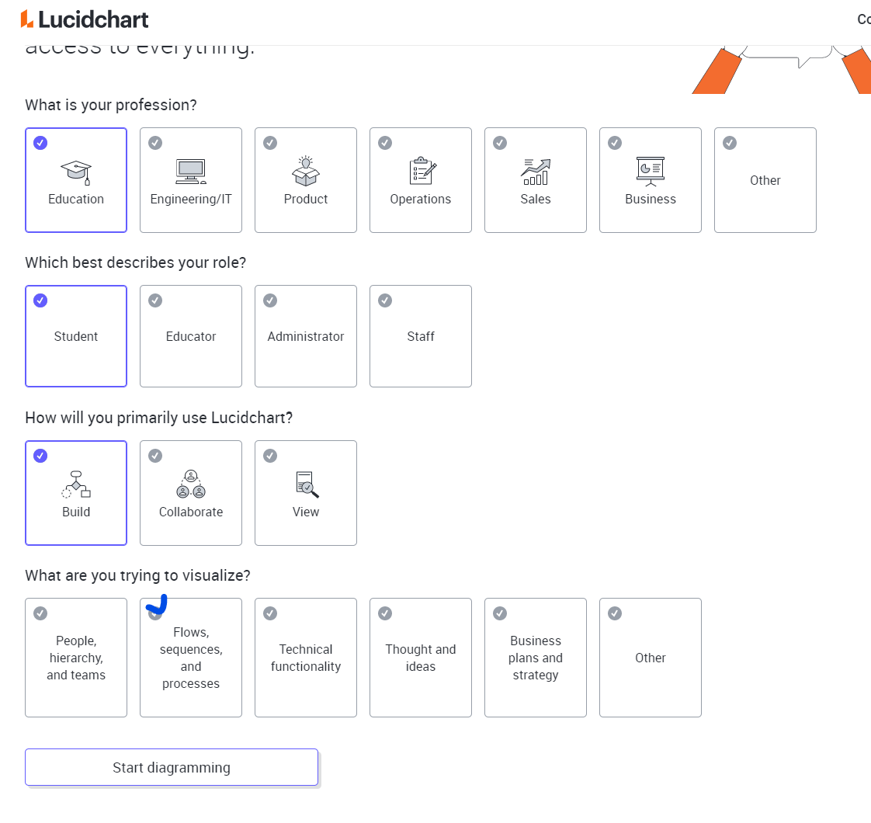

(See below) Select Swimlane Diagrams

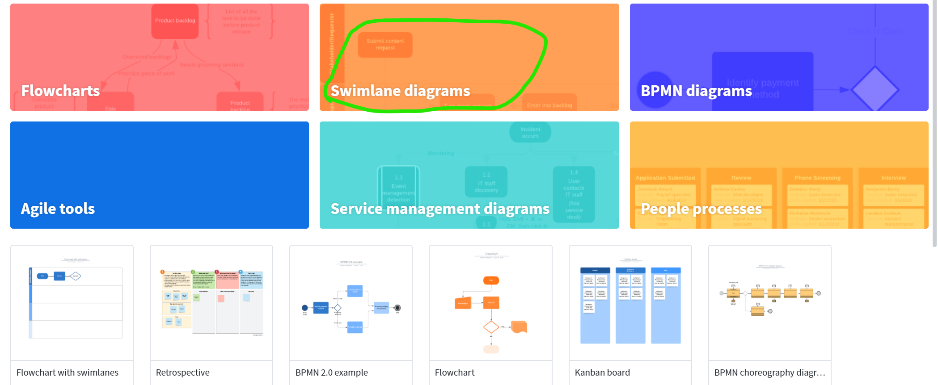

(See below) Select Flowchart with swimlanes
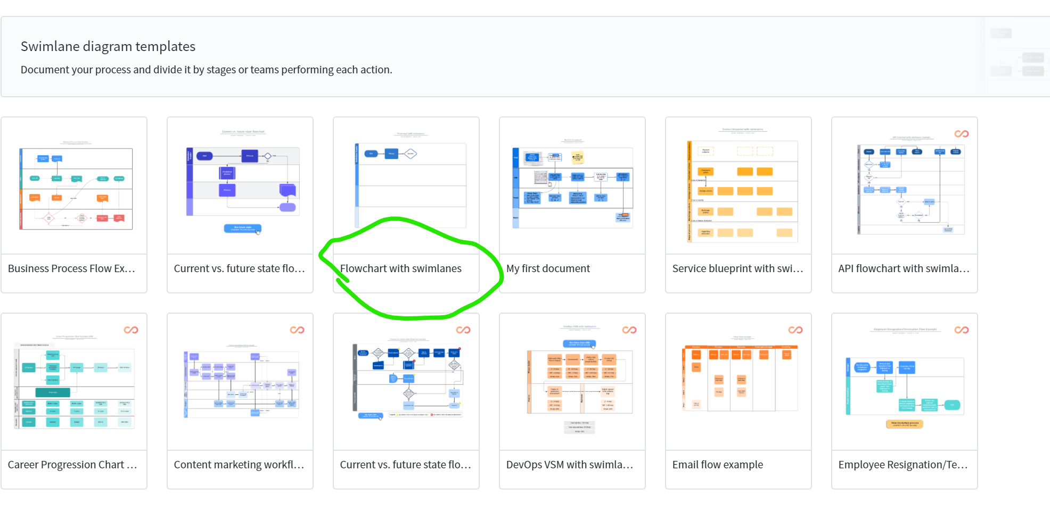

Double click on the example flowchart. Delete the items that are already in the example.
Drag a rectangle to the drawing (see below). Click on a header to put in the name of the actor.
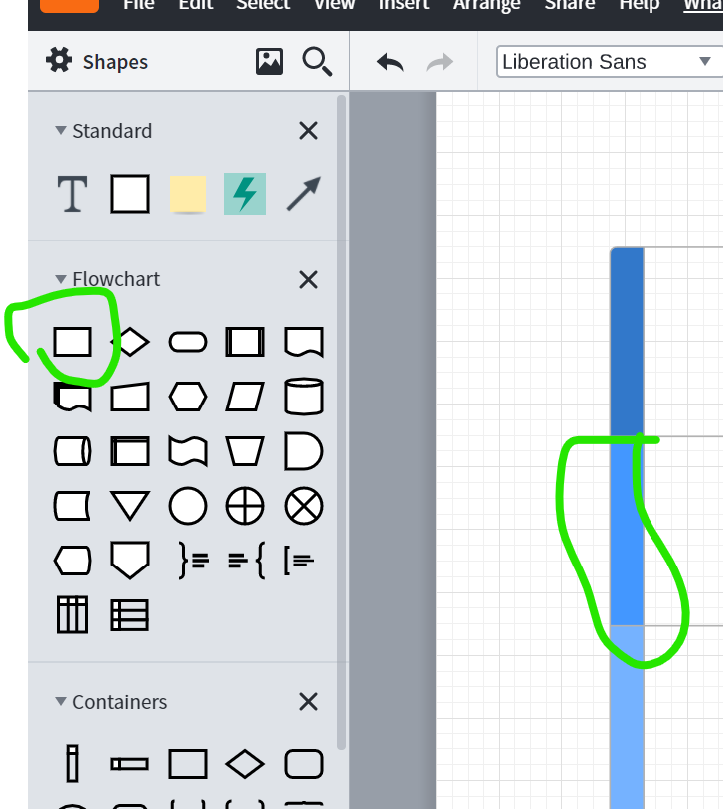

Click on share and enter the email address of someone you want to collaborate with. When they are logged in to Lucidchart, they will get an invitation alert. This may take a few minutes. Once the invitation is accepted, you can work on the same diagram at the same time, similar to working on a paper in Google Docs.

To create a PDF (JPG) output file, click on File Export PDF (JPG), and save the output.

The free version of Lucidchart restricts how many elements (processes, decisions, arrows) you can have in a diagram. When you exceed that number it will ask you to switch to the professional version. Instead, get creative.

