Making ERD Diagrams in LucidChart
Log into Lucidchart
Remember, for making a PDF, use File Export PDF
Use Share to work with someone else.
See picture below. Click on Home, Templates:
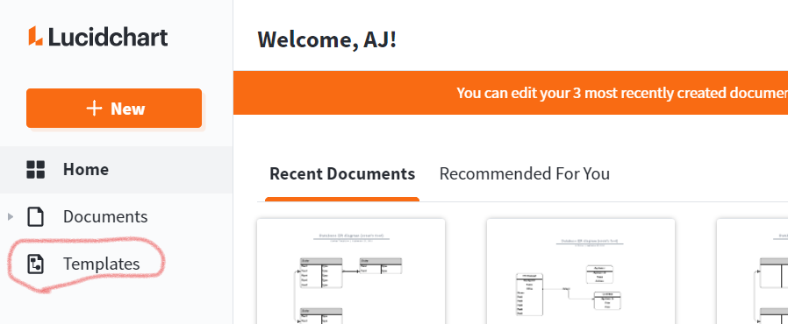

See picture below. See Database Diagrams? Click on it and skip the next step.
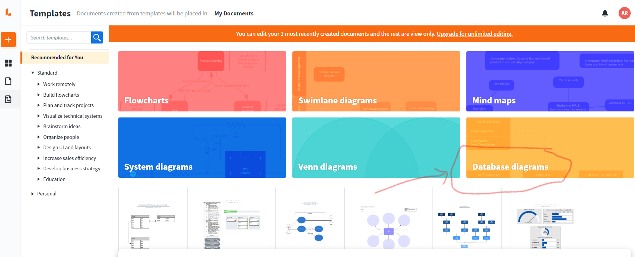

See picture below. Don’t see Database diagrams as an option? Select it from the dropdown.
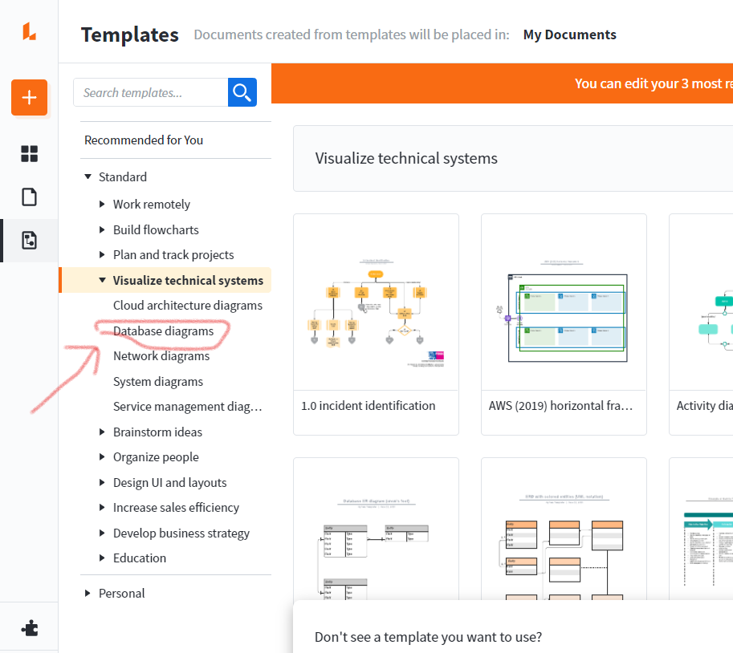

See picture below. Select Database ERD Diagram (crow’s foot). Start with a blank one.
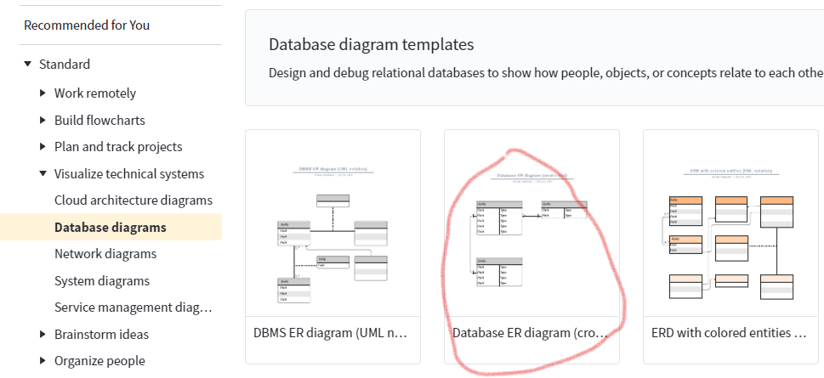
Do File Save to give it a name and save it. If you already used up your three free diagrams, then delete an older one.

See picture below. For the entities, use the simples entity type, on the far left. To add more fields to an entity, use the options I circled. Add above, Add below, or simply change the number from 3 to something higher.
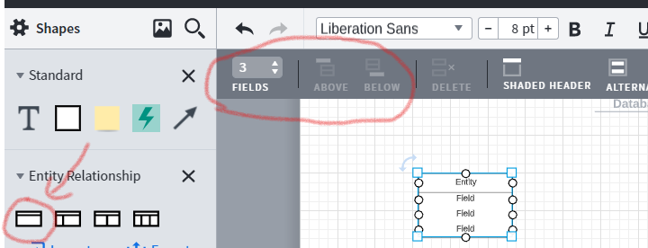

Zoom in to make editing easier.

See picture below. You can center the field names, shade the label on the entity, and shade alternate rows.
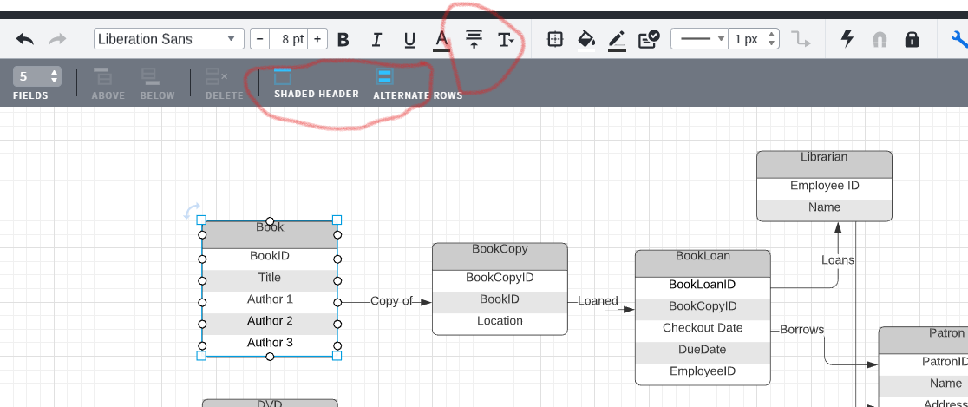
And again: for making a PDF, use File Export PDF

