**MIS2402 – HTML Project**

**Overview:**

Create a web site that provides a useful, informative, and/or fun summary of computer / technology related history. You can use this free e-book as a resource, <https://archive.org/details/my-working-life_202011> or do your own research.

Use your knowledge of HTML and CSS that you learned from the LinkedInLearning videos assigned at the start of the semester.

For some instruction on what *not* to do, you should check this page: <http://www.webpagesthatsuck.com/ugliest-worst-web-pages-of-the-decade.html>

Use only the resources found in the assigned LinkedInLearning HTML video material. Your solution should not contain frameworks, themes, etc. that are not in that video tutorial.

Another useful resource is W3 Schools ( <https://www.w3schools.com/html/> ) You might want to use W3 Schools for a quick reference. But remember, in this project you are limited to the contents of the LinkedInLearning HTML video material.

**Required elements:**

1. Your web site should have at least three html pages. You should be able to navigate from page to page using hyperlinks (that is, anchor tags). The first page of your solution should be named index.html
2. Recall that page layout should be accomplished with the div tags. All your html pages should be consistently laid out in one of the following formats:  
     
   Horizontal Navigation:  
   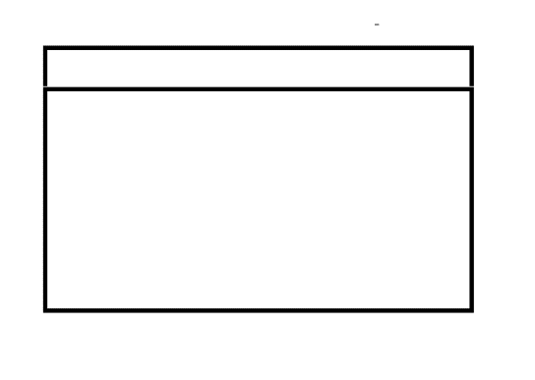  
   Vertical Navigation:  
   

Anchor tags go here. This is your navigation inside the site.

1. Your solution should contain a form. The form should contain appropriate usage of label tags, input tags, and one or more select tags. In addition to input tags of type text, you must also have an input of type radio or checkbox. Be careful to use radio and/or checkbox inputs appropriately. The form in this project is for appearance only. Collecting / Processing data provided on the form is outside the scope of this project. Your form should also have one or more buttons.
2. Your solution should contain a table of information. The table should demonstrate appropriate use of td tags, th tags, and tr tags. Recall that tables should not be used for layout.
3. Your solution should contain a side bar that contains a bulleted list of hyperlinks the refer the user to additional related web pages ***outside*** of your solution. The side bar you create is a way to direct users to external resources, not navigation.

For example:

Side  
Bar

Side  
Bar

OR

1. Your solution should use 2 or 3 colors effectively. If you are unsure as to what colors to choose, do a google search on “complimentary colors in web design” or a similar phase.
2. Design your solution with a conventional laptop screen in mind. That is, roughly, 1280×720. Your solution does not need to be responsive (that is, it does not need to automatically scale to the dimensions of a smart-phone browser)

*Publish* your solution as a web site hosted on misdemo.temple.edu. That means that you should put it in a subfolder under your wwwroot on misdemo.temple.edu. For example: if you named your project “coolproject” then you would create a folder called “coolproject” in your wwwroot. Then, the URL to your work would be:

https://misdemo.temple.edu/tuk54321/coolproject

|  |
| --- |
| Keep your website name simple – no punctuation, no spaces, all lower case. CoolProject, cool project (with a space), cool-project are all bad names.  If you provide your instructor with a bad name or a URL that doesn’t work, you will receive a 20% grade penalty. |

**CONTINUED**

Provide your instructor with the URL of your web site as directed. Consult the class schedule for the project due date.

Your solution will be graded as follows:

|  |  |
| --- | --- |
| Uniqueness and Creativity (awarded at the discretion of the instructor) | 20 |
| Consistency & Navigation from page to page | 10 |
| Use of color / contrast | 10 |
| Form Elements | -- |
| Labels | 5 |
| Inputs of type text, checkbox, radio, button | 5 |
| Select | 5 |
| Table | 10 |
| Sidebar with working links | 10 |
| Correct use of <div> | 5 |
| HTML is error free (Firefox view source will be used to check for errors) | 20 |

Total Points Possible: 100