ICA04 – Conditional Logic – Lemonade calculator

In this activity, students will create three different representations of the same logic. This ICA has 100 points, with each deliverable being worth a percentage of those points.

Scenario
You are creating a calculator to help you determine how much lemonade you can make, with the quantities of the ingredients you have. Our recipe for one serving of lemonade is shown below.

Lemonade recipe
For 1 serving of 240 ml (that is, about 1 cup)
- 190 ml water
- 50 ml lemon juice concentrate
- 80 grams sugar (about 3 ounces)
- 1 disposable cup
The general idea here is that our calculator will take as input the amount of lemon juice, and the amount of sugar we have on hand. We will then be able to determine how many servings we can create with that.
For this activity, we’ll assume an infinite amount of water and cups. But, if we were really budgeting for a lemonade stand, we would need to think about those things too.
The calculator will always respond with the whole number of servings that are possible. We are not interested in preparing half a serving.

General Instructions
- Watch this animation. This represents the kind of logic you are expected to emulate. You will not create this full solution in the activity. You are not expected to reproduce the output exactly as shown here this class. (But, very soon, you should feel comfortable building something like this!)
https://misdemo.temple.edu/classexamples/lemonade.gif
- Notice that some input values are not accepted. Our calculator won’t accept negative numbers (because you can’t have negative cups of sugar!) and it won’t accept non-numeric values.
- You should also notice that the number of servings you can prepare will be limited by the amount of sugar you have, or the amount of lemon juice you have, whichever is more limiting.
NOTE: You need to stick to the recipe. You don’t’ have the option to make the lemonade more or less sweet!
Your calculator will need to do some division. It will also need to round down the results of that division. JavaScript gives you several ways to do that. They will be described further in part 3.

Part 1 – Pseudo Code (50 points)

- Work with a friend in the classroom. Collaboratively compose pseudo code for the calculator. Be sure to specify details related to error trapping, and how the calculator will determine it’s output.
- Write your pseudo code in the box below. It is OK for two collaborating students to have the same answer (see step 4 above) but every student must turn in their own document.

Pseudo code

Part 2 – JavaScript (50 points)
- In the box below, write JavaScript that calculates the number of servings. For the purposes of this activity, assume that you have two variables: sugar and concentrate. Use those two variables to create a third variable called servings.
How do I “round down” to the nearest integer? JavaScript provides “floor” and “ceiling” methods to round down and round up. JavaScript also provides a parseInt function that will convert a number to an integer. The “floor” method and the parseInt method, while subtly different, are both acceptable in this activity.
Here is a screenshot taken from the Chrome Web Developer console that illustrates both techniques:
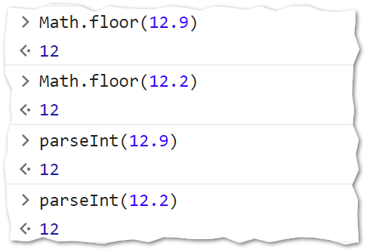
- You can type your code in VS Code and then copy / paste it into the web developer console to see if will run.

- Turn in your work by uploading this document to the ICA 4 assignment on Canvas.

