# ICA05 – Project Management Formulas and Publishing

In this activity, students will create three calculators. This ICA has 100 points, with each deliverable being worth 25 points. Students are encouraged to strategically reuse (copy/paste) portions of their work from one calculator html file to another.

You get a “free” 25 points for publishing your work on the class server.

***Advisory!*** In this activity, you will need to use Bitvise. Bitvise is software that only works on Windows PC computers. If you are using a MacBook laptop, then please use the computers in the classroom to follow along with this assignment.

Students are given step-by-step instructions on the first two calculators and are left to work independently on the last one. They are then expected to publish their work to the class server with guidance.

## Scenario 1 – Natural Number Tester

If this scenario, we will create a function. We will reuse this function many times later in the semester. We will write a function called isNaturalNumber. This function will return the Boolean value true or false. When a function returns true or false, it can be used in place of a comparison in a conditional statement. You have already seen the function isNaN doing this. For example:

|  |  |
| --- | --- |
| if (isNaN("saxophone")) {  console.log("Saxophone is not a number");  } else {  console.log("Saxophone is a number");  } | The function isNaN returns either true or false! |

Notice how (in the example above) the isNaN function can be used in place of a comparison in an if statement. It can be used this way because it returns either true or false.

We will now define a function that the JavaScript language does not give us “out of the box”. Our function will be called isNaturalNumber and it will return true if it is provided a natural number and false if is not.

What’s a natural number?

A natural number is a number that is used for counting: 1, 2, 3, etc. It is a positive integer that has no fractions or decimals. Natural numbers are also sometimes called counting numbers or whole numbers. ***Natural numbers are the first numbers that you learned as a child!***

Math geek alert: some definitions also include zero as a natural number, but for our purpose this semester we will say that zero is ***not*** a natural number.

## Instructions

1. Work with a friend for scenario 1. Be advised that both of you and your friend need to upload your code for scenario 1 individually. You won’t get credit for this part of the ICA if you say “my friend did it and I did not upload it”.
2. Download this file ica05.zip. Unzip the ica05 folder into your workspace. It will contain the files natural.html, ev.html, cv.html, cpi.html
3. Open natural.html in Visual Studio Code.
4. Edit the isNaturalNumber function found there so that it returns false if x is zero, or if x is negative, or if x is not a number, or x is not an integer.

Otherwise, return true.

HINT: You can test if a number is an integer by using comparison and parseInt. The logic goes like this: if a number, parsed as an integer, is the same as the original number, then the original number must have been an integer.

ANOTHER HINT: Be sure that you are returning Boolean true or Boolean false. Do not return the strings “true” and “false”. See below:

return true; // this is correct

return "true"; // this is wrong

1. Test your work. Here are some tests you can use.

|  |  |
| --- | --- |
| Input | Is it a natural number? |
| 1 | True |
| 0 | False |
| -1 | False |
| 500 | True |
| Fred | False |
| 3.14 | False |
| 4 | True |

1. Show your work to the instructor when you are done. You will use this function later in the semester, so you want to get it right this class!

## Scenario 2 – EV (Earned Value)

In project management, a project has Earned Value (EV) that can be expressed as the Planned Value of the completed project multiplied by the percentage of the project that is complete.

The EV formula is EV = ( PV ) * ( % Work Complete )

1. Now, working with your friend, open up ev.html. Copy/paste your isNaturalNumber function from Scenario 1 where indicated.
2. Complete the getEV function so that it works as described below:
   1. The function should require that PV and percentage complete are both natural numbers. If not, then the function should return “Bad data. Try again.”
   2. The function should require that the percentage complete be a number greater than zero and less than or equal to 100. If not, then the function should return “Bad data. Try again.”
   3. If the user has provided good data, then calculate the earned value, rounded to four decimal places.
3. Test your work.

## Scenario 3 – CV (Cost Variance)

In project management, a project has Cost Variance (CV). The formula for cost variance is:

CV = EV – AC

Where: CV = Cost Variance, EV = Earned Value, AC = Actual Cost

This formula tells the project manager how far ahead or behind the project is at the point of analysis.

1. Complete the getCV function found in cv.html.
2. As before, all the inputs are expected to be natural numbers, and a project may not be more than 100 percent complete.
3. Notice that you will need to reuse some of your work from scenario 2 to make this work.
4. Don’t forget to test your work. Notice that the calculated Cost Variance might be negative if the actual cost is greater than the earned value.

## Publish your work

Putting your html, JavaScript, and CSS files out on a server, where they can be accessed using a URL, is known as “Publishing”. When you upload your work, to correct, publicly accessible location, you have ***published*** your work.

1. Open the Bitvise SSH Client on your Windows computer.



1. Your instructor will have provided you with a username and password on the MIS Community site gradebook. You will need that in the following steps. ( <https://community.mis.temple.edu/gradebook> )
2. In Bitvise, specify your host, username, and nothing else. Leave the rest alone!

The host is: **misdemo.temple.edu**

The username is the username assigned to you on the MIS Community gradebook

Click “Log in” when you are done.

1. If you see a prompt like this, you should “Accept and Save”

1. Now type in your assigned password and click OK.  
     
   ***Type*** your password carefully. *You know,* ***type****, with your fingers.* If you copy paste and are off by as little as one character, your password will fail. Students often copy/paste/fail/ copy/paste/fail/ copy/paste/fail/ copy/paste/fail/ copy/paste/fail/ and then are subsequently locked out of their misdemo account.   
     
   The locking behavior is such that it will appear ( to you ) that the server is unresponsive or off line. This leads students to say – it’s not working.

Use the password assigned to you on the MIS Community gradebook

1. If you are logged in OK you will see the words “Authentication Completed” in the notification window, and you will also see that the buttons on the left have changed.

**CONTINUED**

1. Now that you are logged in you can click the **New SFTP window** button. You will see a two-panel display similar to that shown below.

The big idea here will be to drag the files and folders from your local system (on the left) to the remote system (on the right). **You can, of course, drag files in the opposite direction as well.**

DOUBLE CLICK

1. Now get set up.

* On the left, you must navigate to your mis2402workspace folder to find your ica08calc folder. There is an “up” icon (with a little purple arrow) above the left panel to help you navigate “up” to a containing folder.
* You want to end up with a clear understanding of where you are copying your work ***from***, (on the left) and where you are copying it ***to*** (on the right).
* Now, click and drag the whole ica05 folder from left to right.

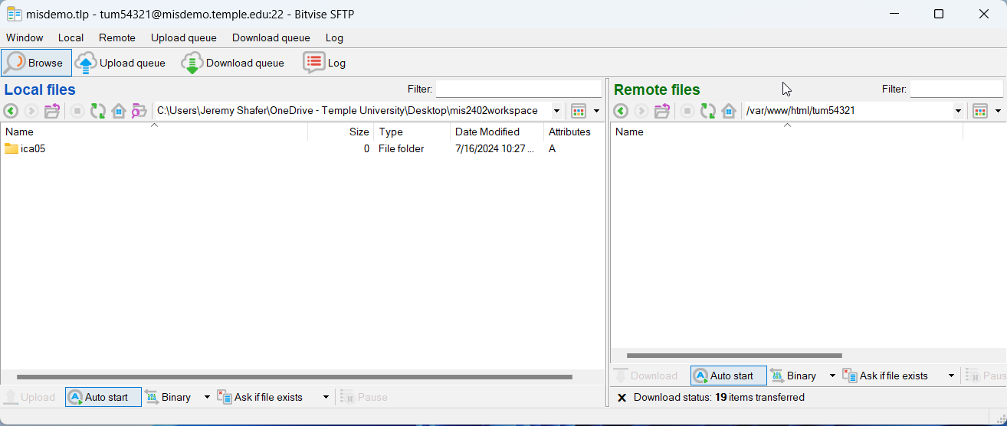

1. When you are all done you should be able to go into your browser and type in this URL in the address bar:

https://misdemo.temple.edu/***tuz54321***/ica05

* Of course, you would type your own username instead of ***tuz54321***
* You will be prompted to provide your MISDEMO username and password. This is expected and you need to do this once per browser session.

* You should see your work at that address!

1. Go to canvas and turn in the URL to your work on MISDEMO.

**A FINAL NOTE**

In this activity, you uploaded your work to a server, so that it could be accessed as a web page in a browser, from anywhere in the world over the https protocol. **That action is called “publishing”**. As the semester progresses, you will do more and more “publishing” and less and less uploading to canvas.

As of this moment, your instructor will expect you to know what it means to **publish** your work to misdemo.

MacBook users can’t use Bitvise, but they can use FileZilla on their personal computers.

Here is video ( for you to watch on your own time) that explains how to use FileZilla:  <https://youtu.be/KEmPzcJJPiM?si=g9BaVxQCFwajISc5>

**For future hands-on quizzes and the final exam, all students must use Bitvise because that is the software available in the classroom! In general, saying “I don’t know how to use Bitvise because I am a Mac user” is not acceptable.**

How will this activity be graded?

Your instructor will check your work for completion.

|  |  |
| --- | --- |
| Task | Points |
| natural.html works | 25 |
| ev.html works | 25 |
| cv.html works | 25 |
| Everything uploaded OK | 25 |
| **Total:** | 100 |