ICA07 – Simulating Calories Burned

SCENARIO 1:
Running on a treadmill a runner burns 4.2 calories per minute. Write a program that uses a loop to display the number of calories burned after 10, 15, 20, 25, 30, etc. minutes.

Your function should take an input, a variable named "iterations", and it returns a string of comma separated values.

If the iterations parameter has the value of 5, then your function's output should look like this:
42,63,84,105,126,

If the iterations parameter has the value of 6, then your function's output should look like this:
42,63,84,105,126,147,

Notice that, in this scenario, it is OK to have a comma at the end of the output. Also notice that there is no HTML input form in this scenario. The focus is on completing the function caloriesBurned1. When you are done, you should be able to issue commands from the Chrome Web Developer console like this:

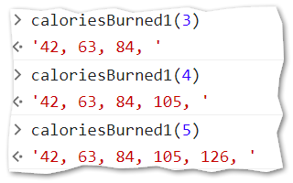

INSTRUCTIONS:

- Find a friend to work with. Retrieve the ica07_calories.zip provided by your instructor.
- Extract the code into your mis2402workspace and open the treadmill1.html file in Visual Studio Code.
- Write the code in the caloriesBurned1 function to get the output described above.
HINT: It will be to your advantage to first figure out how to generate the sequence 10, 15, 20, 25, etc. After you do that, the problem gets a lot easier. There is more than one way to do this!
ANOTHER HINT: Your goal here is to return a string. That means that you will need to have a variable that starts out as an empty string (‘’) and new values get concatenated to it with each step of the loop.

SCENARIO 2:

Loops can also be used to generate repetitive sequences of HTML. So, in this scenario your caloriesBurned2 function will generate an unordered list in HTML instead of comma separated values.

If you don’t remember the syntax for an unordered list in HTML, you will need to go look it up on W3Schools. https://www.w3schools.com/html//html_lists_unordered.asp

When you are done, you should be able to click the “Calculate” button and see output as shown below.

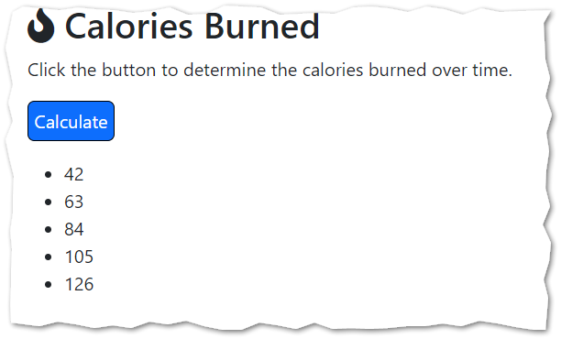

- Keep working with your friend. Open the treadmill2.html file in Visual Studio Code.
- Edit your code so that the function returns an HTML unordered list.
- As before, you should test your work using the Web Developer console. Below is an example: 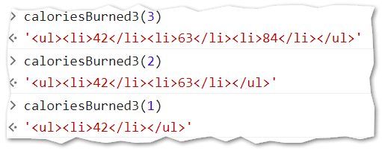
Observe that, in the example above, the HTML sequence begins with <ul> and ends with </ul>.
Also notice that there are no line breaks in the HTML sequence. Your browser does not care about line breaks when evaluating HTML!
- When you are done, upload your work to the class server. Turn in the URL to your index.html file using ICA07 found on canvas.

How will this activity be graded?
Your instructor will check your work for completion.
Task | Points
treadmill1.html | 50
treadmill2.html | 50
Total: | 100

