# ICA08 – Pythagoras

**INTRODUCTION:**

In class today we took a second look at numbers in JavaScript. In this activity we will do some important things.

1. Referencing the Pythagorean Theorem, we will use the Math object in JavaScript to calculate the value of c given a and b.
2. We will upload our calculator to misdemo.temple.edu
3. As you have done previously, you will test your work as a published web page. The URLs to your work will always follow a predictable pattern. You should come to understand that pattern.

As always, every student must submit their own work, even though you are likely to be working on this activity with a friend.

**SCENARIO:**

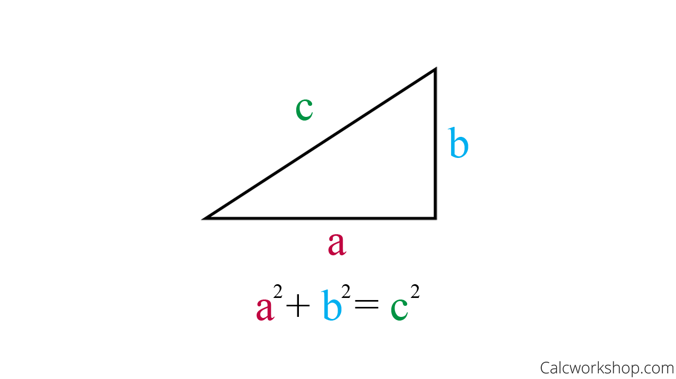

You will recall from Junior High / High School mathematics that the hypotenuse of a right triangle can be calculated with the following formula:

$$c= \sqrt{a^{2}+b^{2}}$$

**INSTRUCTIONS:**

1. Find a friend to work with. Retrieve the ica08calc.zip provided by your instructor.
2. Extract the code into your mis2402workspace and open the triangle.html file in Visual Studio Code.
3. Write the code in the calculateForC function to implement error trapping so that both a and b must be numbers greater than zero. If not, then the function should return “Bad data. Try again.”
4. Write the code in the calculateForC function to calculate the hypotenuse.
5. Make sure that your answer is returned, rounded to 2 decimal places.
6. Test your work.

**CONTINUED…**

**UPLOAD YOUR WORK:**

1. Open the Bitvise SSH Client on your Windows computer.



1. Use the username and password on the MIS Community site gradebook. You will need that in the following steps. ( <https://community.mis.temple.edu/gradebook> )
2. In Bitvise, specify your host, username, and nothing else. Leave the rest alone!

* The host is misdemo.temple.edu
* Click “Log in”.
* Type in your assigned password and click OK.

1. If you are logged in OK you will see the words “Authentication Completed” in the notification window.
2. Click on the “New SFTP Window” button.  
   A screenshot of a computer

   Description automatically generated
3. You will see a two-panel display. On the right panel, if you see a “wwwroot” folder, double click it so that you are in the root folder.
4. Drag the ica08calc folder from your local system (on the left) to the remote system (on the right). **You can, of course, drag files in the opposite direction as well.**
5. When you are all done you should be able to go into your browser and type in this URL in the address bar:

https://misdemo.temple.edu/***tuz54321***/ica08calc/triangle.html

* Of course, you would type your own username instead of ***tuz54321***
* You will be prompted to provide your MISDEMO username and password. This is expected and you need to do this once per browser session.

* You should see your working calculator at that address!

1. Go to canvas and turn in the URL to your work on MISDEMO.

How will this activity be graded?

Your instructor will check your work for completion.

|  |  |
| --- | --- |
| Task | Points |
| URL to triangle.html works | 30 |
| URL is correctly formatted (for example: you used the expected folder name, your URL starts with https:// etc.) | 30 |
| Calculator works as expected | 40 |
| **Total:** | 100 |