Assignment06 – Lemonade Hires
Business is booming at your lemonade stand. You need to hire some staff. That's why the lemonade stand job application form was created.
I'm this assignment you will write JavaScript to validate data provided on this form. You will use your knowledge of functions, strings and numbers to write this code.

Overview
Important notes:
- What we are doing in this assignment is called client-side form validation. We are making sure that the data, provided by the user, on the client, conforms to our expectations before we send it off to “the cloud”.
- You won't go beyond form validation in this assignment. That is, your data won't *really* be sent to “the cloud”. It will just look that way.
- If you use Google to research the topic of form validation, you might discover that there is a whole language dedicated to this kind of task. This language is called "Regular Expressions" or RegEx. Do not use RegEx for this assignment. For the sake of your learning, its best that you stick to the limited subset of string methods presented in class. To be clear: students must use the subset of string functions covered in class this week.
Here is the form.
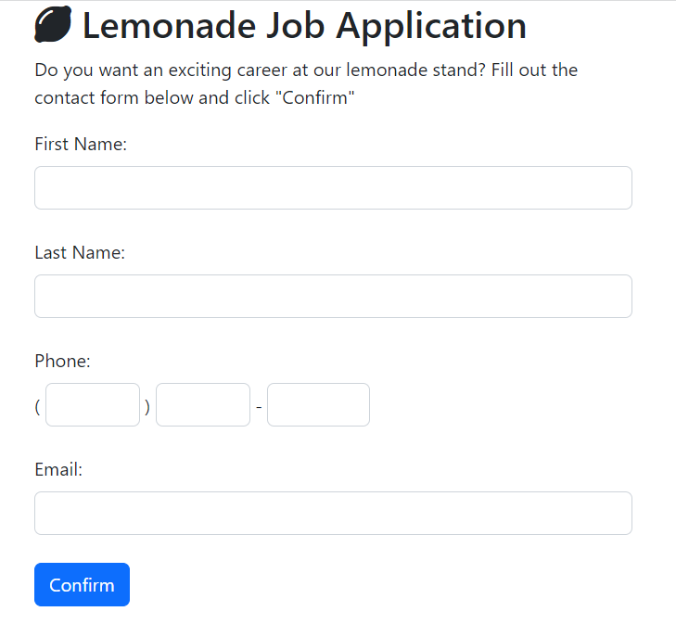

Instructions
- Download assignment06.zip as provided by your instructor.

- In the lemonhire.html file provided complete the following functions.
Function name | Comments
validLemonText | The validLemonText function accepts one parameter. If the parameter has at least one visible piece of text in it, the validLemonText function should return true. If the parameter is empty or all spaces, it should return false.  For example:  validLemonText('') //returns false  validLemonText('x') //returns true  validLemonText('xyz123') //returns true  validLemonText('0') //returns true
validLemonDigits | The validLemonDigits function accepts two parameters: digits and size. The function should return true if the parameter digits contains nothing but digits, and has a length equal to size.  Otherwise the function should return false.  For example:  validLemonDigits('321',3) //returns true  validLemonDigits('321',4) //returns false  //because '123'  //has a length of 3  validLemonDigits('99',3) //returns false  validLemonDigits('',3) //returns false  validLemonDigits('xyz',3) //returns false  validLemonDigits('0123456789',10) //true
ValidLemonEmail | The validLemonEmail function accepts one parameter. If the parameter “looks like” and email address then the function should return true. If not, it should return false.  Students should implement the following (greatly simplified) definition of a valid email address.  - A valid email address must contain exactly one @ character.  - A valid email address may not begin with @ or end with @.  - A valid email address must contain at least one dot “.”. Note that some email addresses may contain more than one dot.  Examples of valid email addresses:  - steve@test.com  - Steve.Martin@test.com  - martin@mail.test.com  - steve.martin@mail.test.com  Examples of invalid email addresses:  - stevetest.com  - @stevetest.com  - stevetest.com@  - steve@martin@test.com  - martin@com

- Then... when all the functions above are completed, tested, and working ... use those functions to complete the function called formLemonValidation.

Function name | Comments
formLemonValidation | The function formLemonValidation receives first name, last name, phone, and email address as parameters. It then calls the supporting functions validLemonText, validLemonDigits, validLemonEmail as necessary. The formLemonValidation function will return one of the following strings appropriately:  - Bad first name.  - Bad last name.  - Bad phone.  - Bad email.  - Got it. Thanks.  Your formLemonValidation function will only return one error at a time. This is true even if there is more than one thing wrong with the input. This is OK for the purposes of this assignment.

- Check your work.

Turn in your work
- Go to canvas and upload lemonhire.html to the corresponding assignment there.

