MIS2402 – Assignment 01

HTML, JavaScript Variables and Simple Math
To complete this assignment, you will need to use either Bitvise (if you are on a Windows computer) or Terminal and SSH (if you are on a Mac). If you don’t have either set up, you need to install them.
If you can’t install them for some reason, use a computer in a Fox lab or the TECH center.

Instructions:
- Connect to the class server. Use the username and password your instructor gave you. The class server’s hostname is: misdemo.temple.edu
- After your successful login, click the “New terminal console” icon in Bitvise.
- At the prompt, type:
cd wwwroot
- At the prompt, type in this wget command:
wget https://misdemo.temple.edu/assigments/assignment01.zip
- Unzip the file with an “unzip” command. This will create a file named algebra.html.
unzip assignment01.zip
Now, in Chrome, type this URL into your browser:
https://misdemo.temple.edu/tuz54321x/algebra.html
You should replace tuz54321x with your own account.
- You will be prompted to provide your misdemo username and password. After you do that. You should see a web page that looks like this:
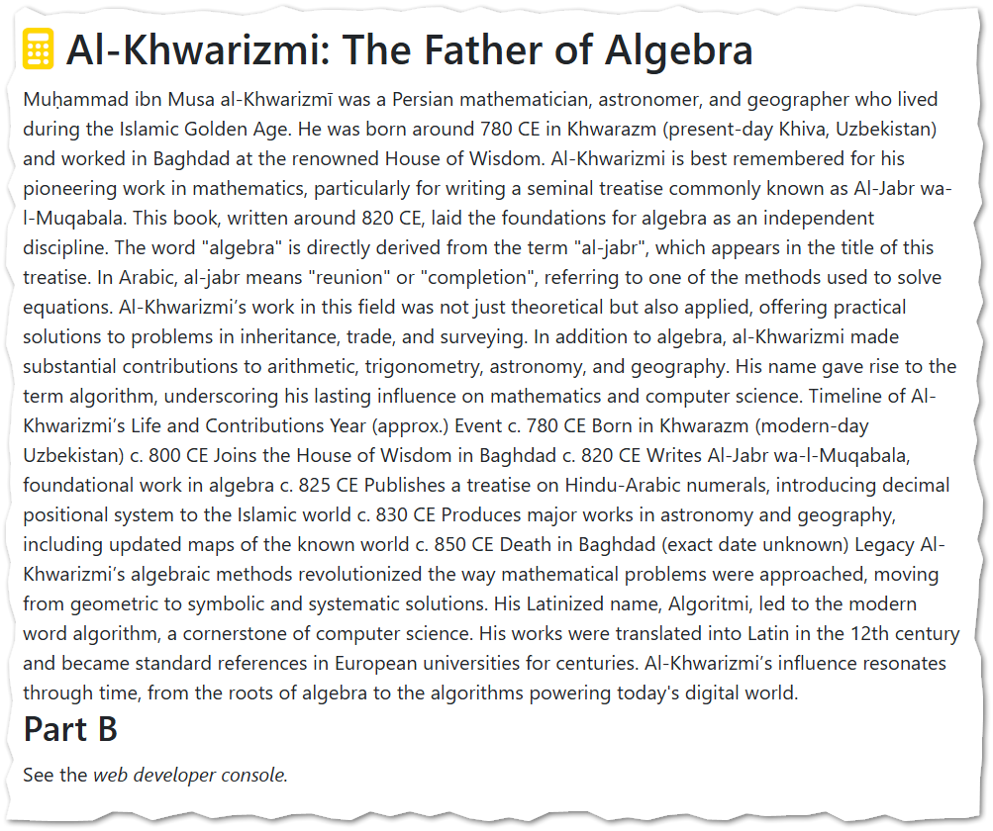
You will notice the calculator icon in the <h1> tag at the top of the page, as well as the <h2> tag for Part B. You can leave those parts of the page alone.
Your job is to use HTML to mark up the unstructured text. You should introduce HTML to create paragraphs, h2 headings, a list and a table. You should also use the italics tag <i> </i> to mark up the book title that appears in two places.
The following figure illustrates what it should look like when you are done.
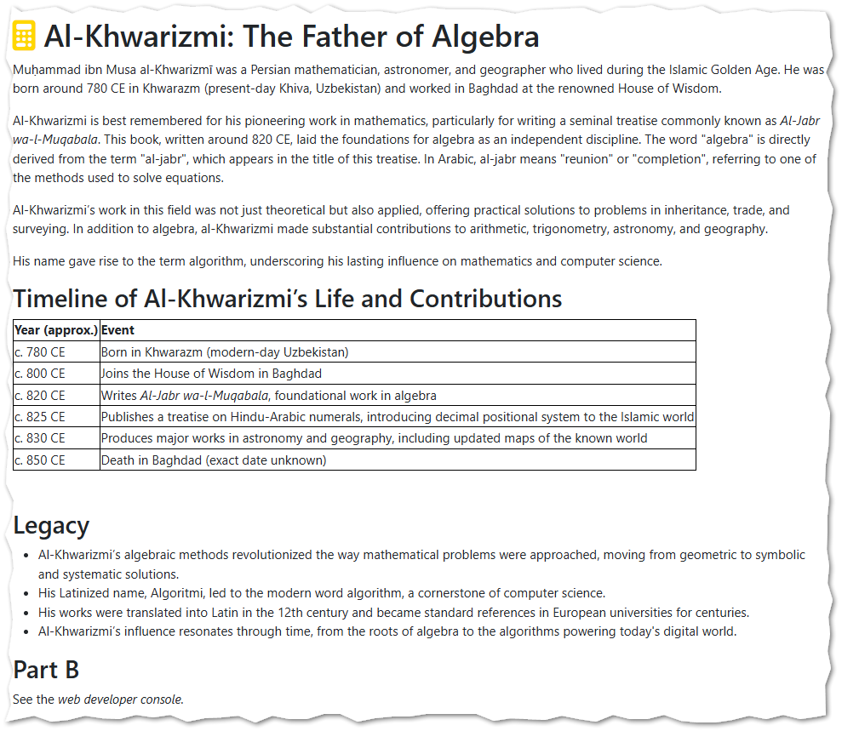

- Open your work in nano and make edits.
nano algebra.html
Save your work in nano when you are done (Control – O). Refresh your web page. Does it look like the screenshot provided?

Part B
Inside the <script> tag, use JavaScript to solve the problems below. (Al-Khwarizmi would have been proud!)

Scenario
Ancient Persian traders depart from the port city of Siraf, where they purchase 120 barrels of Shirazi wine at 12 dinars per barrel. They load all the barrels onto their ship and sail north to Bandar Nishapur, where wine sells for 20 dinars per barrel. (A dinar is a gold coin used in ancient times.)
They know they must pay a flat 50 dinar docking fee at the selling port.
How much profit do they plan to make?
- Start by creating a variable for totalcost.
let totalcost = 120 * 12; //buy 120 barrels at 12 dinars a barrel

- Now create a variable to hold the docking fee.
let dockingfee = 50;

- Now create a variable for totalprice.
let totalprice = 120 * 20; //sell 120 barrels at 20 dinars a barrel

- Now create a variable called profit and calculate the profit in terms of totalprice, totalcost, and dockingfee.

- Create a variable called fmtprofit and write it to the developer console. You don’t need to round but you do need to use concatenation to indicate that monetary unit is denars. So, if profit is 500, then the value of fmtprofit receives would be the string "500 dinars"
- A clever merchant realizes that if the wine is sold by the bottle, it can be sold at a higher price. The new plan is to transport the wine to Bandar Nishapur in barrels and then rebottle it there. You may assume that the wine bottles and the related labor are free.

You can get 60 bottles of wine from a barrel, and a single bottle of wine sells for half a dinar. In the questions that follow, we will use JavaScript to determine how many dinars the merchants can sell their wine for now. Declare a new variable called totalprice2 that determines the new price all the wine can be sold for.

- Now create a variable called profit2 and calculate the profit in terms of totalprice2, totalcost, and dockingfee.

- Create a variable called fmtprofit2 and write it to the developer console.
- Now we want to compare profit and profit2. What percentage gain in profit do they make with this new plan? Create a variable called percgain and using simple math, calculate the percentage gain.
What do you mean “percentage gain”? Well, if the first profit variable was 100 dinar, and the second profit variable was 200 dinar, that would be a 100.00% gain. It’s a gain because you started out with 100, and you made 100 percent more.

Still confused? Here’s another example. If you can sell a fancy donut for $3 and then figure out a clever way to sell that donut for a newer, higher price of $4.50 then that would be a 50% gain. It’s a 50% gain because you have the original amount ($3) plus $1.50 which is 50% more.

- Create fmtpercgain and write it to the developer console. It should be rounded to 2 decimal places, and use concatenation to put a “%” sign on the end.
Careful! When you round, you are expected to use the same approach we covered in class. If you don’t, you will receive a failing grade on this assignment.

- Save your work in nano. Refresh your web page. Check your work. Does your code run? Do your answers make sense?

- Determine the URL for your work. Go find the corresponding assignment on canvas and put the URL to your work here.

How will this assignment be graded?
100 – You provided a good, working URL, everything runs, and your answers are correct.
80 – Your code has one or two small problems (such as a miscalculation or a formatting problem)
50 – Your code has multiple problems, but it does not crash and you made an effort.
0 – Your code is missing, your code completely crashes, or you failed to provide a good URL.

