MIS2402 – In class activity – 04

JavaScript Variables and Simple Math

Instructions (with instructor’s help):
- Log into one of the workstations in the lab. Open the application named Bitvise.
- Connect to the class server. Your instructor will provide you with a username and password. The class server’s hostname is: misdemo.temple.edu
- After your successful login, click the “New terminal console” icon in Bitvise.
- At the prompt, type:
cd wwwroot
- At the prompt, type in this wget command:
wget https://misdemo.temple.edu/classexamples/ica04donuts.zip
- Unzip the file with an “unzip” command. This will create a file named ica04donuts.html.
unzip ica04donuts.zip
Now, in Chrome, type this URL into your browser:
https://misdemo.temple.edu/tuz54321x/ica04donuts.html
You should replace tuz54321x with your own account.
- You will be prompted to provide your misdemo username and password. After you do that. You should see a web page that looks like this:
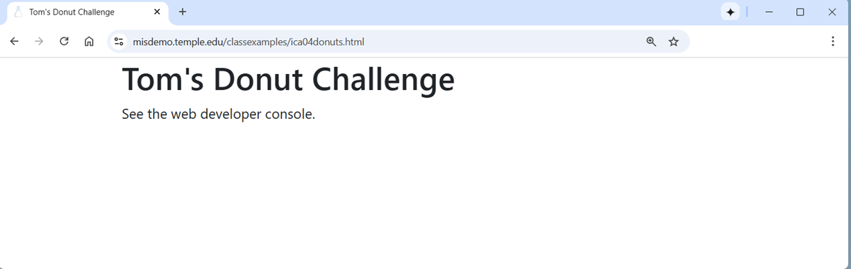
Hmm… looks we are going to see all our output in the developer console today.

- Open the developer console in Chrome.
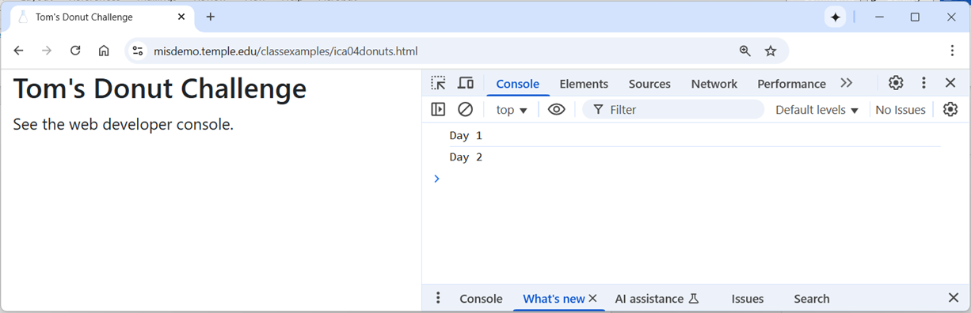
- Now, back in Bitvise, open the ica04donuts.html file with nano.
nano ica04dounts.html
- Instead of typing commands directly into the developer console (like we did during the lecture) we will instead edit the contents of the <script> tag in our html file.

Scenario
Tom is a popular and charismatic young man. But Tom is short on cash. Tom only has $20.00 in his wallet. Every day on his way to school he walks past Rizzo’s Donut Shop. Tom loves donuts, but he also needs to save his money. Tom is going to figure out a way to buy donuts, sell some to his friends, and either break even or come out ahead.
Tom has *a lot* of friends and he is totally sure that he will be able to sell all the donuts he wants to sell.
We will use JavaScript variables and simple math to help Tom figure out what to do.
Rizzo’s is an upscale donut shop, and the fancy donuts there are only sold by the dozen. A dozen Rizzo’s donuts cost $19.99. When you buy a dozen donuts at Rizzo’s, you get a “baker’s dozen”. A “baker’s dozen” of donuts is 13 donuts, not 12.

CONTINUED

Day 1
On day 1, Tom just wants to break even. He plans to buy a baker’s dozen of donuts, sell 12 to his friends, and eat one. He wants to figure out the purchase cost per donut, and the price he must sell each donut for.
- Find the “Day 1” console log statement inside the <script> tag. Create a variable named totalcost and assign it a value of 19.99. For example:
let totalcost = 19.99;
- Next, create another variable named costperdonut and, using the existing totalcost variable, assign it the value of totalcost divided by 13.

- Now create another variable named priceperdonut and, using the existing totalcost variable, calculate the price that Tom must charge his friends so that he can break even.

- Now create a new variable called fmttotalcost and use it to store a string, rounded to 2 decimal places, with a dollar sign prefix. The prefix “fmt” is short for “formatted”.
For example:

let fmttotalcost = "$" + totalcost.toFixed(2);
Notice the use of concatenation in the above example.
- Use console.log to report the fmttotalcost. For example:
console.log(fmttotalcost);
Save your work in nano (Control – O). Reload your web page by clicking on your browser’s refresh button to perform the calculations and see the results in the console log.

- Now create fmtcostperdonunt and fmtpriceperdonunt, assign them appropriately formatted values, and write the results to the console log. When you are done, save your work in nano and refresh the page in your browser.

In the developer console you should see:
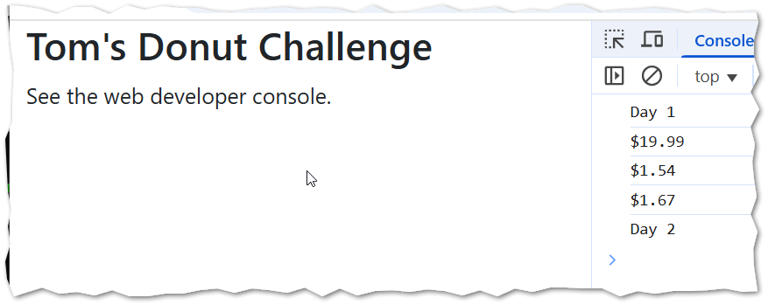
- DISCUSS: Are these the right answers? How will you know? How can you be sure?
Is there a better way to do this?
Of course there is. In programming there is always a better way to do something. And … similarly … there is always more than one way to arrive at the right answer. But what we are doing here is (perhaps) the easiest way for a new programmer with limited knowledge to solve this problem.
These instructions are designed to give you, the student, practice in creating variables.
How important are the variable names like “totalcost”?
There’s nothing magical about our variable name choices here. For example, we could have named the “totalcost” variable “tc” or “total_cost” or “totalCost” or “xyz123”. The variable name “xyz123” is not very helpful, but it would work!
The important thing is that the variable names we choose are helpful, memorable and that they are used consistently.
Food for thought
Many complex problems can be made more solvable by first considering what all the necessary variables are. Defining a few extra variables can make your code more flexible and easier to read.

CONTINUED

Day 2
Things went so well for Tom on day 1 that he is now getting more ambitious. Tom loves donuts so much that on day 2, Tom hopes to eat 3 donuts, sell 10 donuts to his friends at a higher price and also make a $5.00 profit.
- You don’t need to redefine the existing variables costperdonut and totalcost as they have not changed. You don’t need to redefine the fmtcostperdonut and fmttotalcost variables either.

- You do need to create 2 new variables priceperdonut2 and fmtpriceperdonut2 and, using simple math, assign them correct values.

- Under the “Day 2” console log statement, add these three statements. (The first parseInt statement really doesn’t do much. It is just for practice!)
console.log(parseInt(priceperdonut2));
console.log(priceperdonut2);
console.log(fmtpriceperdonut2);

- Save your work in nano. Refresh your web page. Check your work. Does your code run? Do your answers make sense?

- Determine the URL for your work. Go find the corresponding ICA on canvas and put the URL to your work here.

Summary
In this activity, you learned about JavaScript variables and simple math. You also learned how to put JavaScript commands into the <script> tag in an html file. This is good, because you want to be able to save your work and not just throw it away when the browser closes!
You practiced some simple problem solving, concatenation, the toFixed method and the parseInt function.

How will this ICA be graded?
100 – You provided a good, working URL, everything runs, and your answers are correct.
80 – Your code has one or two small problems (such as a miscalculation or a formatting problem)
50 – Your code has multiple problems, but it does not crash and you made an effort.
0 – Your code is missing, your code completely crashes, or you failed to provide a good URL.

