MIS2402 – In class activity – 05

JavaScript Functions, Variables and Simple Math

Instructions (with instructor’s help):
- Log into one of the workstations in the lab. Open the application named Bitvise.
- Connect to the class server. Your instructor will provide you with a username and password. The class server’s hostname is: misdemo.temple.edu
- After your successful login, click the “New terminal console” icon in Bitvise.
- At the prompt, type:
cd wwwroot
- At the prompt, type in this wget command:
wget https://misdemo.temple.edu/classexamples/ica05pies.zip
- Unzip the file with an “unzip” command. This will create a file named ica05pies.html.
unzip ica05pies.zip
Now, in Chrome, type this URL into your browser:
https://misdemo.temple.edu/tuz54321x/ica05pies.html
You should replace tuz54321x with your own account.
- You will be prompted to provide your misdemo username and password. After you do that. You should see a web page that looks like this:
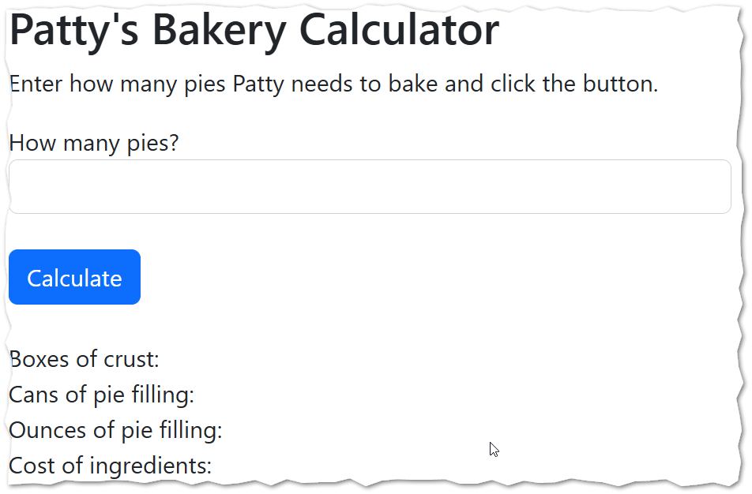

- Now, back in Bitvise, open the ica05pies.html file with nano.
nano ica05pies.html
- Look inside the <script> tag in our html file. We will edit the functions found there.

Scenario
Patty is an entrepreneurial young woman. Patty is very good at baking, and especially good at baking cherry pies. We are going to help Patty with her pie baking business.
To keep our imaginary scenario simple, we are going to pretend that Patty has access to her parents’ kitchen, where she has unlimited access to a conventional oven, and that she does not have to worry about things like paying the gas or the electric bill to make that oven work!
On the form you will find an input that allows Patty to enter how many pies she needs to prepare.
Our JavaScript functions will then calculate:
- How many boxes of pie crust she needs to buy
- How many cans of cherry pie filling she needs to buy
- How many ounces of cherry pie filling she needs (in case she can get it cheaper if she buys it in larger quantities)
- How much her ingredients will cost

- Find the function “calcBoxes” and complete it. Patty can make two pies with a box of premade pie crusts. So, that gets a little tricky… to make one pie, she needs a box of crusts. To make two pies, she needs a box of pie crusts. To make three pies, she needs two boxes of pie crusts (and she would have one crust left over!)
How will we solve this? We will need to divide the number of pies by two and then round up. How can we do that? JavaScript gives us a “ceiling” function that will round up to the next integer for us. Careful! The “M” in “Math.ceil()” is upper case and the method is spelled C – E – I - L

Here is some code to help you with the calcBoxes function.
let answer = pies / 2;
answer = Math.ceil(answer); //reassignment
return answer;

What is going on with return here?
You are not using console.log here in this activity, and that is new. You are instead writing functions. Each function returns a value. Then jQuery commands (already written for you) place those values in the inner HTML of tags that already exist on the web page.

- Test your work. Notice that we are taking it on faith that the user will enter a nice, reasonable number in the text box. That is ok for this week, but soon we will need to think about how to deal with incorrect or unexpected values that a user might provide as input.
- Complete the “calcCans” function. One pie requires two cans of pie filling. Be sure to return your answer.
- Complete the “calcOunces” function. One can of pie filling contains 21 ounces of filling. There are a few ways you could solve this. You could just multiply the number of pies by 42 and get the correct answer. But, instead, consider this:
let answer = calcCans(pies) * 21;
This approach is self-documenting … that is you can look at it and quickly surmise that I am first determining the number of cans I need and then multiply by the 21 ounces.

- Complete the “calcCost” function using the existing “calcBoxes” and “calcCans” function. A box of pie crusts costs $4.29 and a can of pie filling costs $3.50.
Your calcCost function should return an answer that looks like a dollar value (that is, round your answer to two decimal places using toFixed and put a “$” in front of it!)
CONTINUED

- Save your work in nano. Refresh your web page. Check your work. Does your code run? Do your answers make sense? Here is some sample output:
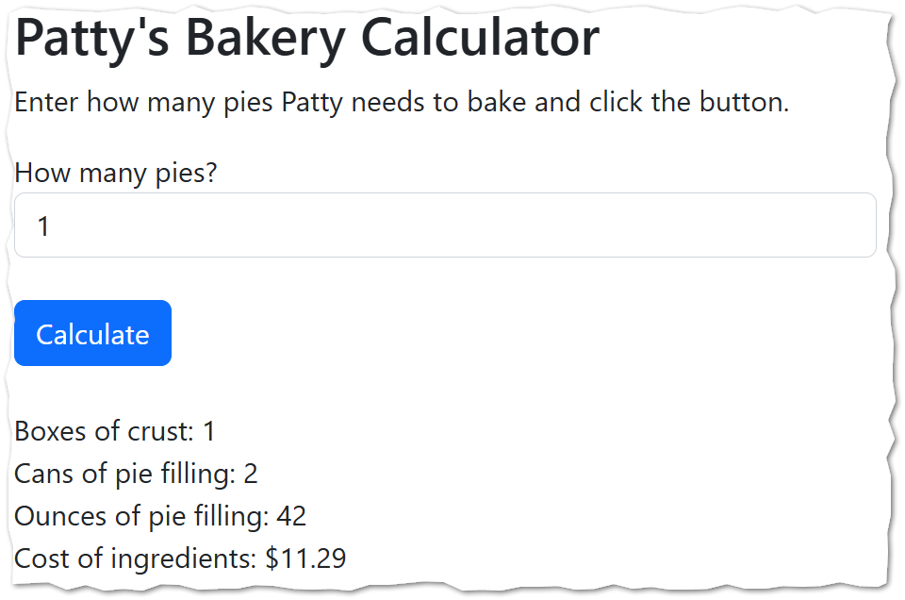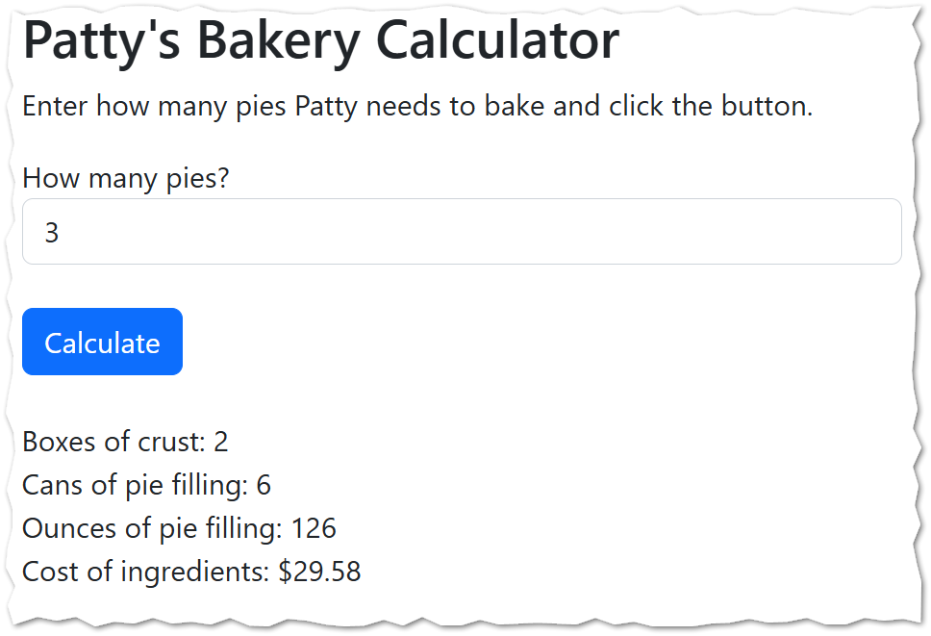

- Determine the URL for your work. Go find the corresponding ICA on canvas and put the URL to your work here.

Summary
In this activity, you learned about JavaScript functions. You saw how a function, once correctly defined, can be reused elsewhere in code.
You also learned how to round up a value to the next greatest integer using Math.ceil

How will this ICA be graded?
100 – You provided a good, working URL, everything runs, and your answers are correct.
80 – Your code has one or two small problems (such as a miscalculation or a formatting problem)
50 – Your code has multiple problems, but it does not crash and you made an effort.
0 – Your code is missing, your code completely crashes, or you failed to provide a good URL.

