MIS2402 – In class activity – 06

JavaScript Conditional Statements and Pseudo Code
Notes: Today’s lecture was a little long, so this In-class activity is intentionally shorter than normal. Instead of writing code, students are expected to read code and translate it into their own words (pseudo code.)

Instructions:
- Visit this web page: https://misdemo.temple.edu/classexamples/numbertests.html
- Enter different values and see what happens. Be sure to watch the web developer console as well.
- Observe that if you enter a non-numeric value it the box, and click “Go” you see “Test 1” written to the console log. But if you enter a number, you will see “Test 1”, “Test 2”, “Test 3” and “Test 4”. Something appears to be making the function stop abruptly. Whatever could it be?

- Right click on the page and (assuming you are using Chrome) choose “View page source”
- Observe line 34, 35, and 36 in the code found there. 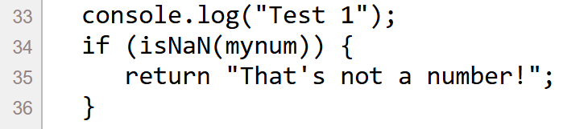
In the box below, write your pseudo code for this statement.

- When the return statement runs on line 35, does the numbertests function stop executing? Or does it continue? Write either “stops” or “continues” in the box below.

- Now look at lines 42 through 52 in the code. In the box below, write pseudo code that explains what is happening on those lines of code.

- The function “wholenumbertest” contains an example of input validation. Express this input validation as pseudo code on the box below. Be sure to describe the purpose of “return” as it is used here.
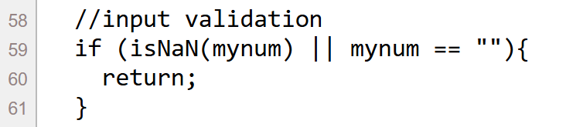

- Lines 63 through 68 are the heart of the “wholenumbertest” function. Write your pseudo code for these lines of code in the box below.

- In the last question, an “if else” statement was used. Was this really necessary? Why or why not?

- When you have filled in your answers. Save your word document and upload it to the corresponding activity on canvas.

Summary
In this activity, you learned about JavaScript conditional statements. You saw an example of input validation. You also saw how the return statement can be used to terminate a function.

How will this ICA be graded?
100 – All questions were answered and your answers are correct.
80 – You made one or two inaccurate or vague statements.
50 – Your answers have multiple problems, but you made an effort.
0 – Answers missing / not provided.

