MIS2402 – In class activity – 07

Clean up and more practice with conditional statements

Part A – Clean Up - Instructions (with instructor’s help):
You now have a lot of zip files lying around on the class server. These can be deleted. Also, we are going to learn how to make a folder, and we’ll also see how that folder changes the URL where your work is published.
- Log into one of the workstations in the lab. Open the application named Bitvise.
- Connect to the class server. The class server’s hostname is: misdemo.temple.edu
- After your successful login, click the “New terminal console” icon in Bitvise.
- At the prompt, type:
ls
… and press enter. This (as you know) is the Linux list command. It shows you all the files in the current folder. In your folder you will see the file scangengerhunt.zip , the folder scanvengerhunt , and the special wwwroot folder.
- At the prompt, enter in this command:
rm scavengerhunt.zip
This command will remove the scanvengerhunt.zip file. The command rm is short for remove. (And, yes, “removing” and “deleting” are the same thing!)
If you are not sure that it worked, enter the ls command again and look for it. The zip file should be gone!
- Do you have any other zip files lying around there in your home folder? If so, delete those too.
Play it safe (for now) and only delete zip files.

When you are done, change to your web root folder by entering this command:
cd wwwroot
If you ever need to go back to your home folder, you can enter the command:

cd ~

In Linux the tilde character (~) is special. It means “home”.

- Now, working in your wwwroot folder, enter an ls command.
You should see one zip file for every activity and assignment you have worked on this semester. The zip files were just used to get you started in each activity, and you don’t need them anymore.
- Type a rm statement and press enter for each one of your zip files until there are none left. ONLY DELETE THE ZIP FILES. DO NOT DELETE YOUR HTML FILES.
- Now, while still in your wwwroot folder, enter these two commands:
mkdir pies
cp ica05pies.html pies/example.html
Careful! The direction of the slash is important. Use a forward slash as shown above (note forward “/” versus backward “\”). The first command ( mkdir ) made a directory named pies. The second command ( cp ) copied your ica05pies.html file into the pies folder and gave it a new name: example.html.
Now, in Chrome, type this URL into your browser:
https://misdemo.temple.edu/tuz54321x/pies/example.html
You should replace tuz54321x with your own account.
- You will be prompted to provide your misdemo username and password. After you do that. You should see a web page that looks like this:
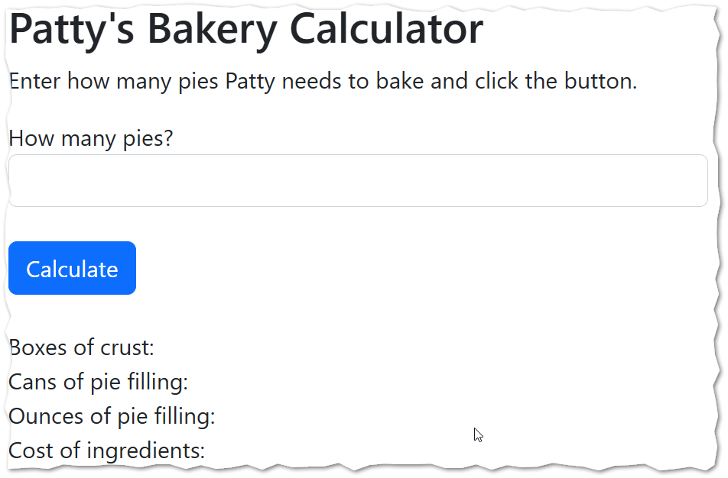
Look at your browser’s address bar. The “pies” folder you created in a prior step here became part of the URL.
This is an important idea: the files and folders you create in your wwwroot are broadcast to the World Wide Web. The web server software (Apache) running on MISDEMO is responsible for making those folders and files available to the world at URLs.
- In part B of this activity, we will wget and unzip a file (as always). But today’s zip file will be special. It will create a folder and a file. This will be standard, expected behavior from this point onward.
From here on out, you, the student, need to be comfortable enough with ls and cd commands to find your work so you can edit it with nano.

Part B – Conditional Statements at an airport check-in counter
We are going to write a little “helper” application that represents logic to be used at an (imaginary) airport check-in counter. Imagine that the employee at the counter just can’t quite remember what all the rules are, and that they need an application to help them know what to do next. Either that, or perhaps this application could be used to help train new employees!
We will see how JavaScript if statements can be used to do two things: validate user input and implement business rules.
The business rules for our imaginary check-in counter are represented by the flowchart diagram at the end of this document. Notice that the workflow represented there is used to determine one of two outcomes … either “No (Deny)” or “Yes (Admit)” … to admit in this case means print the boarding pass and send the customer to the TSA security checkpoint.
The “kiosk” mentioned at the start of the flowchart represents all those security questions you get asked before talking to a human being, things like: “are you carrying lithium batteries in your luggage?" If the customer gets past the kiosk, you can assume that they have a valid ticket.
- At the prompt, enter these commands, one at a time:
cd ~
cd wwwroot
wget https://misdemo.temple.edu/classexamples/ica07airport.zip
unzip ica07airport.zip
cd ica07
nano airport.html
- Now, in Chrome, type this URL into your browser:
https://misdemo.temple.edu/tuz54321x/ica07/airport.html
You should replace tuz54321x with your own account.
You will be prompted to provide your misdemo username and password. After you do that. You should see a web page that looks like this:
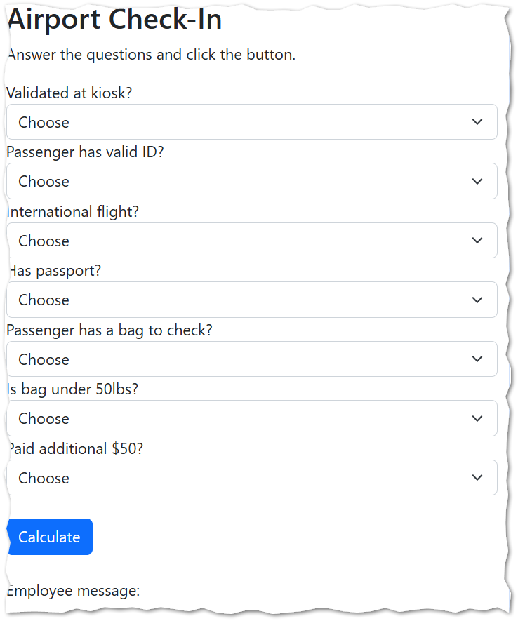
- Before we start writing JavaScript code, you should pay attention to some HTML tags we have not seen before. The HTML select tag allows us to create dropdown lists in an HTML form.
For example, look at lines 21 through 26.
<label for="textInputA">Validated at kiosk?</label>
<select id="textInputA" class="form-select">
<option value="">Choose</option>
<option value="N">No</option>
<option value="Y">Yes</option>
</select>

This HTML code indicates that there is an HTML select list, with an id of textInputA. The list allows the user to pick one of three options from the list: “Choose”, “No”, and “Yes” and each one of those options has a corresponding value (any empty string, “N”, and “Y”).

The tag attribute class="form-select" is not strictly necessary, but it makes the selection list look a lot nicer. This attribute is applying a CSS style to the select tag to make it look nice.

The HTML select tag is very useful, because it prevents users from entering unexpected values. This can greatly simplify the logic of input validation!

- We should also note that there is a label tag that tells the browser which form element corresponds to a particular piece of label text. In the example above, we see that the words “Validated at kiosk?” are for the form element with id textInputA.
Our application will run just fine without labels tags, but including good, correct labels for form inputs is universally accepted as a best practice.
Notice that if you are in Chrome, and you click on the text “Validated at kiosk” the browser somehow knows to put your focus on that textInputA select list. How does it know? Does it have the notion of tags being next to each other? Does it use AI??
Nope. The browser is nowhere near that smart. The browser only “knows” what HTML form tag, goes with what label text, because of the for attribute of the label tag!

- Your first challenge is to complete the validateForm function. The whole form is considered valid if every question has been answered. Notice here that the task of validating the form is different from the purpose of the next function that should determine if the customer will be admitted (given a boarding pass and sent to a gate) or denied.

Look at lines 84-87 in the code:

// see box A on the diagram
if (kioskok == ""){
return "N";
}

This logic says, in essence: “if the kiosk question has not been answered, stop, go no further, the form is not valid.”

Now you need a conditional statement like this for each one of variables that have been sent to the function. Write those input statements.

IMPORTANT: We are not using the flowchart diagram yet. That comes in a later step.

- Now, look at lines that implement the click event handler (they are shown below). Don’t change anything here. Work with a friend in the classroom to translate this code into Pseudo code. You should be able to explain this code in a few sentences. Put your pseudo code in the box below.
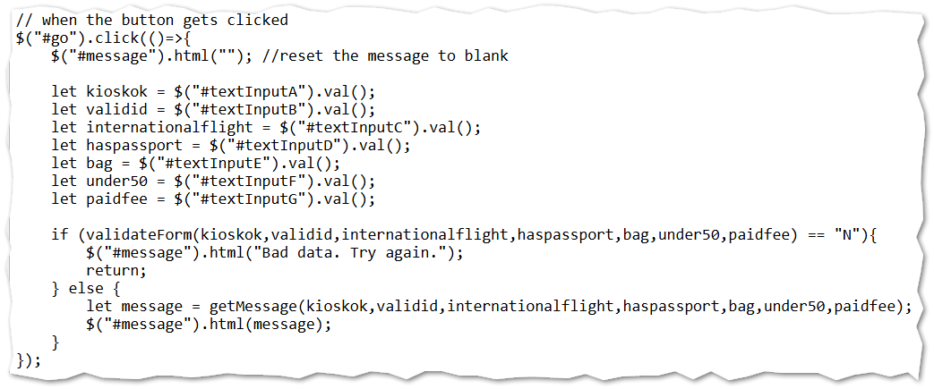
YOUR PSEDUO CODE:

- OK. Now it is time to translate our flowchart into code. Complete the getMessage function so that the values of answeryes and answerno are returned appropriately.
There is more than one correct way to write this code, but be sure to limit yourself to syntax we have covered in class.
It would be advisable to work your way systematically down through the logic of the flowchart. In some places, students will find using either “and logic” ( && ) or “or logic” ( || ) to be helpful.
For example: if a customer has a bag, and it weighs more than 50 lbs, and they have paid the extra handling fee then they should be admitted.

- When you have written your code, test your work. Pay extra close attention to cases where the flight is / is not an international flight, and cases where the customer does / does not have a bag to check.
There are no big surprises in the logic here. Like, if a customer doesn’t have a passport, we should not let them on an international flight! But, if you are in doubt, consult the flowchart diagram. The flowchart diagram is your authoritative source here.

- Determine the URL for your work. Put it in this box:

- Go find the corresponding ICA on canvas and upload this word document there.

Summary
In Part A of this activity, we learned a few new Linux commands and deleted some files that we no longer needed. You also learned how to put your work in subfolders that are under your web root.
In Part B, you had the opportunity to practice using conditional statements some more. You used conditional statements for validation and also to implement some business rules.

How will this ICA be graded?
100 – You provided a good, working URL, everything runs, and your answers are correct.
80 – Your code has one or two small problems (such as a miscalculation or a formatting problem)
50 – Your code has multiple problems, but it does not crash and you made an effort.
0 – Your code is missing, your code completely crashes, or you failed to provide a good URL.

Flowchart Diagram / Business Rules

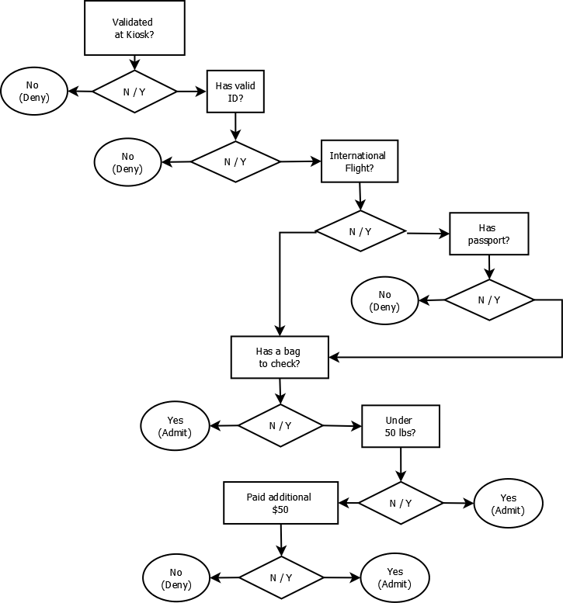

While flowchart diagrams are time-consuming to produce, and of limited value in day-to-day work, they can come in handy sometimes. At the very least, they can be authoritative documentation.
- The diagram is read from top to bottom.
- The diamond shape consistently represents a decision. The “Yes” decisions consistently flow to the right (the direction we read in), and the “No” decisions flow to the left.
- The oval shape consistently represents the end of the flowchart: the Yes (Admit) or No (Deny) outcome
- The letters A – G are not typically part of a flowchart diagram. They are added to help students complete the activity

