MIS2402 – Assignment 06: Coin Flip Simulation

Scenario
In this assignment you will use JavaScript’s Math.random() to simulate repeated flips of a fair coin. A “fair” coin has a 50% chance of coming up “Heads” and a 50% chance of coming up “Tails”
You will use Math.random(), loops, input validation and return values together to create the simulation.

Step‑by‑Step Instructions
- Log in to the class server. Use the username and password your instructor gave you. The server’s address is misdemo.temple.edu. After you log in, click the New terminal console icon in Bitvise.
- Download and prepare the assignment. At the prompt, type each of these commands exactly as shown:
cd wwwroot
wget https://misdemo.temple.edu/assignments/assignment06.zip
unzip assignment06.zip
rm assignment06.zip
cd assignment06
- Open the start file in your browser. Replace <yourusername> with your own account name:
- https://misdemo.temple.edu/<yourusername>/assignment06/coinflip.html
- You should see a form with a single text box and a “Run Simulation” button. If so, you are ready to begin.
- Open the HTML file for editing. Return to your terminal and open the page with nano:
nano coinflip.html
- Scroll down to the <script> tag near the bottom. You will see one empty function: flipCoin. Write your code inside these functions. Do not change the names or parameters.
- Complete flipCoin(). This function has one parameter n. This number governs the number of coinflips that will be simulated. So, if n is 1, your loop will iterate once. If n is 100, your loop will iterate 100 times. The value of n is determined by whatever the user types into the HTML form.
  - Use parseInt() and reassignment to convert n to an integer.
  - If n is not a number, or if n is less than or equal to 0, return “Bad data. Try again.”
  - Declare a variable named heads and set it to 0. You will use this to count the number of times the coin comes up “Heads”
  - Declare a variable named tails and set it to 0. You will use this to count the number of times the coin comes up “Tails”
  - Write a for loop that iterates n times.
  - Inside the loop, use Math.random() and if statements to add one to either heads or tails.
    - How to do it? Put the result of Math.random() in a variable.
    - If the variable is greater than 0.5 then call that outcome “heads” otherwise call the outcome as “tails”
  - At the end of the function use concatenation to return a string similar to the following:
Heads: 99, Tails: 99 (Here, of course “99” is just a placeholder for the number of heads and tails)

  - Save your file and test in the Chrome developer console by typing flipCoin(10);. The function should return the string showing the number of heads and tails.
  - IMPORTANT: Math.random() is … random! That means that you will get slightly different answers every time you run your simulation.
- Save and test your code. Press Ctrl‑O to save in nano and refresh your browser page. Click the button to verify that the correct results appear. ( Some sample screenshots are on the next page.)
- Determine the URL to your improved treadmill page. It will look like:
- https://misdemo.temple.edu/<yourusername>/assignment06/coinflip.html
- Replace <yourusername> with your own account and test the link to make sure it works.
- Go to the assignment in Canvas and paste your URL into the submission field. Be sure your page loads without errors.

Facts & Formulas
- Use parseInt() to convert strings to numbers when reading the value from the text input.
- Use isNaN() to determine whether a value is not a valid number.
- The Math.random() method of JavaScript will return a floating-point number somewhere between 0 and 1. You can test if the number is greater than 0.50 to determine Heads versus Tails.

Hints & Reminders
- Always begin a function with parameters by validating the inputs. Return the error message immediately if the data is bad.
- Use return to send a result back to the caller. Do not rely on console.log() for the final answer.

Grading rubric:
- 100 points: You provided a valid URL, all three functions work correctly, and your code follows the rules.
- 80 points: Minor problems such as a small miscalculation or formatting issue.
- 50 points: Multiple problems but the page does not crash and you attempted the assignment.
- 0 points: The file is missing, the URL is wrong, or the code uses features not covered in class.

SAMPLE OUTPUT
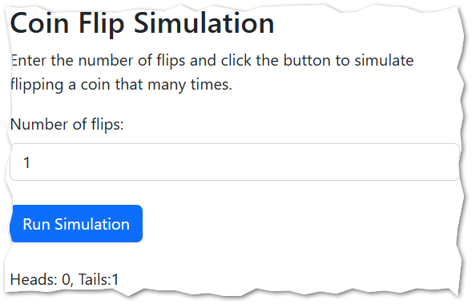
If “Number of flips” is 1 then you will get either
Heads: 0, Tails: 1
or
Heads: 1, Tails: 0
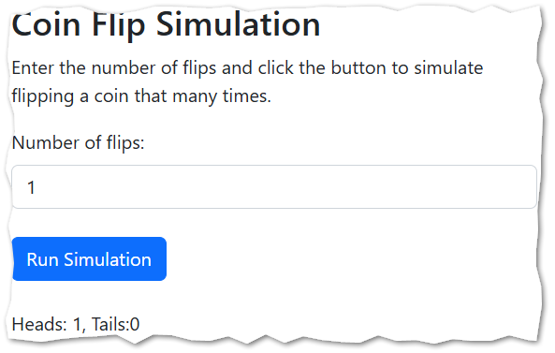
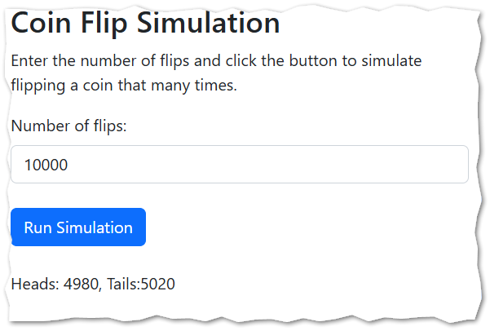
The bigger n gets, the closer you get to a 50% heads, 50% tails.

