MIS2402 – In class activity – 08

JavaScript loops and treadmill simulation

Overview
The first three functions in this activity are practice problems that help you learn how a for loop repeats a task. The last three functions simulate calories burned on an imaginary treadmill.
Sample output is provided at the end of this document.

Step‑by‑step instructions
- Log into one of the workstations in the lab and open Bitvise. Connect to the class server. The server’s hostname is misdemo.temple.edu.
- At the prompt, navigate to your web directory by entering:
cd wwwroot
- Download the starter file by entering:
wget https://misdemo.temple.edu/classexamples/ica08treadmill.zip
- Unzip the file by entering the command:
unzip ica08treadmill.zip
- Clean up your zip file by entering:
rm ica08treadmill.zip
- Change your directory by entering:
cd ica08
- Open the HTML file in a text editor by typing nano treadmill.html and pressing Enter. Review the extensive comments in the file; they tell you exactly what each function should do. As you work, don’t forget to save your changes using Ctrl+O
- Open up treadmill.html using Chrome. The URL to your work will look like: https://misdemo.temple.edu/yourusername/ica08/treadmill.html
As you work, don’t forget to refresh this page.
- Complete the practice functions that correlate to the first three buttons on the HTML page:
  - In example1, write a for loop that prints the numbers 1 through 10 to the console.
  - In example2, write a for loop that prints the numbers 10 down to 1 to the console.
  - In example3, write a for loop that prints the multiples of 5 from 5 through 30 to the console.
- These practice loops use console.log() to show output. This is not of any practical value, but it is very good for a learning / practice activity!

- Complete the treadmill functions that correlate to the last three buttons on the HTML page.
A person running for ten minutes on our imaginary treadmill burns 148 calories. We want to use a loop to calculate how many calories we will burn in an hour. Using a loop for this may seem like an overly elaborate approach, as you could just answer this question with some simple math.
However, with a loop, you can both calculate the correct answer, and also show the user step by step where that answer came from. (As seen in simulation3.)

- simulation1
  - Create a variable named totalcalories and set it to 0. Write a for loop that counts by 10 from 10 up to 60.
  - Inside each iteration, add 148 to totalcalories and use console.log() to display the running total.
  - After the loop finishes, return the message "See the console log." so the web page displays a simple message.
- simulation2
  - Start with declaring totalcalories again. Write the same for loop counting by tens. but this time do not call console.log().
  - Instead, after the loop completes, return totalcalories. Returning a value allows the HTML page to show the number of calories burned instead of printing to the console.
- simulation3
  - Begin with two variables: totalcalories and progress.
  - The variables: totalcalories will be used to hold the current value. Give it an initial value of 0.
  - The variable progress should be a string with an initial value of “” (the empty string). We will add to this string in each iteration of the loop. This variable will represent the progress of calories burned, over time.
  - Write the familiar for loop. In each iteration add 148 to totalcalories and also use concatenation to append the new total plus a comma (“,”) to progress.
  - At the end of the loop, return progress.
  - This produces a comma‑separated list of cumulative calories that you can display on the page. You should see computed output like this:
148, 296,444,592,740,888,
You might be asking yourself … “how do I get rid of that comma on the end of the string?” Good question! You will do that in the assignment that follows this activity.

- When done, submit your URL to the corresponding activity on Canvas.

Hints & reminders
- This activity illustrates how it is important to think ahead and declare all variables with let at the start of your function.
- Use console.log() only when you are practicing or troubleshooting. When the result should appear on the page, return a value from your function instead. A return statement sends the result back to the code in the click event handler.
- When building a progress string, begin with an empty string ("") and concatenation to append new values.

Sample Output
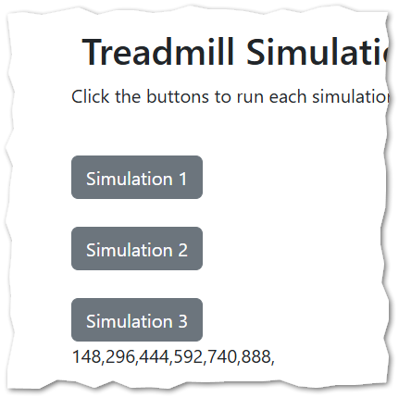
There is an extra comma here. That’s OK for the in-class activity, but we will fix it in the assignment!

