# MIS2402 – In class activity 09 – Pythagoras

## JavaScript Math (Square Root)

### Overview

In class today we took a second look at numbers in JavaScript. In this activity, referencing the Pythagorean Theorem, we will use the Math object in JavaScript to calculate the value of c given a and b.

As always, every student must submit their own work, even though you are likely to be working on this activity with a friend.

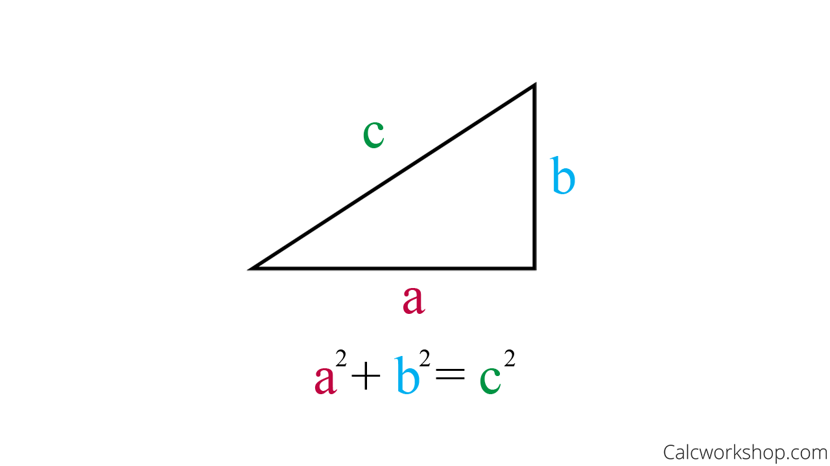

You will recall from Junior High / High School mathematics that the hypotenuse of a right triangle can be calculated with the following formula:

$$c= \sqrt{a^{2}+b^{2}}$$

### Step‑by‑step instructions

1. Log into one of the workstations in the lab and open Bitvise. Connect to the class server. The server’s hostname is **misdemo.temple.edu**.
2. At the prompt, navigate to your web directory by entering:   
   cd wwwroot
3. Download the starter file by entering:  
    wget https://misdemo.temple.edu/classexamples/ica09triangle.zip
4. Unzip the file by entering the command:  
   unzip ica09triangle.zip
5. Clean up your zip file by entering:  
   rm ica09triangle.zip
6. Change your directory by entering:  
   cd ica09
7. Open the HTML file in a text editor by typing nano triangle.html and pressing Enter. As you work, don’t forget to save your changes using **Ctrl+O**
8. Open triangle.html using Chrome. The URL to your work will look like: https://misdemo.temple.edu/yourusername/ica09/triangle.html

As you work, don’t forget to refresh this page.

1. Write the code in the calculateForC function to implement input validation (a.k.a. “error trapping”) so that both a and b must be numbers greater than zero. If not, then the function should return “Bad data. Try again.”
2. Write the code in the calculateForC function to calculate the hypotenuse.
3. Make sure that your answer is returned, **rounded to 2 decimal places.**
4. Test your work.
5. When done, submit your URL to the corresponding activity on Canvas.

### Hints & reminders

* Don’t forget that you can use return to quit a function. There’s no need to create elaborate if / else if conditional statements.
* Use parenthesis to enforce order of operations.
* There is more than one way to square a variable x
  + You could use Math.pow(x,2)
  + Or .. you could simply multiply x by itself: x*x
* There is more than one way to take the square root of a variable x
  + You could use Math.sqrt(x)
  + Or .. you could use Math.pow(x,0.5)
* Use console.log() only when you are practicing or troubleshooting.

### Sample Output

