Find the Owls -- JavaScript functions – Assignment08

In this assignment, students will complete code to create a game. This game can be best built using logical operators. In JavaScript a logical operator can be used to construct a compound Boolean expression.

THE GAME: In this game there are two owls hiding somewhere in a 5 x 5 table. In this table, the rows are labelled A,B,C,D,E and the rows are numbered 1,2,3,4,5. Each <td> tag in the table has an id. The tag id is the combination of the row and column. For example, A1, A2, A3, A4, A5, B1, B2, etc.

To play the game, a user must guess where the owl is. To make a guess the user will the column letter, specify the row number, and click the “Check” button.

Instructions/Notes:
- In this version of the game, the owls are always in the same spots (A1 and B5). Adding some randomness into the game would make it more fun, but also harder to write. For now, just assume that the owls are always hiding in the same two places.
- If the user omits either the row or column, the checkTable function should return the text “Bad data. Try again.”
  - The row should be a letter: A,B,C,D or E.
  - The column should be a number: 1,2,3,4 or 5.
- If the user guesses incorrectly (no owl found) then put an X in the cell. The function should then return the string “Keep playing…”.
- If the user guesses correctly then put the text “Hoo Hoo!” in the cell. The function should then return either the string “Keep playing…” or if the user has found both owls, the function should return “You Win!”

Using the start file provided complete the function checkTable. You will need to write multiple if statements. There are many acceptable approaches to solving this challenge. Some will use lots of compound Boolean expressions, and some will use very few. It’s up to you.

When you are done with your code, use paper and pencil to draw (by hand) a flowchart that describes the conditional statements that you wrote. For full credit on the assignment, turn your hand-drawn diagram into the instructor when the class next meets after the due date / time. Be sure to put your name on your paper.

Students may find it to their advantage to draw this sketch before attempting to write the code.

Getting started
- Retrieve assignment08_owls.zip provided by your instructor.
- Read the instructions found in the zip file.
- There’s a bug in the HTML section of the assignment.

CONTINUED…

The button on the web page looks like this:
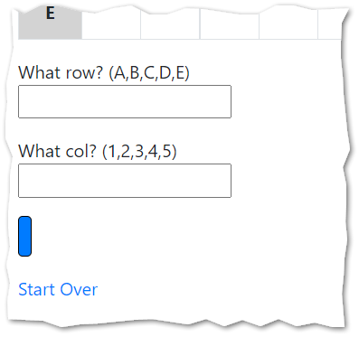
But it is supposed to look like this:
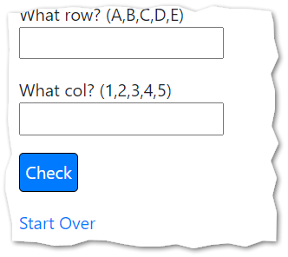
Can you fix it?
- After you fix your HTML problem, review the contents of the start file. Look at the HTML and note how the <td> tags are identified. Also review the contents of the click event handler. You should be able to read and follow the purpose and logic of the code there.
NOTE: The global variables: owl1found, owl2found, owl1, and owl2 play an important role in this assignment.
- Complete the solution by completing the checkTable function.
NOTE: If you are having difficulty envisioning how the final solution should work, please see this short video: https://youtu.be/NV5PNrwH36Q (there is no audio in this video.)
- Test your work.
- Draw a hand-written diagram that illustrates your logic. The logic in your code needs to match the logic of your diagram and vice versa.
- Upload your work. Be sure that you can find your work on the class server by typing in its URL in the browser. Test your work *again* on the class server.
For example:
https://misdemo.temple.edu/tux99999/assignment08_owls

How will this assignment be graded?

Item | Point Value
All folders uploaded OK?  (solutions must be exactly where requested!) | 10
Report “Bad data. Try again.” If column not a number. | 10
Report “Bad data. Try again.” If column or row is out of bounds. | 10
Report “Keep playing…” as expected. | 10
Report “You Win!” as expected. | 10
Cells are populated with “X” as expected. | 10
Cells are populated with “Hoo! Hoo!” as expected. | 10
Code works. No irregularities in game play. | 10
Workflow diagram provided. The diagram must accurately reflect your code. | 20

