ICA01 – Pseudo Code and Flowcharts

Your Name:

Overview
In this ICA you will have an opportunity to draw a flowchart and write some pseudo code. You will work on four separate (but similar) problems.

Unless otherwise directed by your instructor, turn in your work on canvas. This ICA has 100 points, with each deliverable being worth 25% of those points.

Deliverable 1 – Fahrenheit to Celsius
- In class you were shown this diagram:
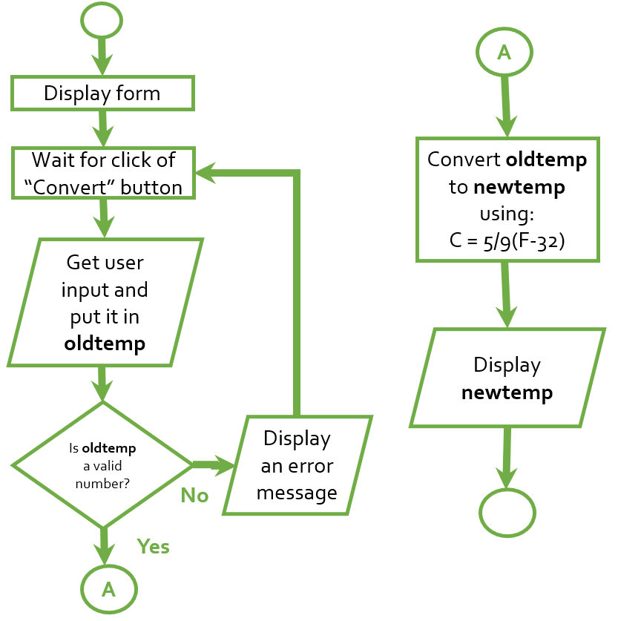
- Write the pseudo code that corresponds to this diagram. Post your pseudo code to the canvas discussion group dedicated to this task.
- After class discussion, write your final version of the pseudo code in the box below.

CONTINUED …

Deliverable 2 – Area of a Circle
- On a piece of paper, draw a flowchart that represents a simple web form that calculates the area of a circle. The area of a circle is calculated by taking square of the radius, and multiplying it by Pi, as seen in this formula:
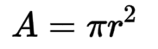
- Your flowchart should include error trapping.
- Be sure to put your name on your paper and turn it in to your instructor.

Deliverable 3 – Area of a Triangle
- Refer to the HTML form shown below.
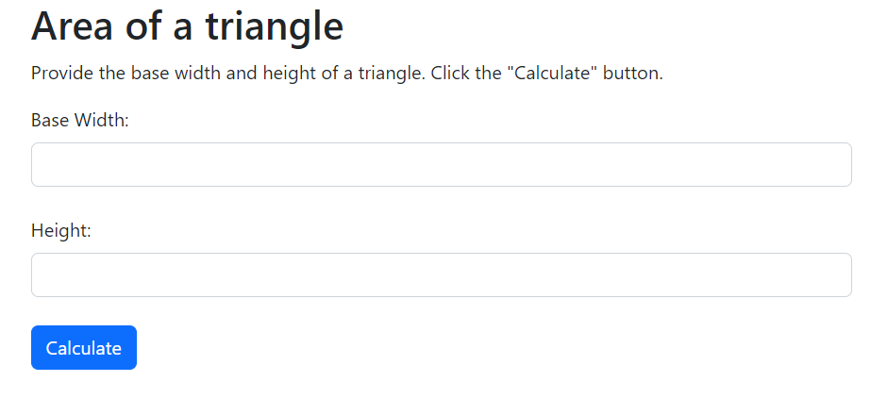
- Write the pseudo code that calculates the area of a triangle.
  - Include error trapping.
  - Be sure to specify the calculation that you will need to perform.
- Post your pseudo code to the canvas discussion group dedicated to this task.
- After class discussion, write your final version of the pseudo code in the box below.

Deliverable 4 – BMI calculator
Body Mass Index is a rough measure of body fat based on height and weight of an adult person. Using pounds for weight and inches for height, the formula for BMI is: 703 x weight / height²
FUN FACT: If your BMI is 18.5 to 24.9, it falls within the healthy range. Less than 18.5 is considered underweight, over 24.9 is overweight.
- Write the pseudo code that calculates the numeric BMI, given a person’s height in inches, and weight in pounds.
- Post your pseudo code to the canvas discussion group dedicated to this task.
- After class discussion, write your final version of the pseudo code in the box below.

- Provide your name at the top of this document.
- Upload your finished word document and upload it to Canvas as directed by your instructor.

