# ICA08 – Pythagoras and Publishing

**INTRODUCTION:**

In class today we took a second look at numbers in JavaScript. In this activity we will do some important things.

1. Referencing the Pythagorean Theorem, we will use the Math object in JavaScript to calculate the value of c given a and b.
2. We will upload our calculator to misdemo.temple.edu
3. You will test your work as a published web page. The URLs to your work will always follow a predictable pattern. You should come to understand that pattern.

Advisory! In this activity, you will need to use Bitvise. Bitvise is software that only works on Windows PC computers. If you are using a MacBook laptop, then please use the computers in the classroom to follow along with this assignment.

As always, every student must submit their own work, even though you are likely to be working on this activity with a friend.

**SCENARIO:**

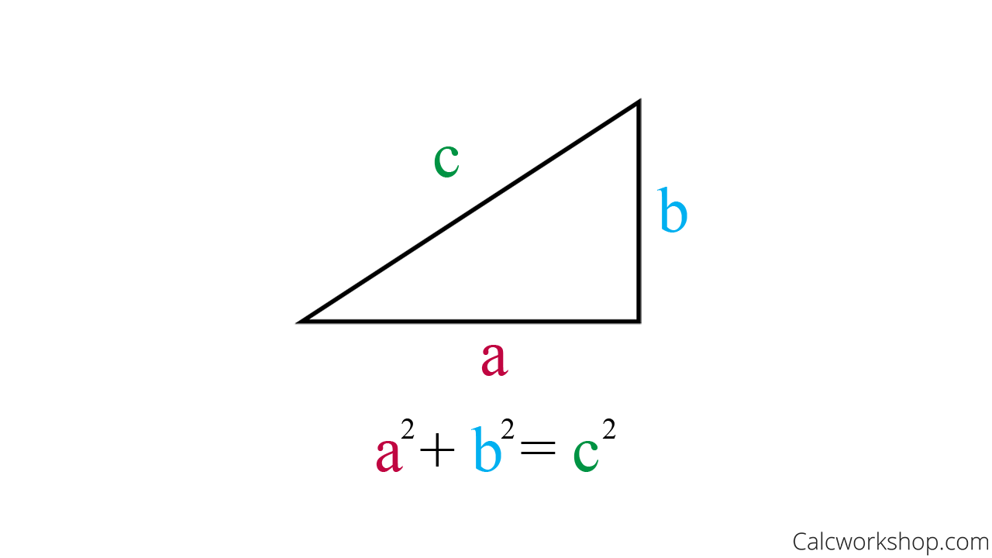

You will recall from Junior High / High School mathematics that the hypotenuse of a right triangle can be calculated with the following formula:

$$c= \sqrt{a^{2}+b^{2}}$$

**INSTRUCTIONS:**

1. Find a friend to work with. Retrieve the ica08calc.zip provided by your instructor.
2. Extract the code into your mis2402workspace and open the triangle.html file in Visual Studio Code.
3. Write the code in the calculateForC function to implement error trapping so that both a and b must be numbers greater than zero. If not, then the function should return “Bad data. Try again.”
4. Write the code in the calculateForC function to calculate the hypotenuse.
5. Make sure that your answer is returned, rounded to 2 decimal places.
6. Test your work.

**CONTINUED…**

**UPLOAD YOUR WORK:**

1. Open the Bitvise SSH Client on your Windows computer.



1. Your instructor will have provided you with a username and password on the MIS Community site gradebook. You will need that in the following steps. ( <https://community.mis.temple.edu/gradebook> )
2. In Bitvise, specify your host, username, and nothing else. Leave the rest alone!

The host is misdemo.temple.edu

The username is the username assigned to you on the MIS Community gradebook

Click “Log in” when you are done.

1. If you see a prompt like this, you should “Accept and Save”

1. Now type in your assigned password and click OK.  
     
   You really should type your password carefully. If you copy paste and are off by one character, your password will fail. Students often copy/paste/fail/ copy/paste/fail/ copy/paste/fail/ copy/paste/fail/ copy/paste/fail/ and then are subsequently locked out of their misdemo account.   
     
   The locking behavior is such that it will appear ( to you ) that the server is unresponsive or off line. This leads students to say – it’s not working.

Use the password assigned to you on the MIS Community gradebook

1. If you are logged in OK you will see the words “Authentication Completed” in the notification window, and you will also see that the buttons on the left have changed.

**CONTINUED**

1. Now that you are logged in you can click the New SFTP window. You will see a two-panel display similar to that shown below.

The big idea here will be to drag the files and folders from your local system (on the left) to the remote system (on the right). **You can, of course, drag files in the opposite direction as well.**

1. Now get set up.

* On the left, you must navigate to your mis2402workspace folder to find your ica08calc folder.
* On the right, you will want to double click on the wwwroot folder.
* You want to end up with a clear understanding of where you are copying your work ***from***, and where you are copying it ***to***.

1. Now, click and drag the whole folder from left to right.

**CONTINUED**

1. When you are all done you should be able to go into your browser and type in this URL in the address bar:

https://misdemo.temple.edu/***tuz54321***/ica08calc/triangle.html

* Of course, you would type your own username instead of ***tuz54321***
* You will be prompted to provide your MISDEMO username and password. This is expected and you need to do this once per browser session.

* You should see your working calculator at that address!

1. Go to canvas and turn in the URL to your work on MISDEMO.

**A FINAL NOTE**

In this activity, you uploaded your work to a server, so that it could be accessed as a web page in a browser, from anywhere in the world over the https protocol. **That action is called “publishing”**. As the semester progresses, you will do more and more “publishing” and less and less uploading to canvas.

As of this moment, your instructor will expect you to know what it means to **publish** your work to misdemo.

MacBook users can’t use Bitvise, but they can use FileZilla on their personal computers.   
  
But for future hands-on quizzes and the final exam, all students must use Bitvise because that is the software available in the classroom! In general, saying “I don’t know how to use Bitvise because I am a Mac user” is not acceptable.

How will this activity be graded?

Your instructor will check your work for completion.

|  |  |
| --- | --- |
| Task | Points |
| URL to triangle.html works | 30 |
| URL is correctly formatted (for example: you used the expected folder name, your URL starts with https:// etc.) | 30 |
| Calculator works as expected | 40 |
| **Total:** | 100 |