# JavaScript functions – Assignment08

In this assignment, students will complete code to solve a problem. This problem can be best solved using logical operators. In JavaScript a logical operator can be used to construct a compound Boolean expression.

THE PROBLEM: The colors red, blue, and yellow are known as the primary colors because they cannot be made by mixing other colors. When you mix two primary colors, you get a secondary color.

Design a program that allows the user to enter the names of two primary colors to mix. If the user enters anything other than “red,” “blue,” or “yellow,” the program should display an error message. Otherwise, the program should display the name of the secondary color that results.

## Getting started

1. Retrieve assignment08_colormixer.zip provided by your instructor.
2. Read the instructions found in the zip file.
3. There’s a bug in the HTML section of the assignment.   
     
   You web page looks like this:  
     
   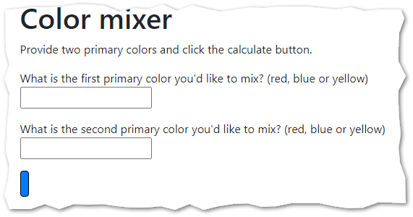  
     
   But it is supposed to look like this:  
     
   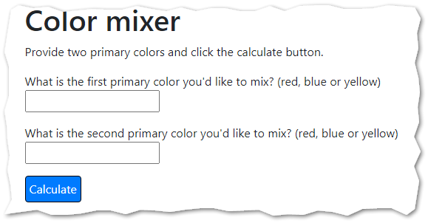

Can you fix it?

CONTINUED…

1. After you fix your HTML problem, complete the solution by writing a code in the findSecondaryColor function. Notes:
   1. Be aware that mixing order doesn't matter, and that you can't predict which the user will type first. So, when a person mixes red and blue, the result will be purple. Also, if the person mixes blue and red, the result should also be purple.
   2. Be aware that mixing blue and blue only gets you more blue.
   3. Depending on what the user inputs, your color mixer should report one of the following statements. Be sure to reproduce them ***exactly.***

When you mix red and blue, you get purple.

When you mix red and yellow, you get orange.

When you mix blue and yellow, you get green.

More blue.

More red.

More yellow.

Bad data. You can only enter red, blue or yellow.

1. Test your work.
2. Upload your work. Be sure that you can find your work on the class server by typing in its URL in the browser. Test your work *again* on the class server.  
     
   For example:   
   http://misdemo.temple.edu/tux99999/assignment08_colormixer

How will this assignment be graded?

This assignment will be evaluated by an automated process.

* If your work is not found at the expected location on misdemo, you will get a score of **zero**.
* If your work generates **all output** correctly, you will get a score of 100%.
* If your work generates **almost all output** correctly (**only one** bad output), you will get a score of 80%
* If your work generates **some output** correctly (some right output, some wrong output), you will get a score of 60%
* If your work generates **only one output** correctly, you will get a score of 40%
* If your work does not generate any correct output, you will get a score of **zero**.