In-Class Activity #1: Database Schema

Submission Instructions
Submit your solutions as a Word or PDF file through Canvas>Assignments>To-Do Submissions.
You must create your database schemas electronically, and they cannot be hand-drawn.
For part 1, use Vertabelo to create your schemas (https://www.vertabelo.com/ ). When you finish creating your database schemas, export the schemas as a PNG file which can be placed into a Word document.
For part 2, use the power point template provided on the community website.
How to create an account in Vertabelo?
- You can create an academic account by using your TUemail. Click ‘register here’ and follow the instruction.
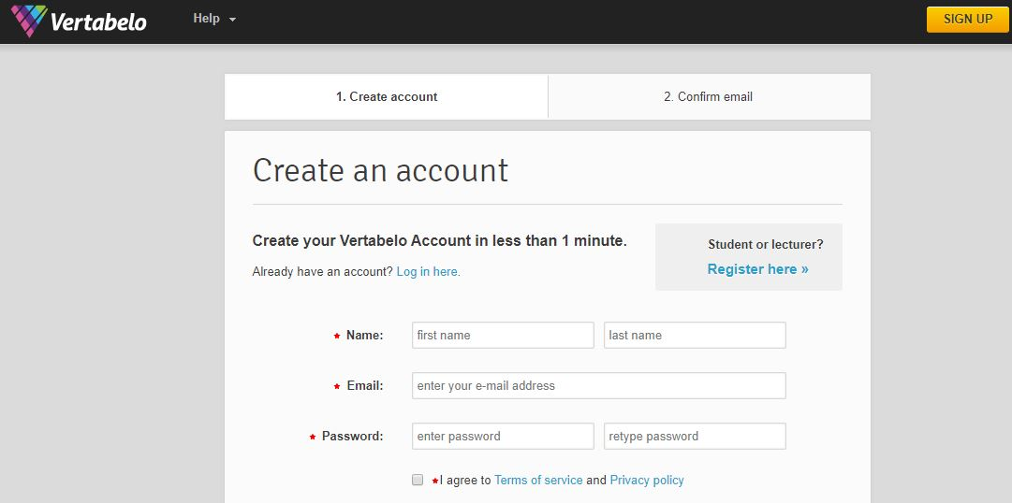

Part 1.
Use the information from the following tables to create a database schema for each of the scenarios. Remember to specify the cardinality of the relationships when you create the schema. Maximum cardinality is given, however you will have to identify the minimum cardinality if necessary.
Scenario 1: Housing Authority
Entities | Attributes
Development | DevelopmentID, Name, Number of units
Unit | UnitID, Unit Number, Bedrooms, Bathrooms, Square footage
Household | HouseholdID, Description
Resident | ResidentID, First name, Last name, Birthdate, Head of household?

Relationships | Relationship Attributes
Development-Unit: One to Many
Unit - Household: Many to Many | Move in date, Move out date
Household- Resident: One to many

What is data type?
In relational database,
- Each field should contain only one type of data
- That must be specified when the table is created
- There are many data types; we’re only going to cover the most important ones
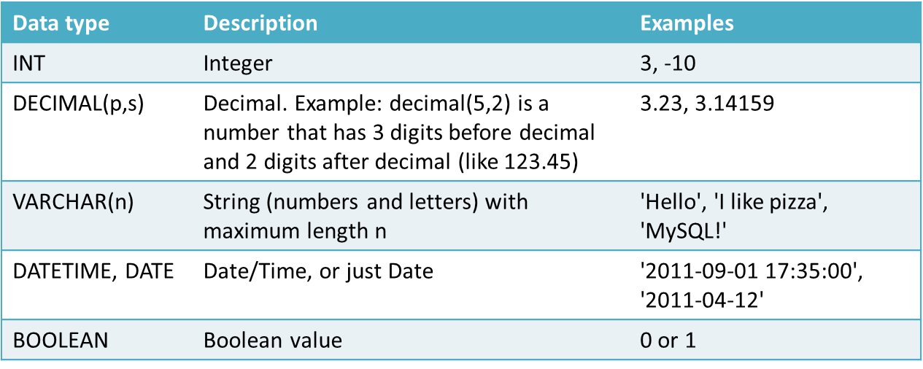
Part 2.
Specify the maximum and minimum cardinality based on the following statement. If maximum or minimum cardinality is not specified, define them based on your assumption.
Scenario 2: Safety Incident Database for Amusement Park
A medium-sized amusement park in suburban Philadelphia is required to keep a record of all safety-related inspections and incidents (such as accidents) for each ride.
A ride is described by a name and type. An operator is described by first name, last name and social security number. Each time an operator runs a ride at the park, the date and shift are recorded (there is only one operator each time a ride is operated). (1) Each ride has at least one operator, and different operators may run the same ride over time. Operators may be included in the database even if they haven’t operated any ride (i.e., new operators with no ride), and an operator may run different rides.
An incident involves both a ride and an operator. All operators and rides are included in the database whether or not they’ve been involved in a safety incident. (Hence it is possible that there are operators who have no incident; similarly, it is possible that there are rides without incident). When an incident occurs, its date and time are recorded along with a description of the incident.
Inspection records are also recorded in the database. An inspection occurs at a particular date and time, with a numeric score from 1 to 5, and location where the inspection happened. (2) There is only one ride per inspection, but a ride can have multiple inspections over time. A ride may be included in the database even if no inspection has been performed yet.
(1) Ride-Operator
(2) Ride-Inspection

